# How I created the sample reports

21-Feb-2025

There are TWO sample BIRT reports that are built in this tutorial. The completed versions of both reports are found in the Demo_Reports folder underneath the nurs6293_reports root directory in BIRT. You can find these files in the Project Explorer tab (red box) in the lower left corner of the BIRT application:

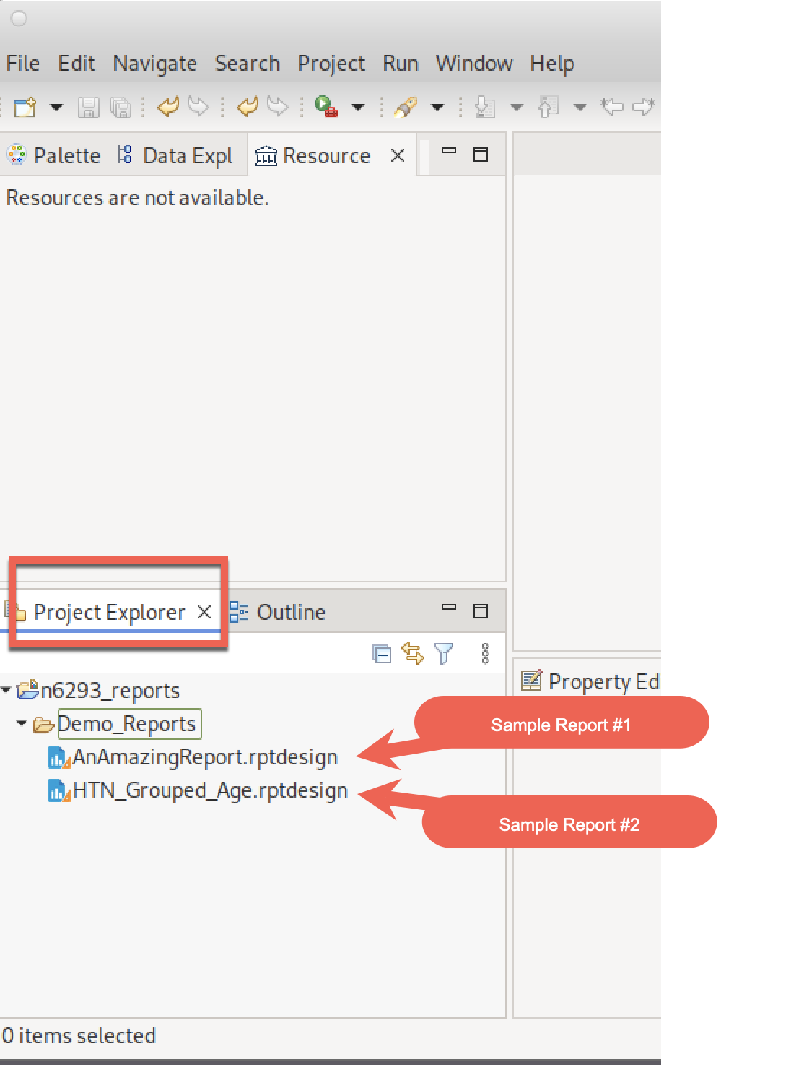

Most BIRT tutorial content on the web is very old, ending when the key BIRT supporter (Actuate) was purchased by OpenText. I find the most recent BIRT tutorials are in the context of BIRT that is embedded in somebody’s product. While the context is their product, the basic features of these tutorials are still valid for our use.

The tutorials that I used for these examples come from IBM’s InfoSphere Data Architect product. Other IBM products have similar BIRT tutorials that may also be useful.

I used the “Creating a simple column report” for Report #1: <https://www.ibm.com/docs/en/ida/9.1.2?topic=designs-creating-simple-column-report>

I used the “Grouping data in a report” tutorial for Report #2:

<https://www.ibm.com/docs/en/ida/9.1.2?topic=designs-grouping-data-in-report>

You may find the “Formatting a Report” tutorial on the IBM site useful, but it starts to dip into more programming concepts than you need to meet the course objectives:

<https://www.ibm.com/docs/en/ida/9.1.2?topic=designs-formatting-report>

These tutorials refer to databases/data sources that are part of IBM’s product. Also, some of the tutorials are using an older version of BIRT so the screen shots are “close” but not identical to the dialog boxes you see in our newer version of BIRT. But close enough to figure out how to use their methods in our version.

**\*\*\*\*\*\*\*\*\*\*\*\*\*\*\*\*\*\*\*\*\*\*\*\*\*\*\*\*\*\*\*\*\*\*\*\*\*\*\*\*\*\*\*\*\*\*\*\*\*\*\*\*\*\*\*\*\*\*\*\*\*\*\*\*\*\*\*\*\*\*\*\*\*\*\*\*\*\***

**Step 1: Understanding the EMR50K/EMR100K data**

Start with understanding the data model of the database(s) you will use in your report. You have access to two de-identified outpatient databases: emr50K and emr100k. These databases are identical in structure. The emr50K database has the same patients as the emr100k database filtered to only include patients with odd-numbered PAT_IDs.

Spend time understanding the EMR100K ERD that is provided. It should feel very familiar to you based on the approach you used for your own registry. This is an “encounter-centric” data model because all clinical events are tied together via an encounter. Patients are then tied to one or more encounters.

Use PGModeler to explore the various tables. In PGModeler, left side panel, select “Manage”. In the next column under “Database Explorer” select “postgres (postgres:5432)” Under to “Found 14 databases” dropdown, select emr100k or emr50k -> Schema(1) -> Public -> Tables(15).

|  |  |
| --- | --- |
|  |  |
|  |  |

Explore the various tables so you understand the difference between the enumeration entities (diagnoses, lab_tests, medications, observations, procedures) versus the association entities (enc_diagnoses, enc_medications, etc). Note that the only dates in these databases are in the encounter table (obsdate = observation date) and patient (dob = date of birth). If you need the date that a lab test, observation, medication or procedure occurred, you need to do the required JOINs to bring in the ENCOUNTER table. If you want to do anything with patient age (this is Example #2), you need to do the required JOINS to bring in the PATIENT table.

I will show you how I figured out how to convert DOB to current age so you can utilize the same strategy if you want to do some calculations but don’t know the correct SQL syntax. Bottom line: Google (or any AI Chatbot) is your friend.

**Step 2: Generate the data results you will use in your report.   
DON’T GET TOO FANCY HERE. THE FOCUS ISN’T ON THE QUERY BUT THE REPORT PRESENTATION.**

This step requires a bit of creativity due to the severe limitations of the de-identified databases we were allowed to use. THE POINT OF THIS MODULE IS NOT THE CLEVERNESS/COMPLEXITY OF YOUR QUERY so do not spend a ton of time on creating some super-complex query. The focus on this module is understand the challenges with creating visually useful data presentation.

This is the incremental cycle that I did to create the query I used in the sample report. The final query looks complicated. But follow the logic presented here where I build up the query incrementally, starting with a simple query and adding more pieces to it.

Use PGModeler for this step. The query tools in BIRT, the report-writing tool we will be using, are awful. After you nail down a good query, you can copy-paste the SQL from PGModeler into BIRT.

In PGModeler, I selected the emr50K database because queries are quicker with the smaller database. I figured I could change to the 100K database if needed. As you will see, in the end, I got too many patients and had to add limits to make the report a reasonable size.

|  |  |  |  |
| --- | --- | --- | --- |
|  |  |  |  |

* I started my exploration of the emr50K database by looking at the list of diagnoses in the DIAGNOSES table:
  + SELECT * FROM DIAGNOSES

This query returns 892 possible diagnoses.

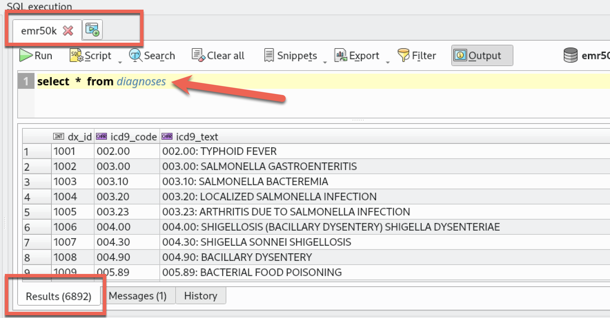

Hmmm. This seems too large for what I know is a very limited database. **POSSIBLE** diagnoses listed in the DIAGNOSES table is not the same as ACTUALLY USED diagnoses. Of the 6,892 possible diagnoses, I suspect only a small number of them were ever used with an encounter. So, let’s look at the diagnoses that are **\*\*\*ACTUALLY\*\*** used in this database. To answer this question, we need to look at the ENC_DIAGNOSES table because it lists diagnoses that were recorded in encounters. Let’s do a query that lists the diagnoses actually used and a count of the number of encounters that used each DX:

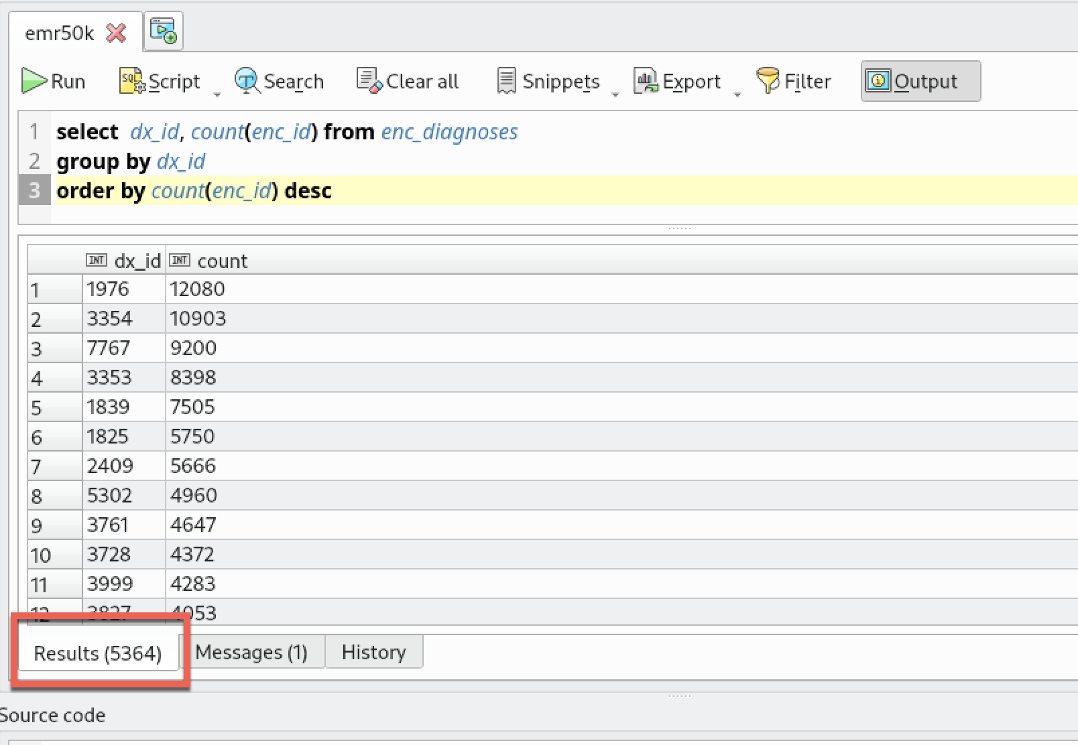

Take some time to understand this GROUP_BY query.

This query result “says” that there are 5,364 different diagnoses (red box) and that the most frequent is DX_ID = 1976, used in 12,080 encounters (first row).

Great, but I have no idea what diagnosis is represented by DX_ID=1976. To find out what DX_ID=1976 represents, I want to add the text description of each diagnosis to the previous query. Looking at the ERD, I see that the DIAGNOSES table contains a column called ICD9_TEXT, which is what I am seeking. So, I need to add a JOIN between ENC_DIAGNOSES in my previous query and the DIAGNOSES table so I can include the ICD9_TEXT in my expanded query. The common key that links these two tables is the DX_ID column. Here is what the expanded query looks like:

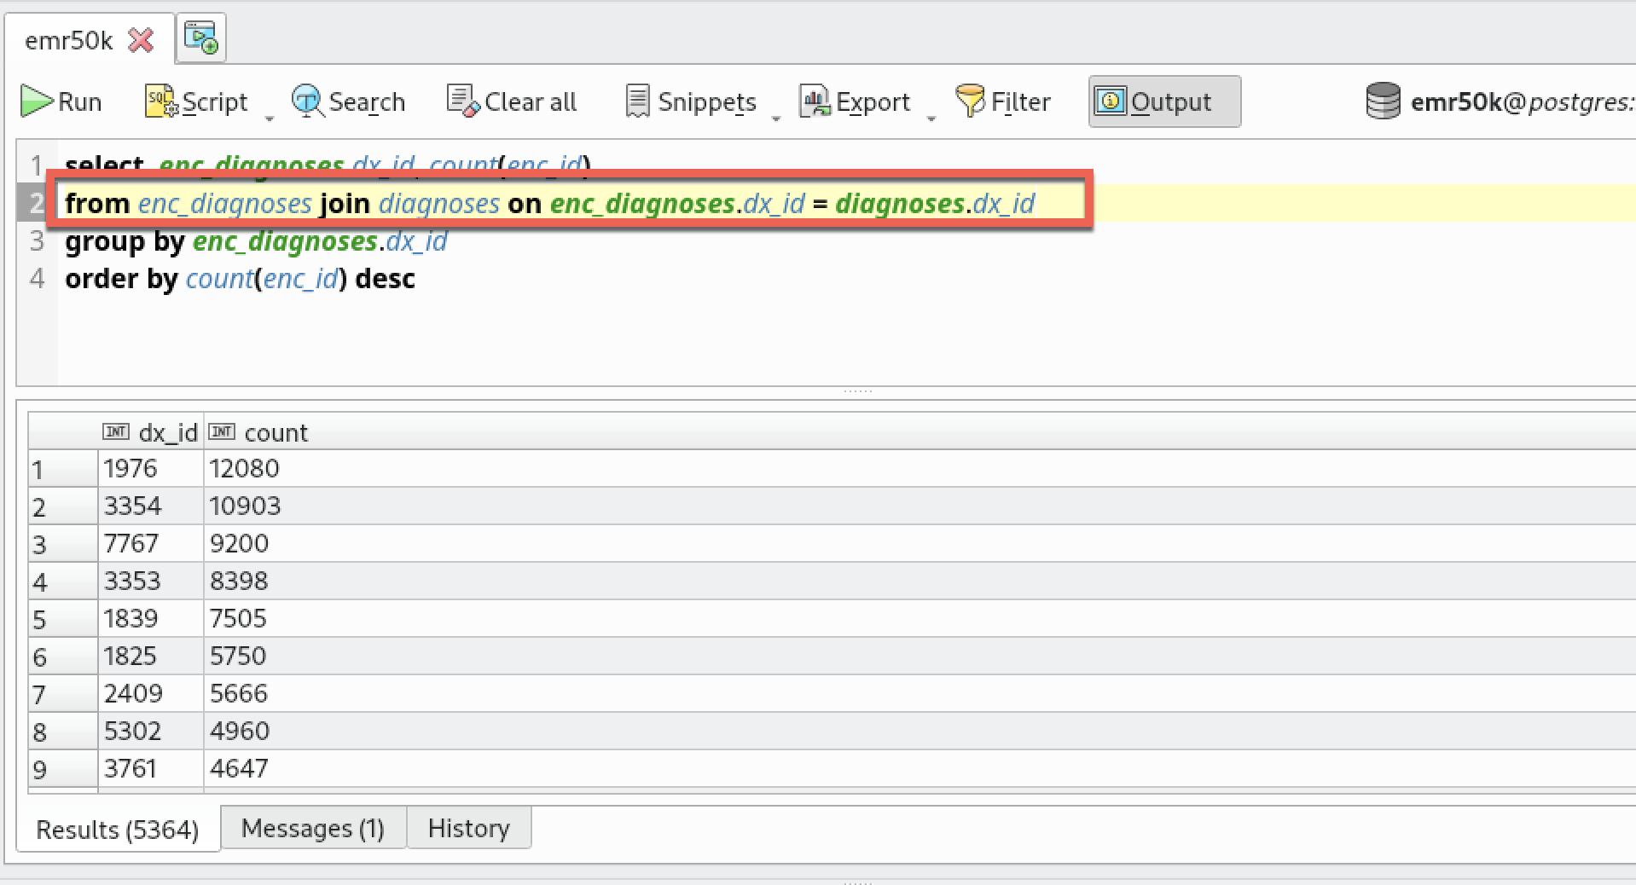

Notice the addition of “JOIN DIAGNOSES on enc_diagnoses.dx_id = diagnoses.dx_id” (red box) to bring the two tables together.

Wait a minute. I added the JOIN to the DIAGNOSES table, but the output looks the same as before. Can you tell what’s wrong?

I forgot to add ICD9_TEXT to the SELECT and GROUP_BY clause. This is the same query but with ICD9_TEXT added: 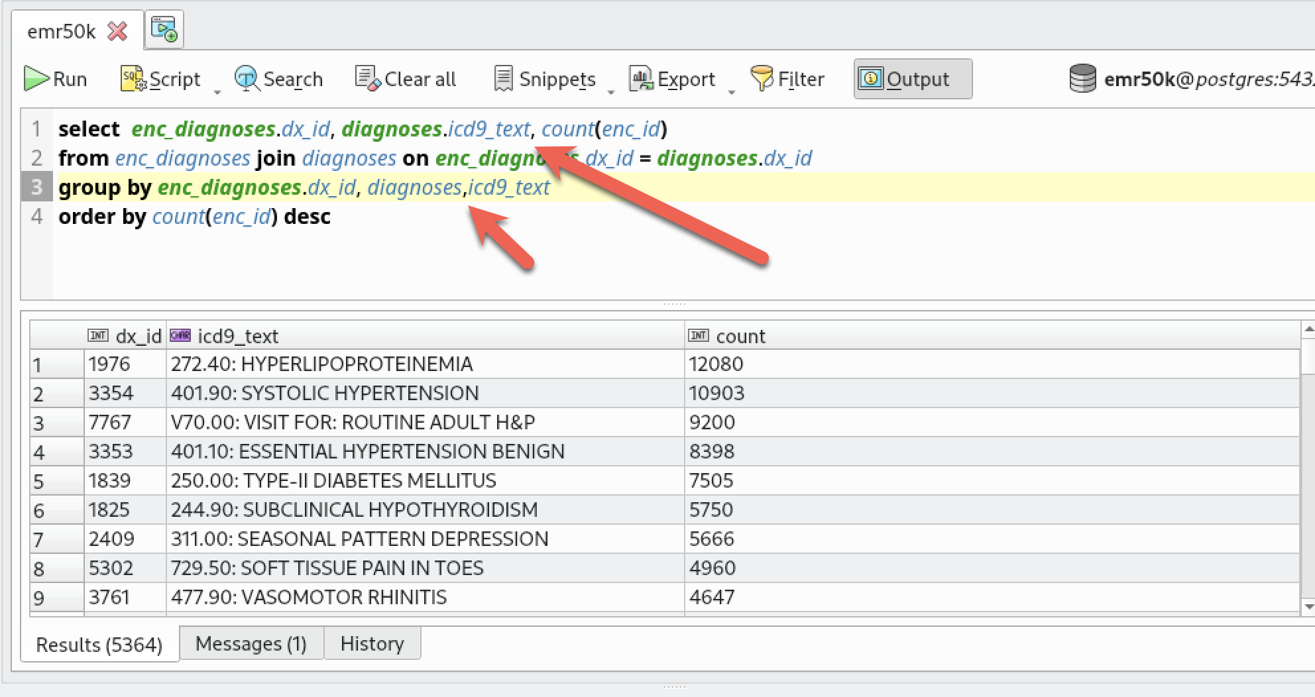

OK, now we are getting somewhere. We see that DX_ID=1976 corresponds to ICD9CM code “272.40: HYPERLIPOPROTEINEMIA”. Wow, not what I would have guessed to have the highest number of encounters. Second highest DX is DX_ID=3354 for Systolic Hypertension, which makes sense to me.

You can do the same type of exploration with medications, lab tests, procedures and other tables.

I have decided to focus on hypertension related diagnoses. You may decide to focus on other diagnoses. Or, you may go thru this same anaysis looking at medications or observations or procedures to see if there is something else of interest that you wish to pursue in your query.

So, how do I isolate the hypertension queries that are in the 5,364 diagnoses used in the EMR50K database? The query below modifies the previous query so that it only pulls out rows where the ICD9_Text field has the word “hypertension” anywhere in the string:

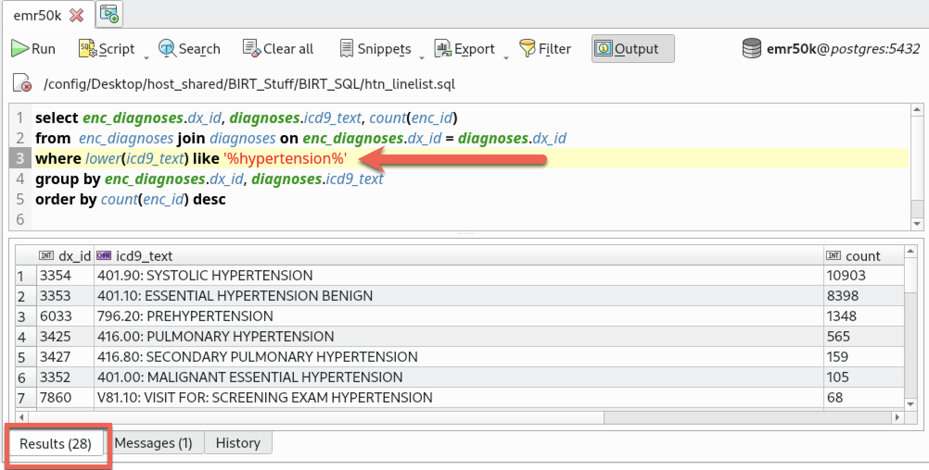

The new bit added to the previous query is:

where lower(icd9_text) like '%hypertension%'

What does this do? The lower() function ensures that all text is lower case so I don’t need to worry about mixed upper/lower case (yes, there is an UPPER() function…..).

What is the LIKE ‘%hypertension%’ all about? The LIKE command is SQL’s text-matching command. It looks for any text that matches ‘%hypertension%’. The % symbol is SQL’s string “wildcard” symbol. It matches zero to many of any character. So the string ‘%hypertension%’ matches text that has any characters before the letters h,y,p,e,r,t,e,n,s,i,o,n followed by any characters. That is blah-blah-blah-hypertension-blah-blah-blah where “blah” could be **zero**-to-many characters.

As you can see, with additional clause, there are 28 different diagnoses where the ICD9_TEXT string has the letters hypertension somewhere in the label (red box).

Things are starting to look promising. This query is good enough for the class. It returns a small number of rows (28 rows). **We will use this query for the report.**

select enc_diagnoses.dx_id, diagnoses.icd9_text, count(enc_id)

from enc_diagnoses join diagnoses on enc_diagnoses.dx_id = diagnoses.dx_id

where lower(icd9_text) like '%hypertension%'

group by enc_diagnoses.dx_id, diagnoses.icd9_text

order by count(enc_id) desc

As mentioned at the beginning, the BIRT query writer is awful. You should do the above data exploration/query writing using PGModeler. When you are happy with your query, you can save it and/or copy-past from PGModeler into BIRT to get past BIRT’s terrible SQL query writing tool.

**Step 3. Introducing the BIRT report writing tool**

**NOTE: Most of the online materials/Youtube videos/posting are terribly out of date. Most refer to Version 1.x or 2.x. We are using Version 4.16. If you find online materials that use Version 4.x, please let me know.**

**A high level description of the current BIRT design editor is at**

**https://eclipse-birt.github.io/birt-website/docs/t_brief-editor-tour**

BIRT is the report writing tool that we use to take the database output from our query and create a more useful human-readable report. There is an entire field called data visualization that focuses on how to make insightful, easily consumed data presentations. Our goal here is to give you a simple experience with tweaking (and tweaking and tweaking and tweaking) even simple visual presentations of data. In practice, this step can be a tremendous black hole of time. But if you are visually talented, some amazing visualizations are possible. Google for “amazing data visualizations” to see examples of the true artistic craft of data presentation.

But for class, we intend to keep things simple.

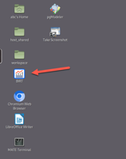

To start (or resume) BIRT, click on the desktop icon

The BIRT screen is very busy – a bit overwhelming at first. We will use only a small fraction of the deep formatting capabilities of the tool.

Before you open an existing report or start a new report, the BIRT screen looks like:

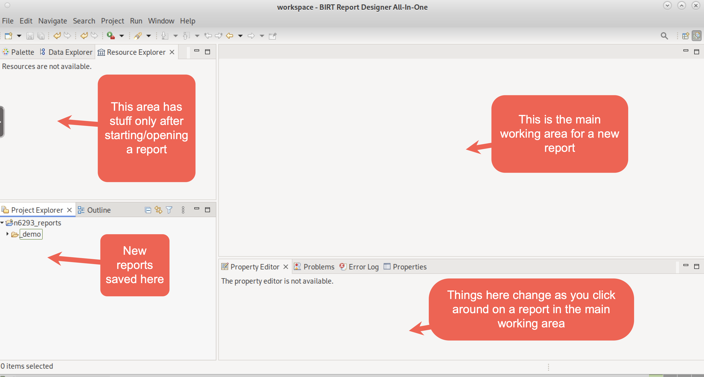

To start a new report, from the top menu: File -> New -> Report

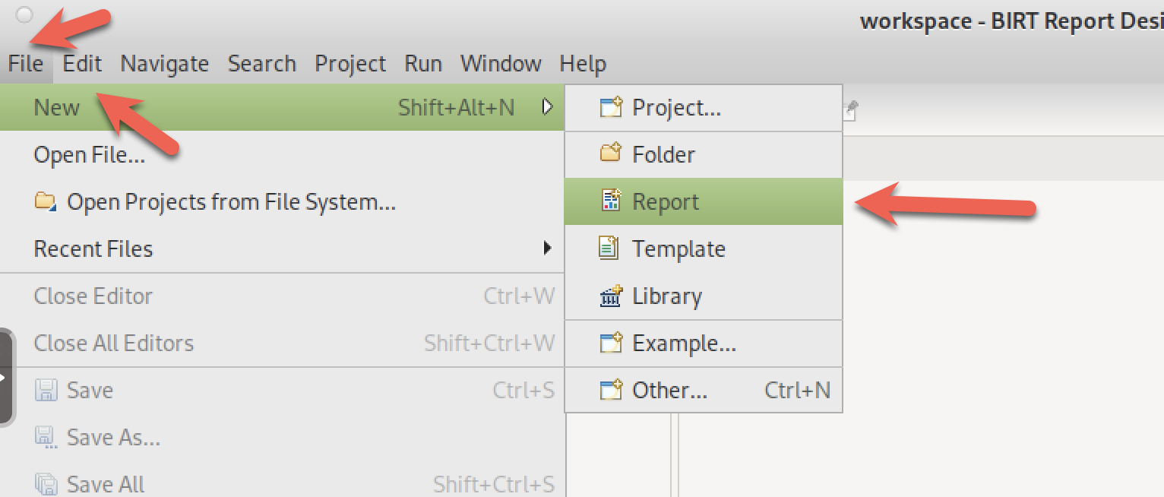

To resume work on a saved report, just double click on the report in the Project Explorer:

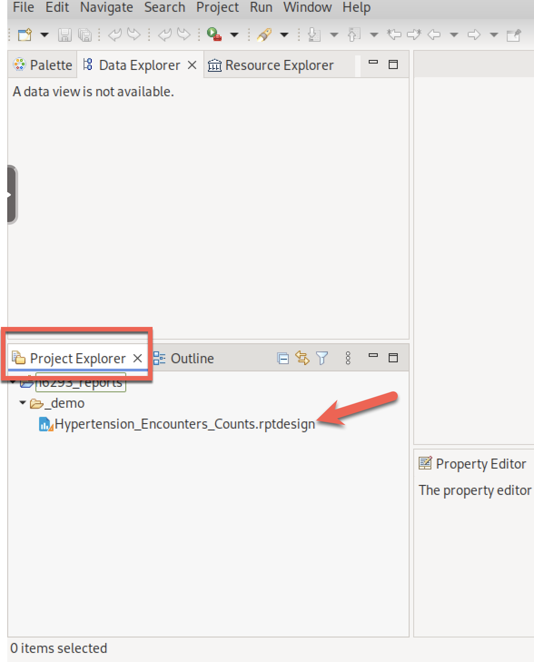

For a new report, you need to go thru the following sequence:

|  |  |  |
| --- | --- | --- |
| From File->New -> Report, click on “n6293_reports” as the folder for storing the report. | Give your report a name and click “Next”. If you don’t give a name here, your report will be named new_report. The name must end with “.rptdesign” | Pick “Blank Report”. You can explore the other templates but for class, starting with a blank report should be sufficient. I only use “Blank Report” for the two examples. |
|  |  |  |

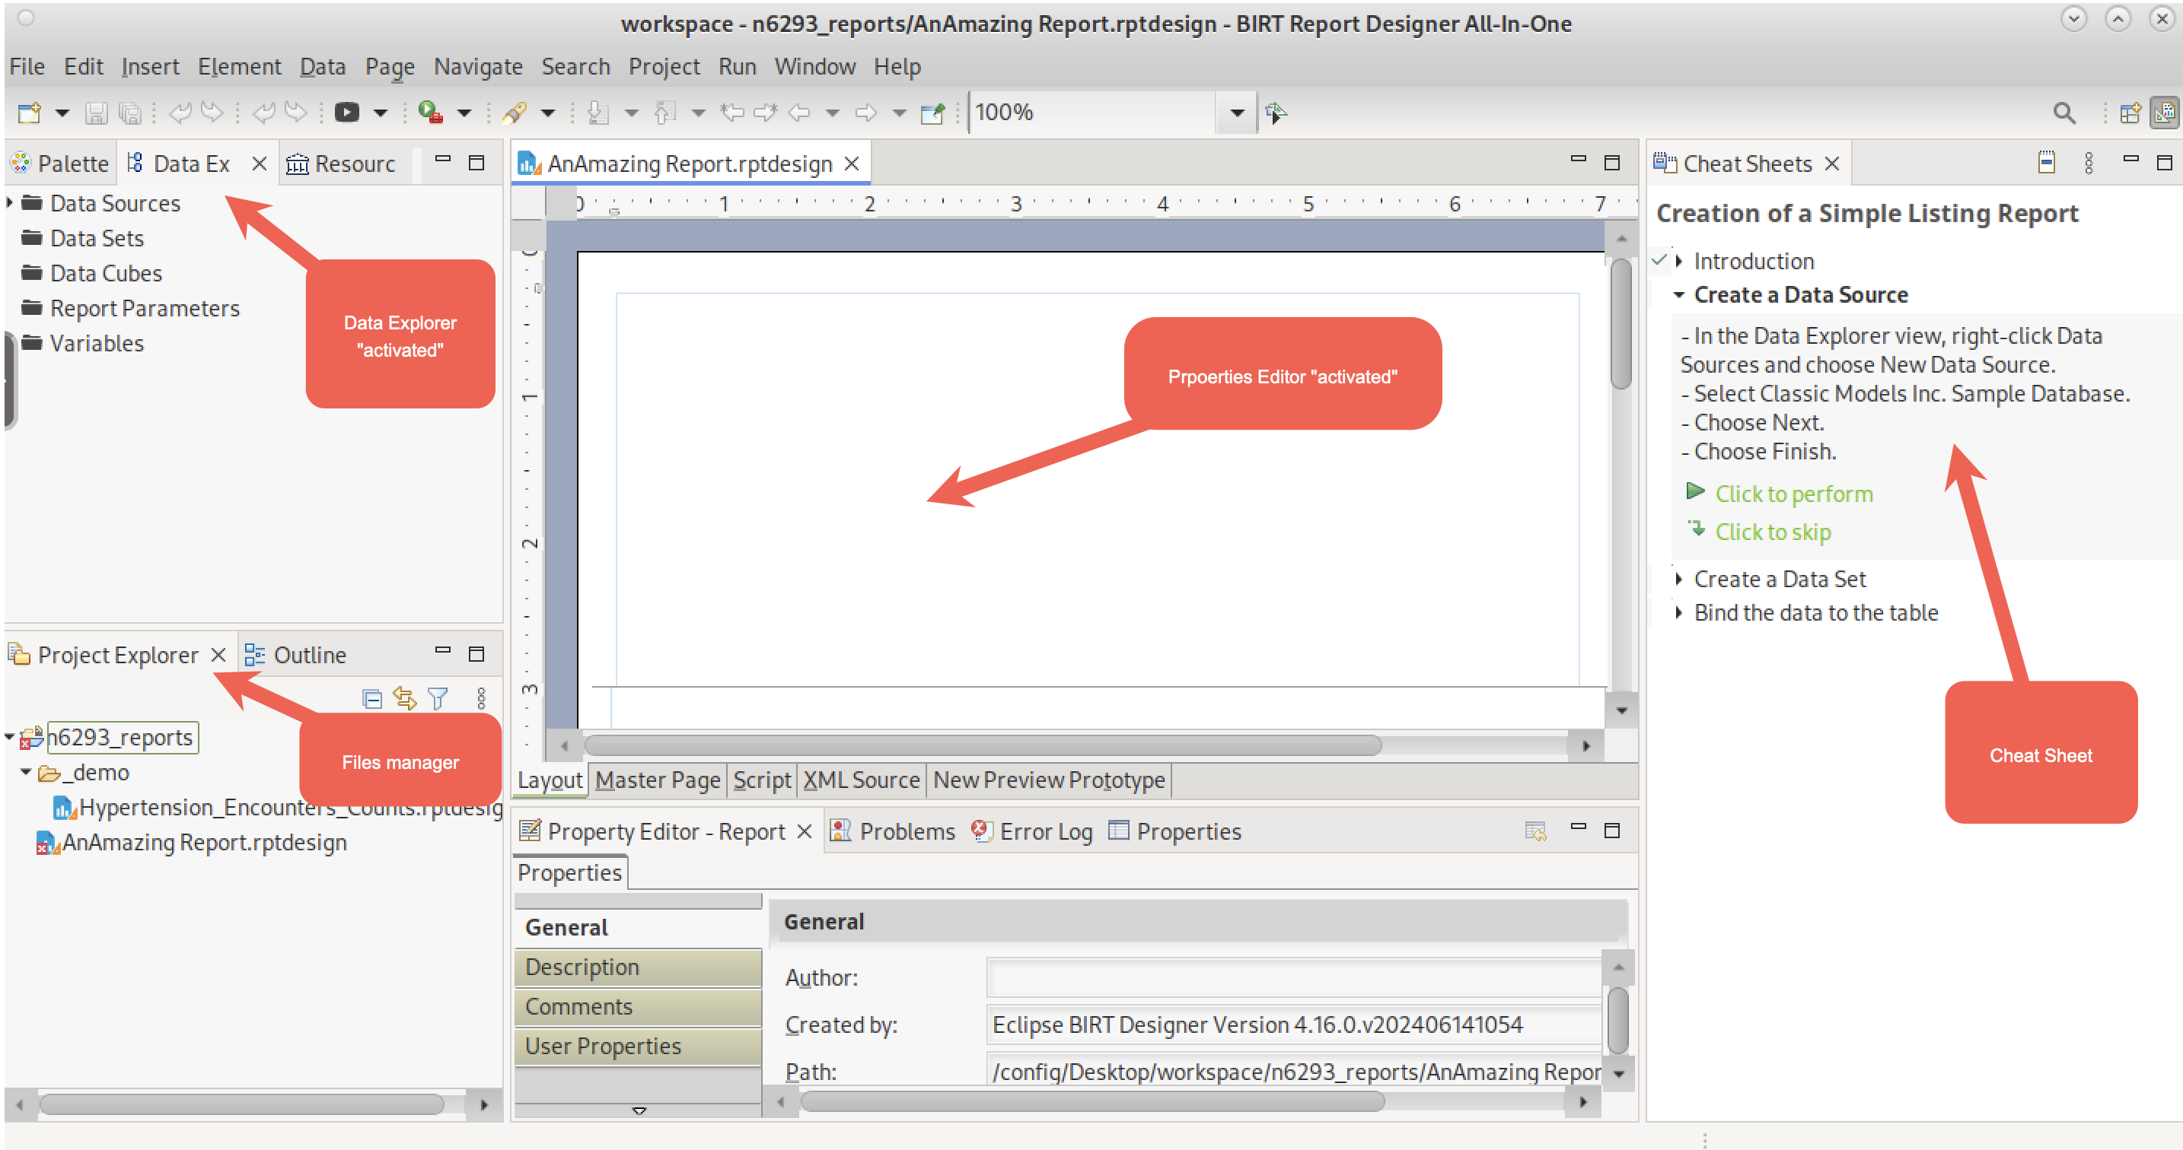

If you get a cheat sheet panel on the far right, you can close that tab (red arrow below) because we are not following those instructions. It will also give you more space with the report designer:

|  |  |
| --- | --- |
|  |  |

I have modified the “out-of-the-box” templates so that they already have connections to the two EMR databases. Look for the Data Explorer tab in the left-side panel and open “Data Sources”. You will see pre-configured connections to emr100k and emr50k (red box)

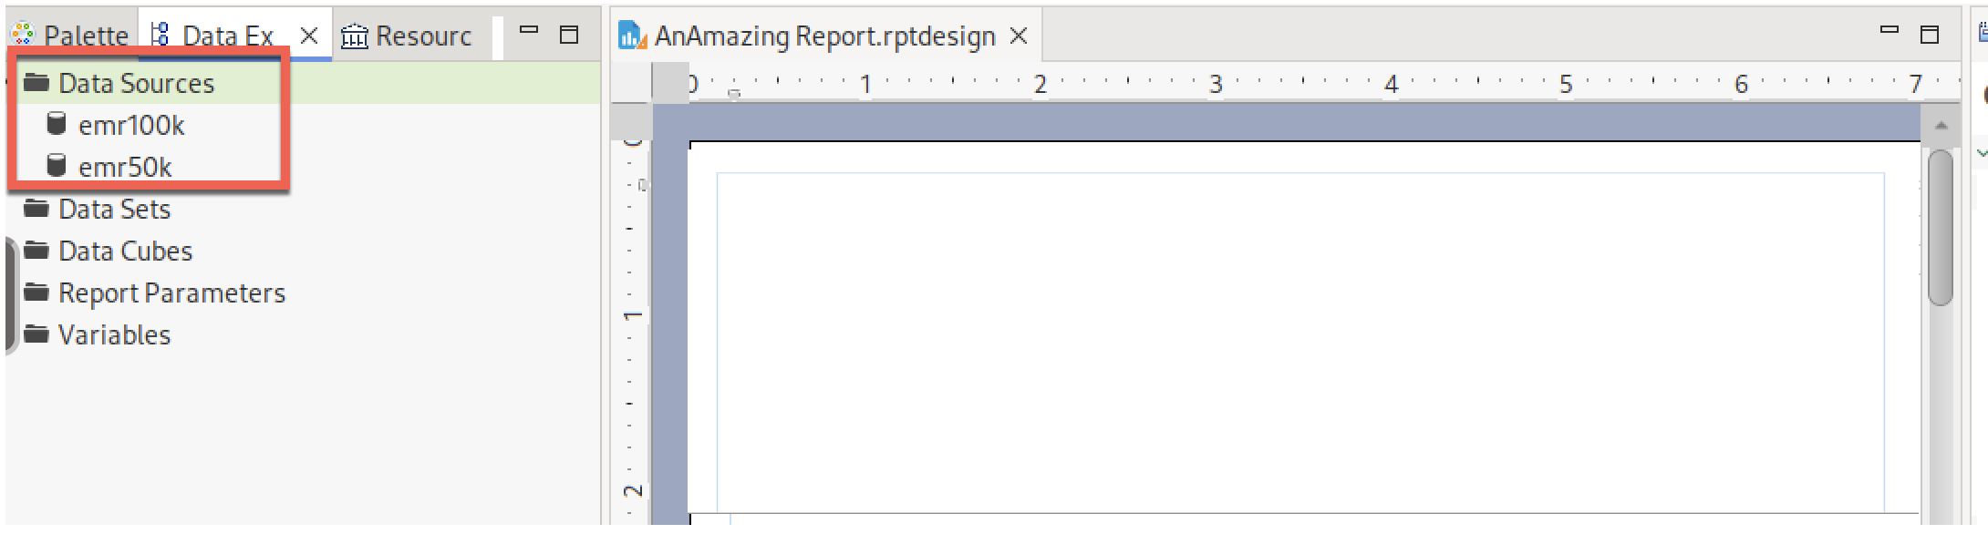

Before we start mucking around with this report, let’s see what the “blank” report looks like.

**You will be doing this step a zillion times**: Make a change, render the report to see what it looks like, make a change, render the report to see what it looks like, make a change……

To render the report, click on the icon in the menu bar:

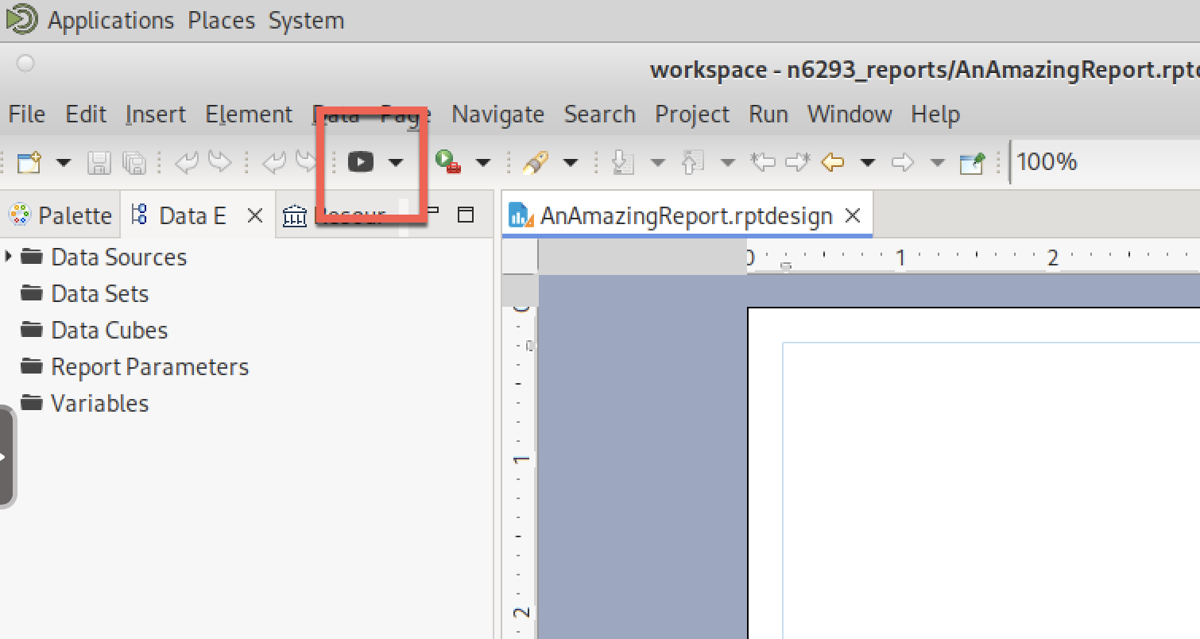

This opens a web browser with the report:

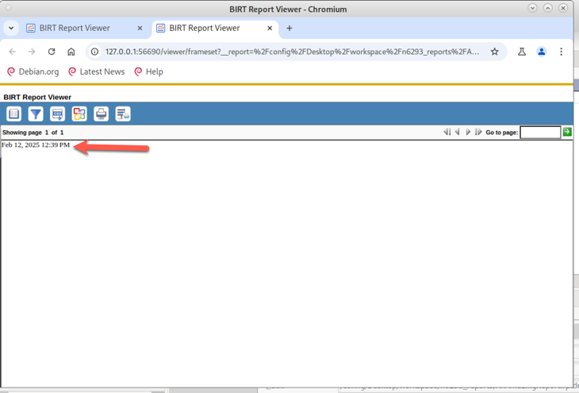

As expected, not a lot there. But there is one strange item – there is a date that has magically appeared in the “Blank” report (red arrow). Where is that item coming from if this supposedly is a Blank Report template?

Back to the Report Designer. At the bottom, there are two tabs (red arrows): 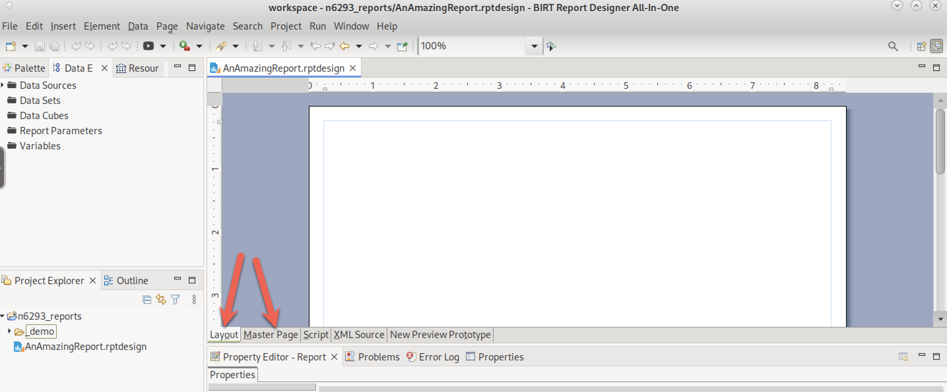

Layout: This is the main tab that we will be using for our report.

Master Page: This is the tab that allows us to define elements that appear in the header and footer **of every page in a report**. If we click on “Master Page”, we see the following (I had to scroll down to the bottom of the page to see the footer)(red box):

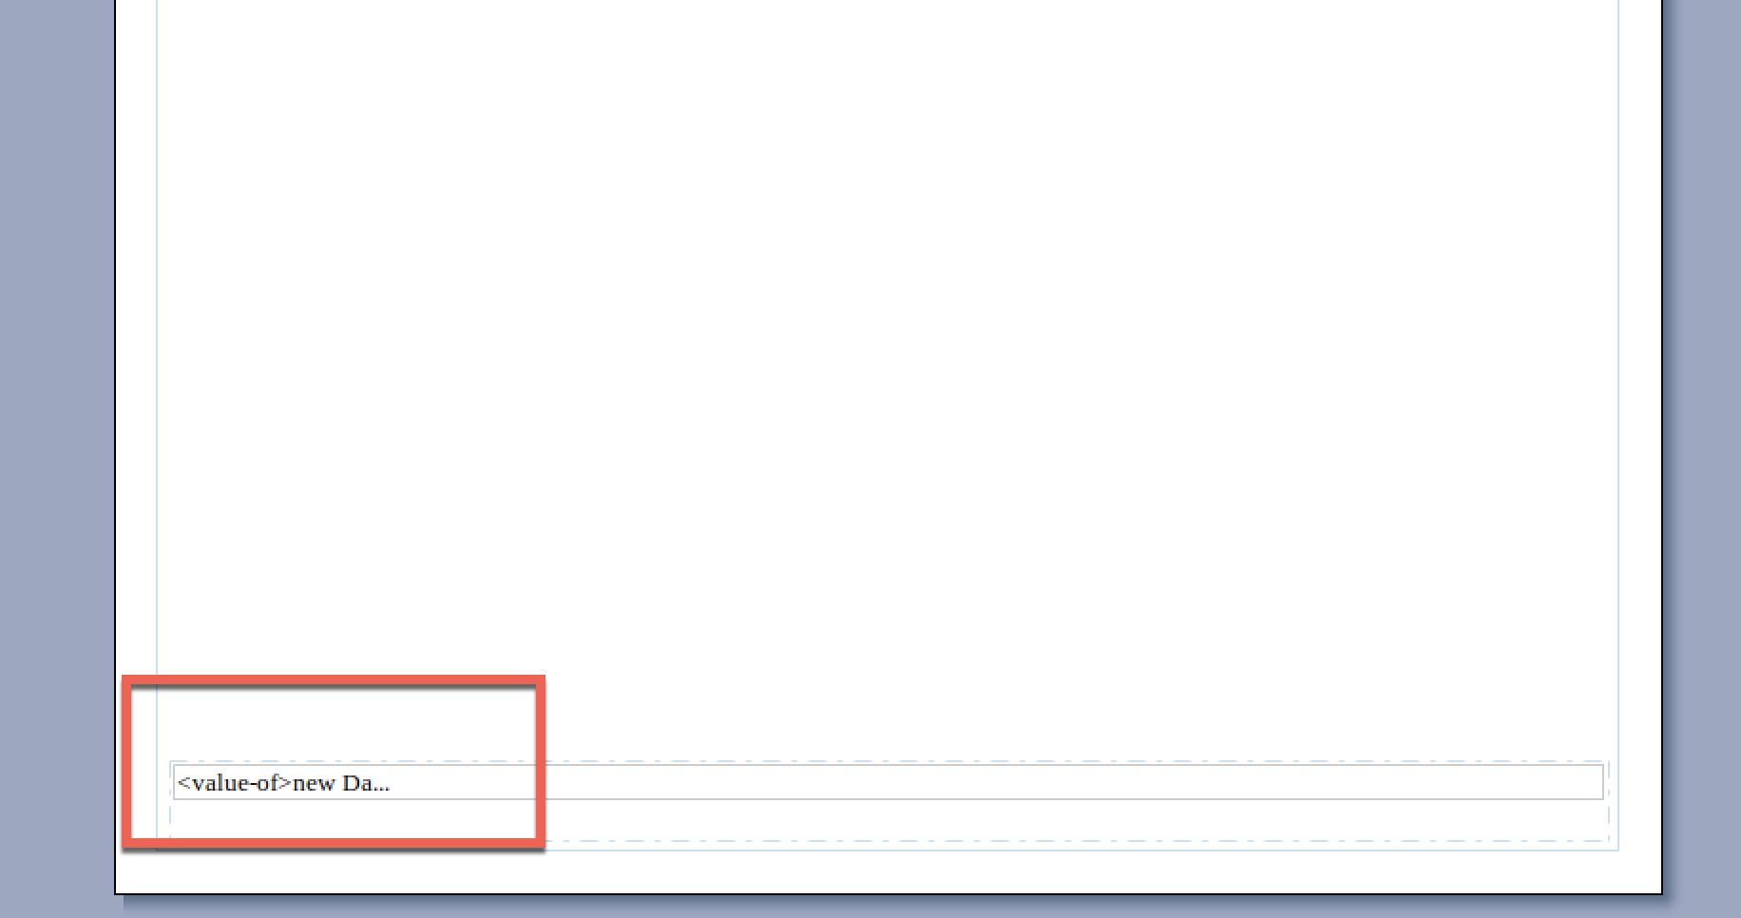

This is where the date is coming from.

ONLY PUT HEADER/FOOTER INFORMATION IN THE “MASTER PAGE” TAB. FOR CLASS, NEARLY EVERYTHING WILL ALWAYS GO INTO THE LAYOUT TAB. In these examples, I only use the Header to print the CU logo to brand the top of every page. Even this was a bit of a stretch that I concocted for these examples.

Moving on the creating a report that has our query data:

The first step is to create a “Data Set”, which defines the data that can be used in this report. Not all elements in a data set must be used and, as you will see, we can add more elements to this list. This is the step where we copy-paste the final SQL statement that we created using PGModeler rather than the SQL in BIRT:

|  |  |  |
| --- | --- | --- |
| RIGHT click on “Data Sets”. Select “New Data Set” | Select which of the two available databases you want to use, give your query a name (or just use the default) and select “Next” (bottom arrow) | Paste the SQL from PGModeler here and then click on Finish (red arrow). |
|  |  |  |
|  | | |

The next box is asking if you want to make changes to the SELECT clause variables. For class, just hit the “OK” button. We can always remove unwanted variables from the report, and we will make some changes to the column display names, fonts, alignment, etc in the report designer rather than doing that here.

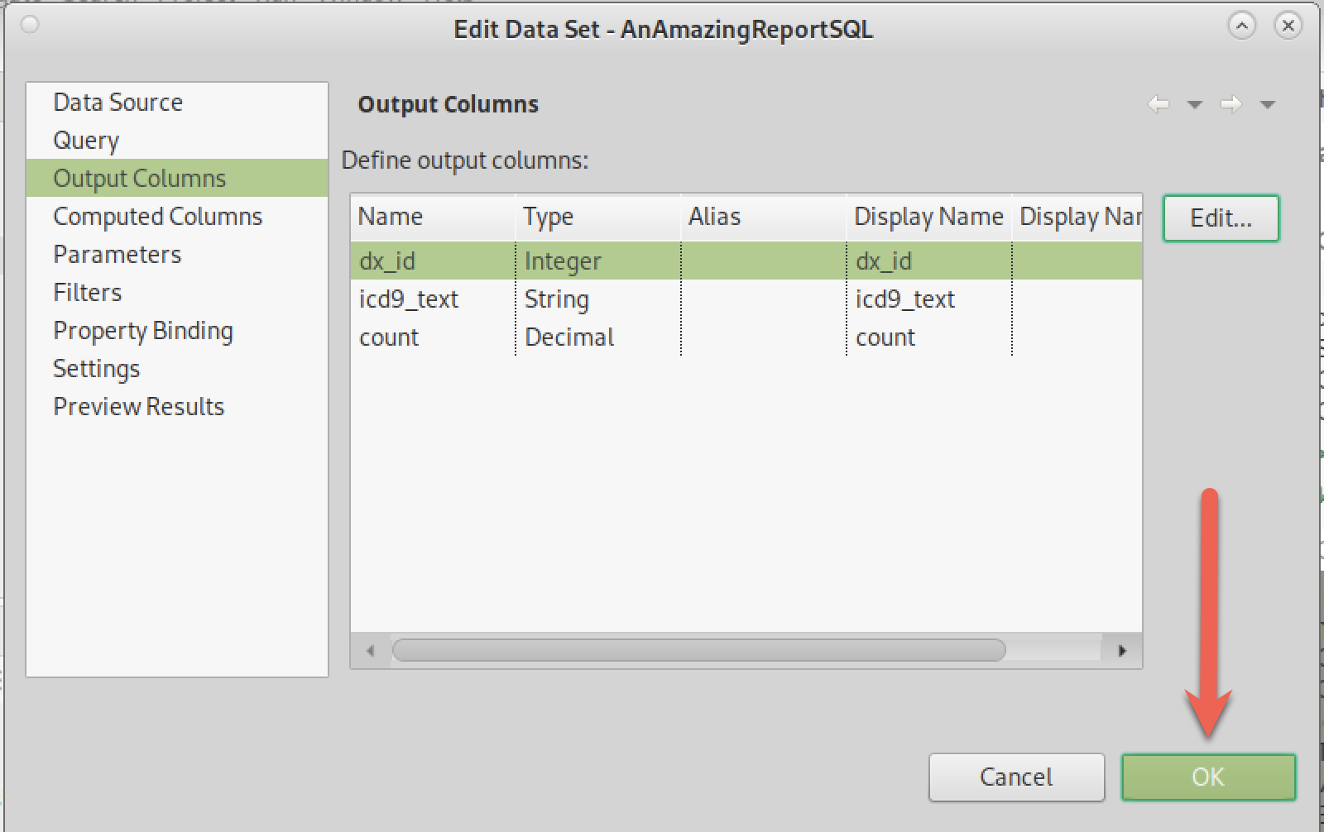

This is what you should see in the Report Designer. Notice that you now have access to all three variables from the SELECT clause. You can now bring these variables into the report for formatting. Make sure you are in the “Layout” mode (red box) as you begin creating your report.

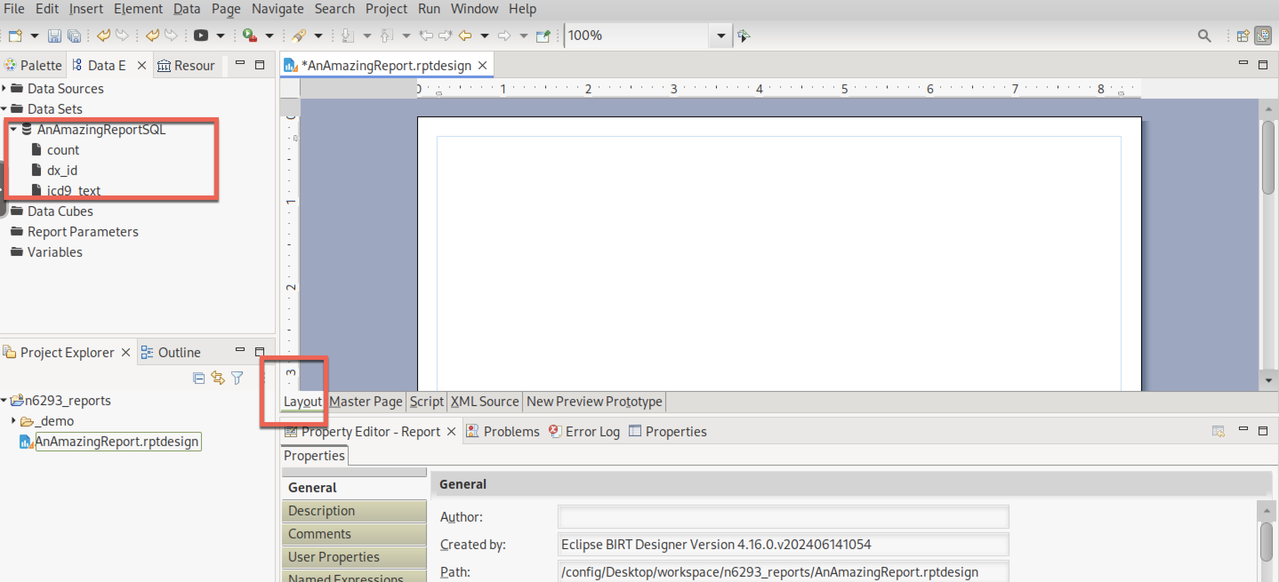

Let’s start with the most obvious, **but wrong**, way to move data into your report. For each field in the data set, drag that field into the main body of the report (three arrows) **one at a time**. Then render the report (red box):

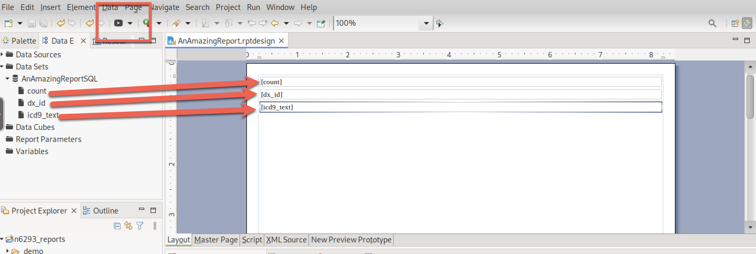

What comes out is:

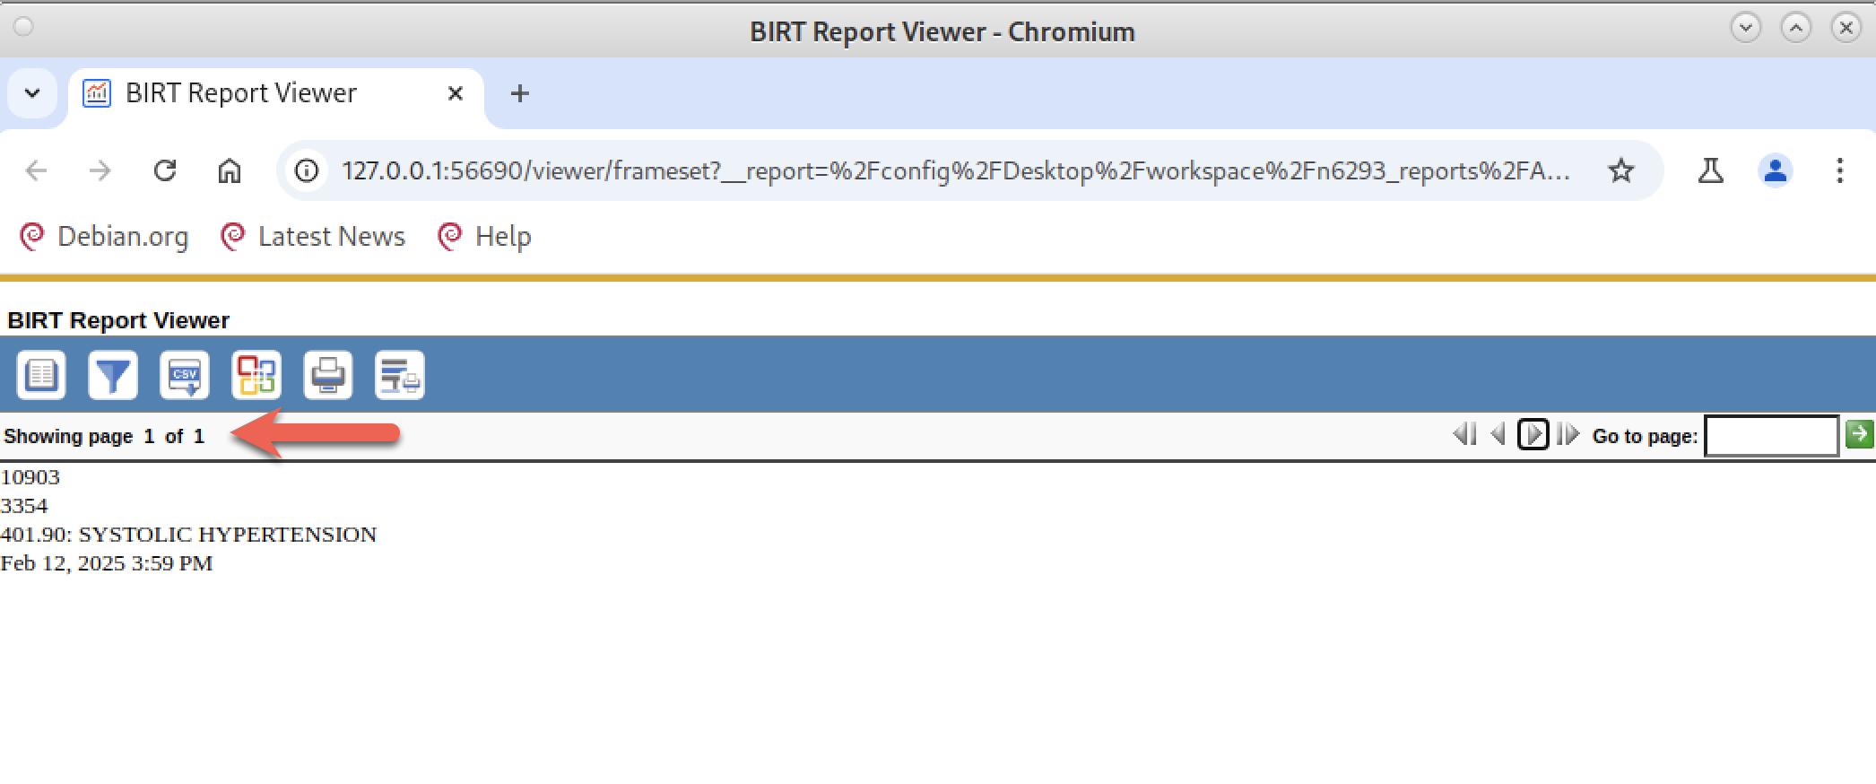

One page with only one row of data with the counts,dx_id, icd9_text and the footer date. This is not what we want. Turns out that this is the data from only the first row in our query.

We want a table showing all the rows in column format. So we being the dreaded cycle of “Make a change – render the report – Make a change - render the report…..” Get used to this cycle. It is a constant in data reporting.

First we need to delete the items that got put into our first (incorrect) attempt. There are two ways to do this: Delete from the GUI designer or delete from the outline view. Neither method is preferred.

Delete from the designer:

**Right click** on the item to be deleted and select delete.

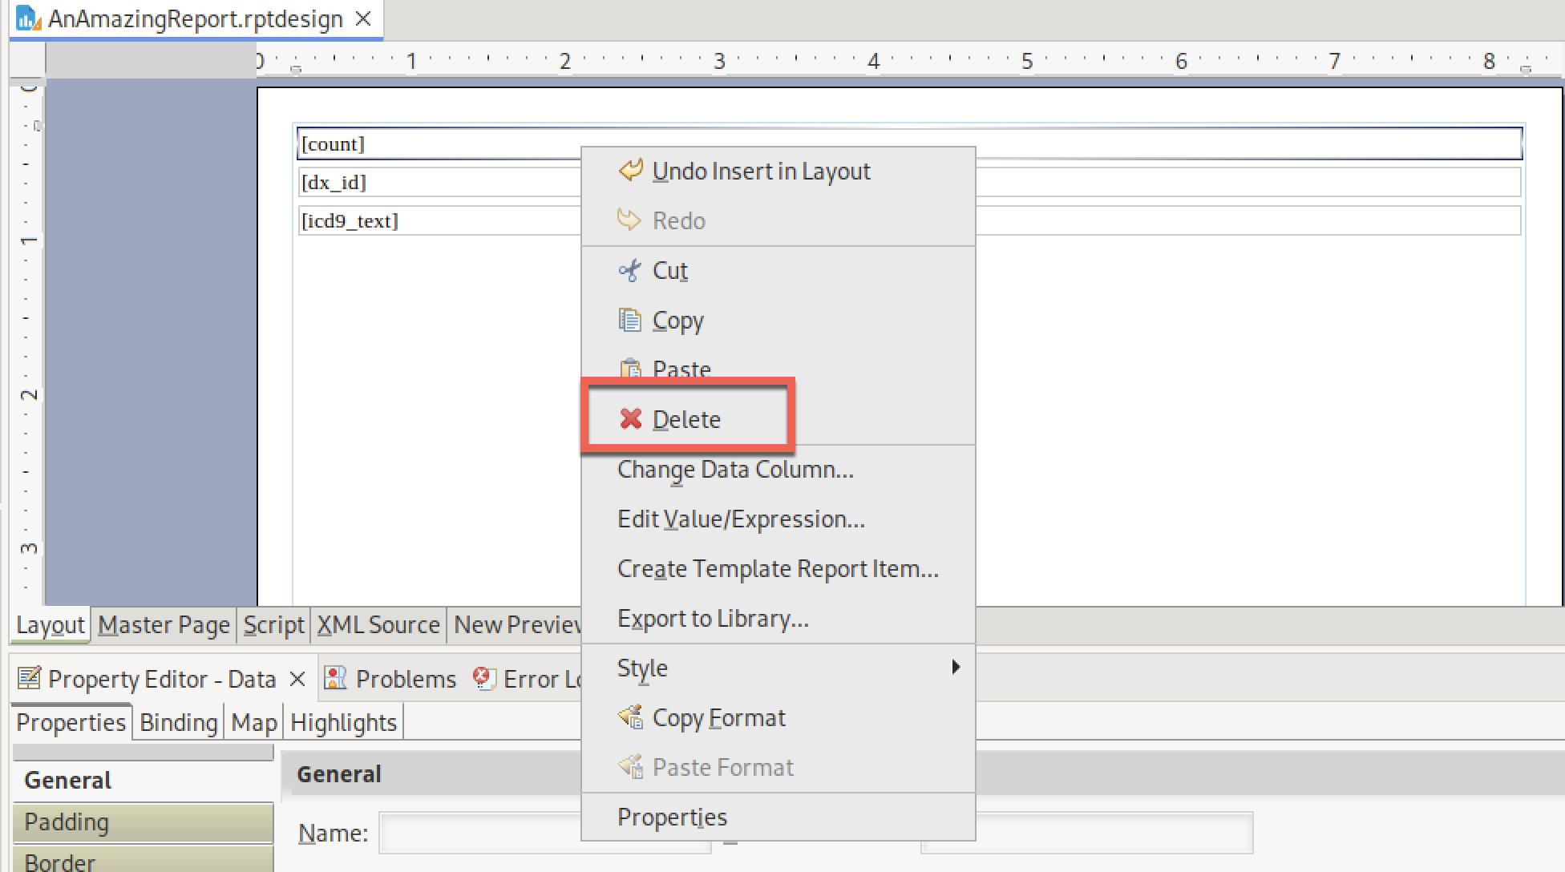

An alternative that is preferred by some is using the Outline view. The outline view lists every item that is in a report in the order they appear:

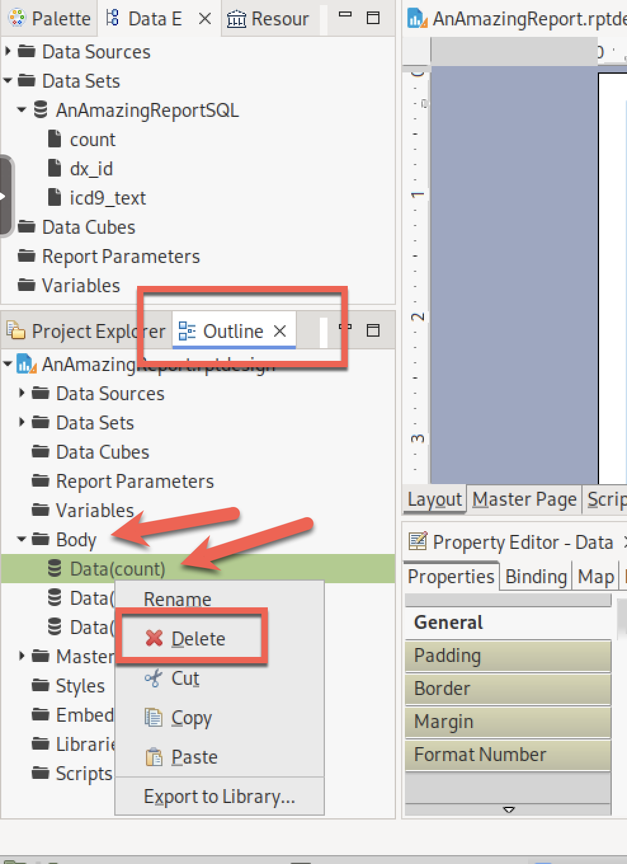

In this example, we opened the document “Body” and we see the three items listed there.

After deleting the three items, there is nothing in the Designer panel, and also nothing under the “Body” outline: 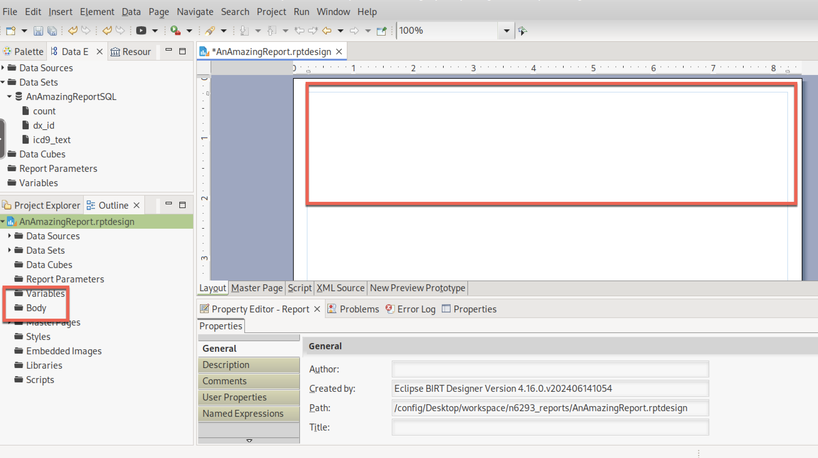

We are back to our original “Blank” report.

So, how do we move the data items into the report so that it is handled as a table with columns?

The quickest way (there are many other ways) is to right click on the data set name (AnAmazingReportSQL/red arrow) and select “Insert in Layout” (red box):

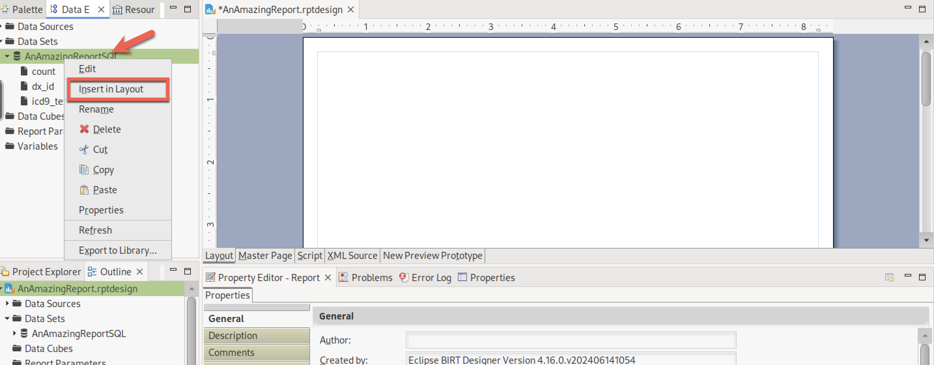

Decide which of the available variables you want in your report. You do not need to use all of them if the SQL returns more columns (variables) than you want/need. But for this example, I selected all variables using the “Select All” button at the bottom. And then “OK”.

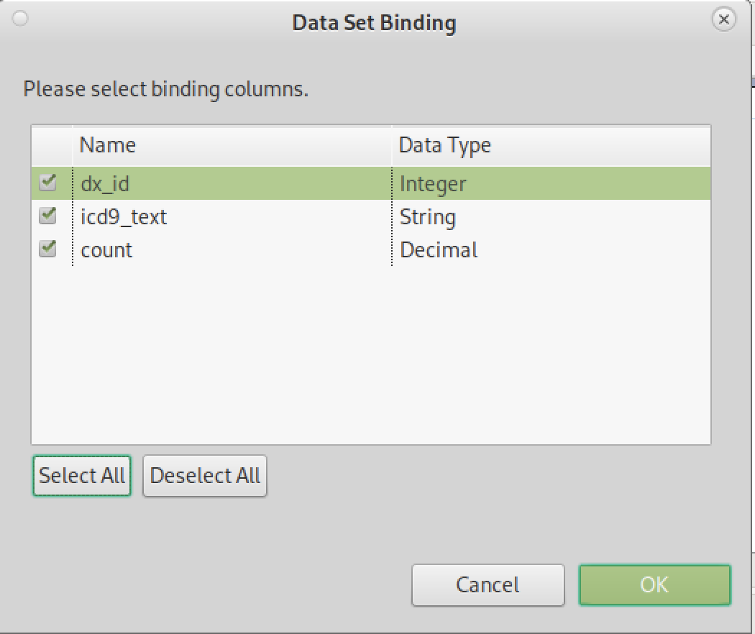

The resulting Designer now looks like this:

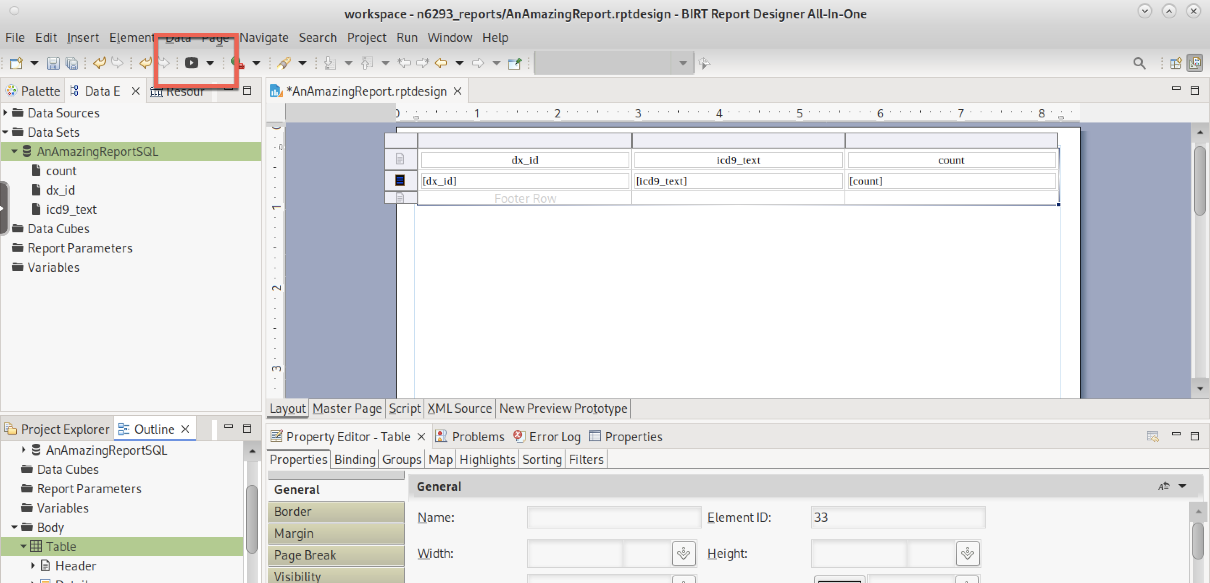

There is a lot going on here in both in the Designer GUI view and also in the Outline view. Before we dive deeper into the items that are in the Designer, let’s render the report (red box) and see if we are closer to what we are seeking:

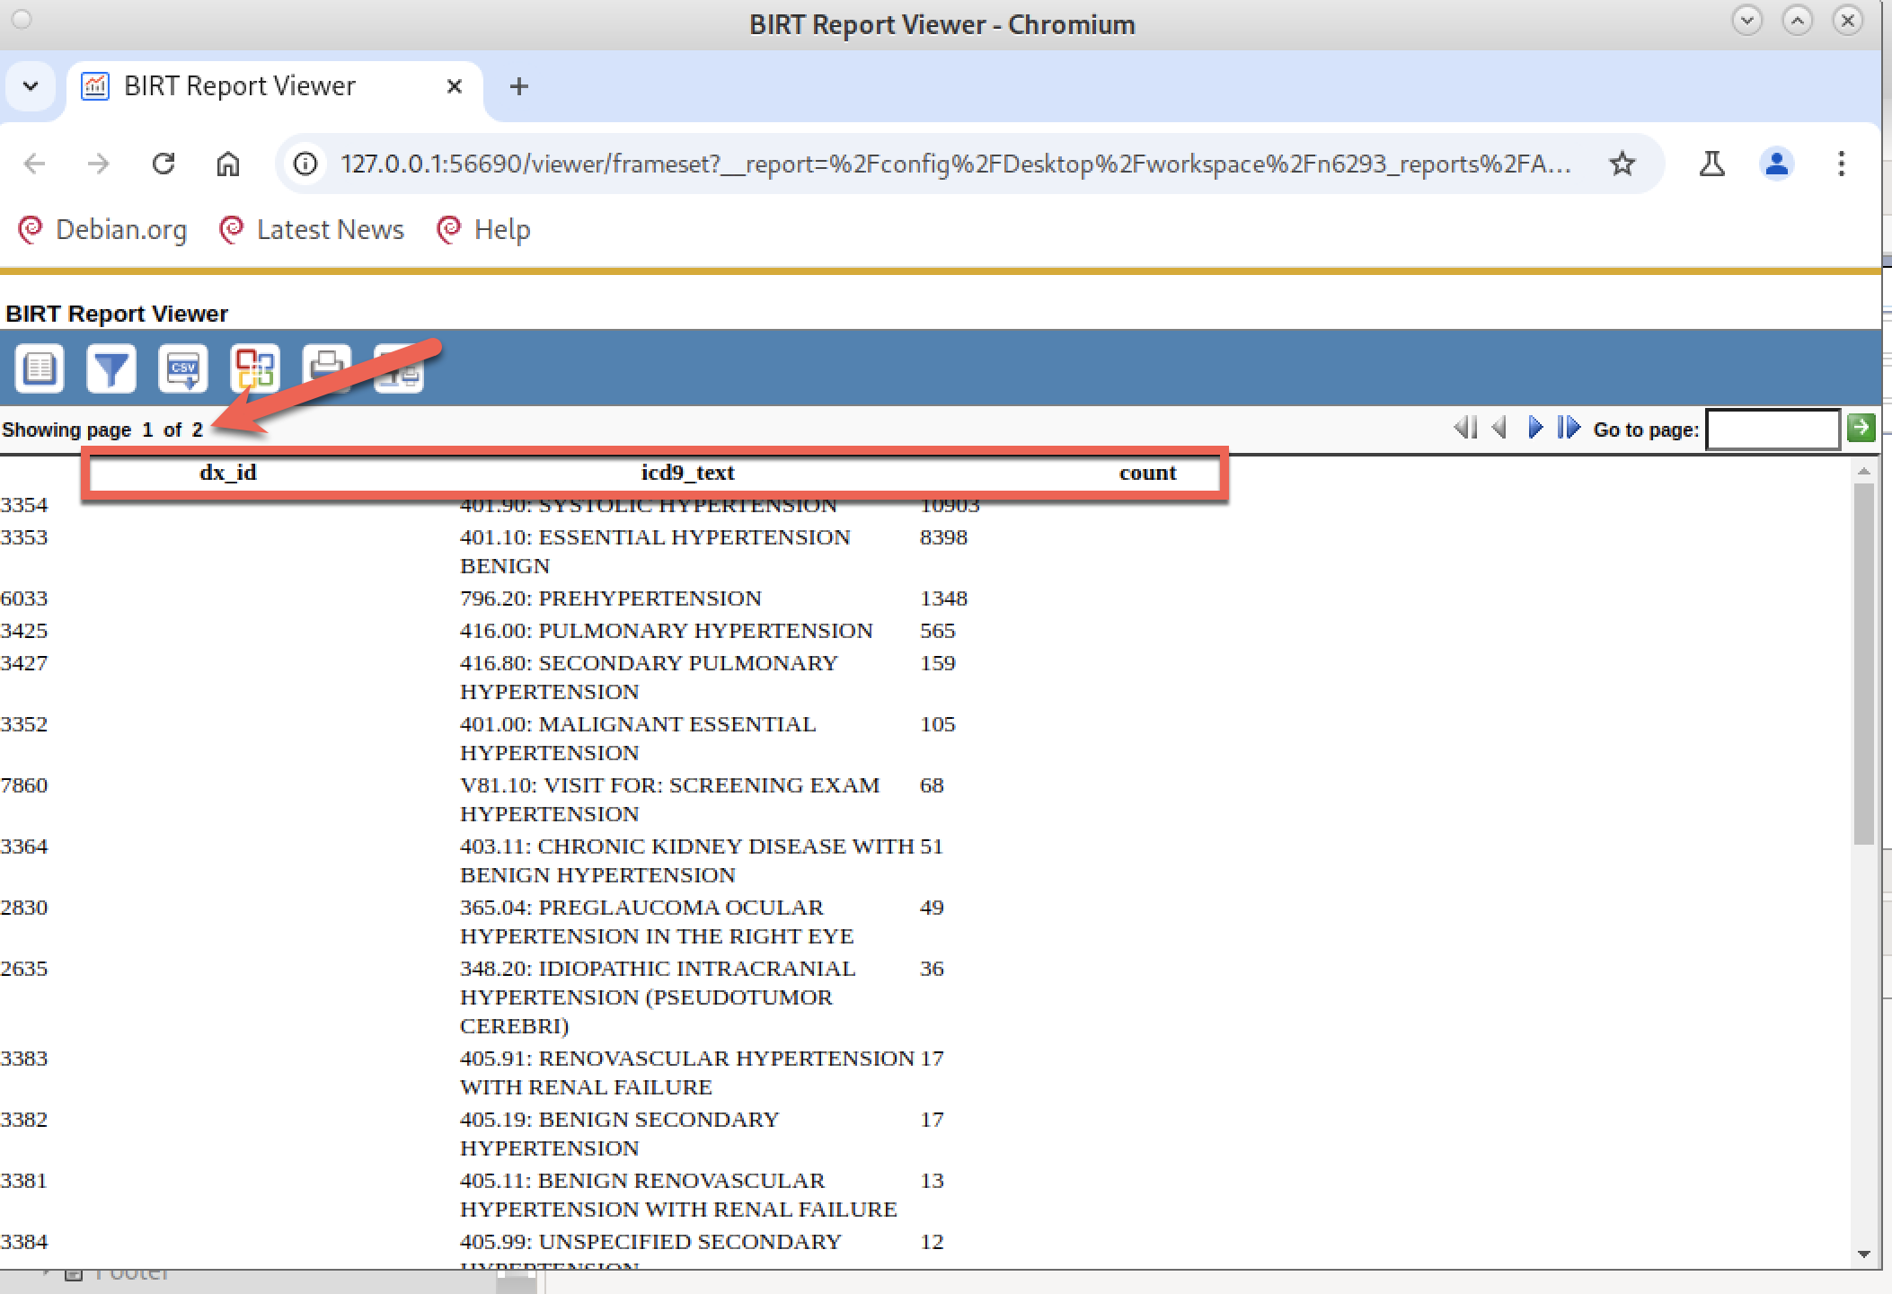

This is A LOT better! We now have two pages of output (red arrow), the column headers (red box) come from the SQL column names (we’ll change those to be more user-friendly below) and we see one row of data for each row from the SQL query.

Going back to the Designer: a table has three high-level components: A table header, table detail, and table footer row. Note that the table header and footer is not the same as the report header/footer, which we see only in the “Master Page” view as described previously.

Also note that there is a one-to-one correspondence between what you see in the Designer GUI and the items that appear in the Outline view (bidirectional arrows):

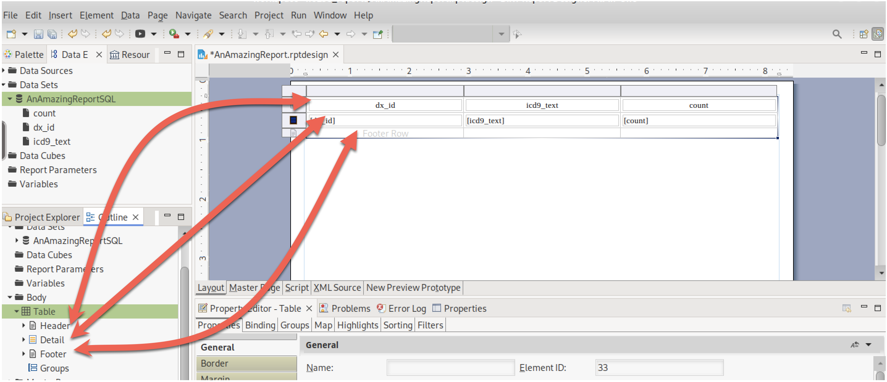

If you fully expand the “Header” element in the Outline view (screen shot below), the top left table cell is in the Header item, which contains a row item (in the header), which contains a cell item (in the row in the header) and has a label. We can see from the GUI that the label is dx_id.

If you click on an item in GUI, the cursor will highlight that same item in the Outline view. Similarly, if you click on an item in the Outline view, the same item will highlight in the GUI view. Your preference which way you like to navigate the items on your report. I personally find the Outline view to be more exact but the GUI view more intuitive. I switch back-and-forth depending on what I’m trying to do.

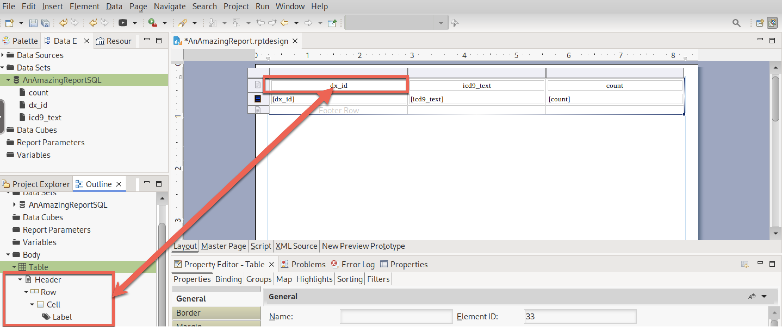

While the current report does render our data, the PRESENTATION of the data is not very appealing. Let’s make some formatting changes. I’m going to make the following changes:

1. Rename the column headers from database labels into user-friendly text
2. Center-align the first and last column
3. Make better use of the white space in each column
4. Change the font color for all counts that exceed 1000 encounters. This is called “conditional formatting”
5. Add a new text box that describes what this report is showing so the user understands the data being displayed.
6. Add the CU logo to brand each page (this is just showing-off. Beyond class expectation)

I will do each change separately, render the report to make sure I am getting the change that I want (maybe multiple times until I get it right) and then move on to the next change.

**Change #1:** Rename the column headers to user-friendly text. The easiest way to do this is to double-click on the existing label and type in the new label. In this example, I renamed:

* Dx_id 🡪 Diagnosis Identifier
* Icd9_text 🡪 ICD9CM Description
* Count 🡪 Number of Patient Encounters

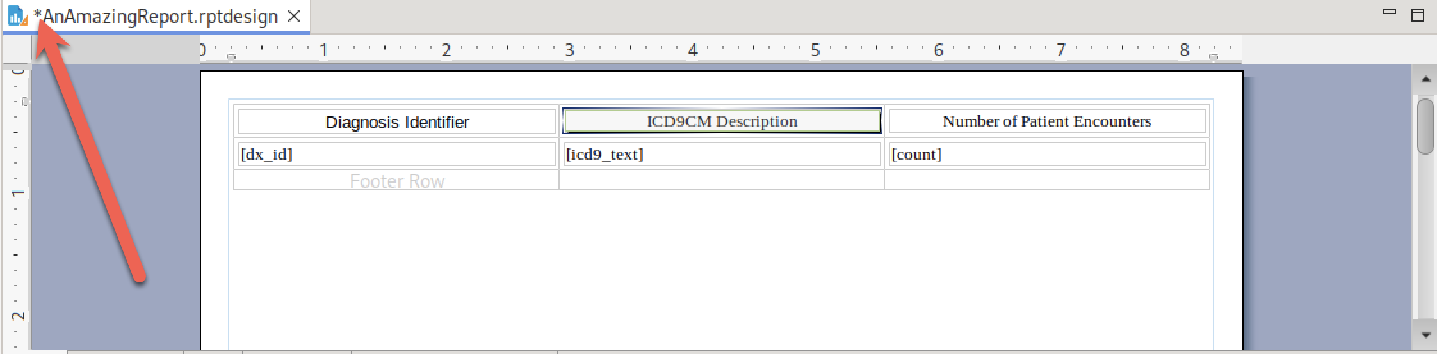

Before you render the report to see if your changes are what you expect, you should save the report. If the file has a star in front of its name in the GUI Designer (red arrow), there are unsaved changes that may not appear in the rendering. Once you save the report, the star goes away, and you know your changes will appear in the rendering.

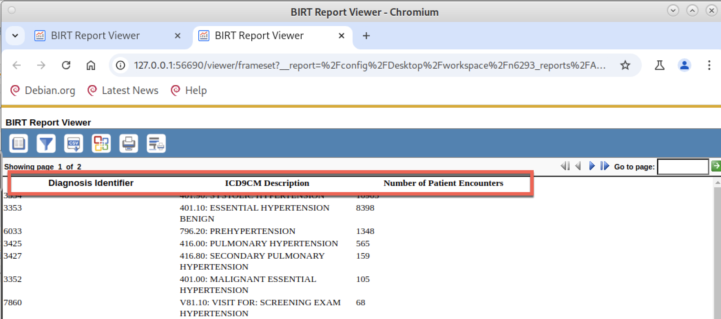

I am happy with these changes, so I’ll move on to the next tweak.

**Change 2**: Center align the first and third column. I think it would be better if these columns were center aligned with the column label.

For the first column, click on the [dx_id] detail box (red arrow), in the lower panel, click on Properties / General tab (red box). This shows many properties for the [dx_id] field. Things like fonts, colors, and other simple changes can be made here. We want to center-align this column, so we click on the center-align button (red box)

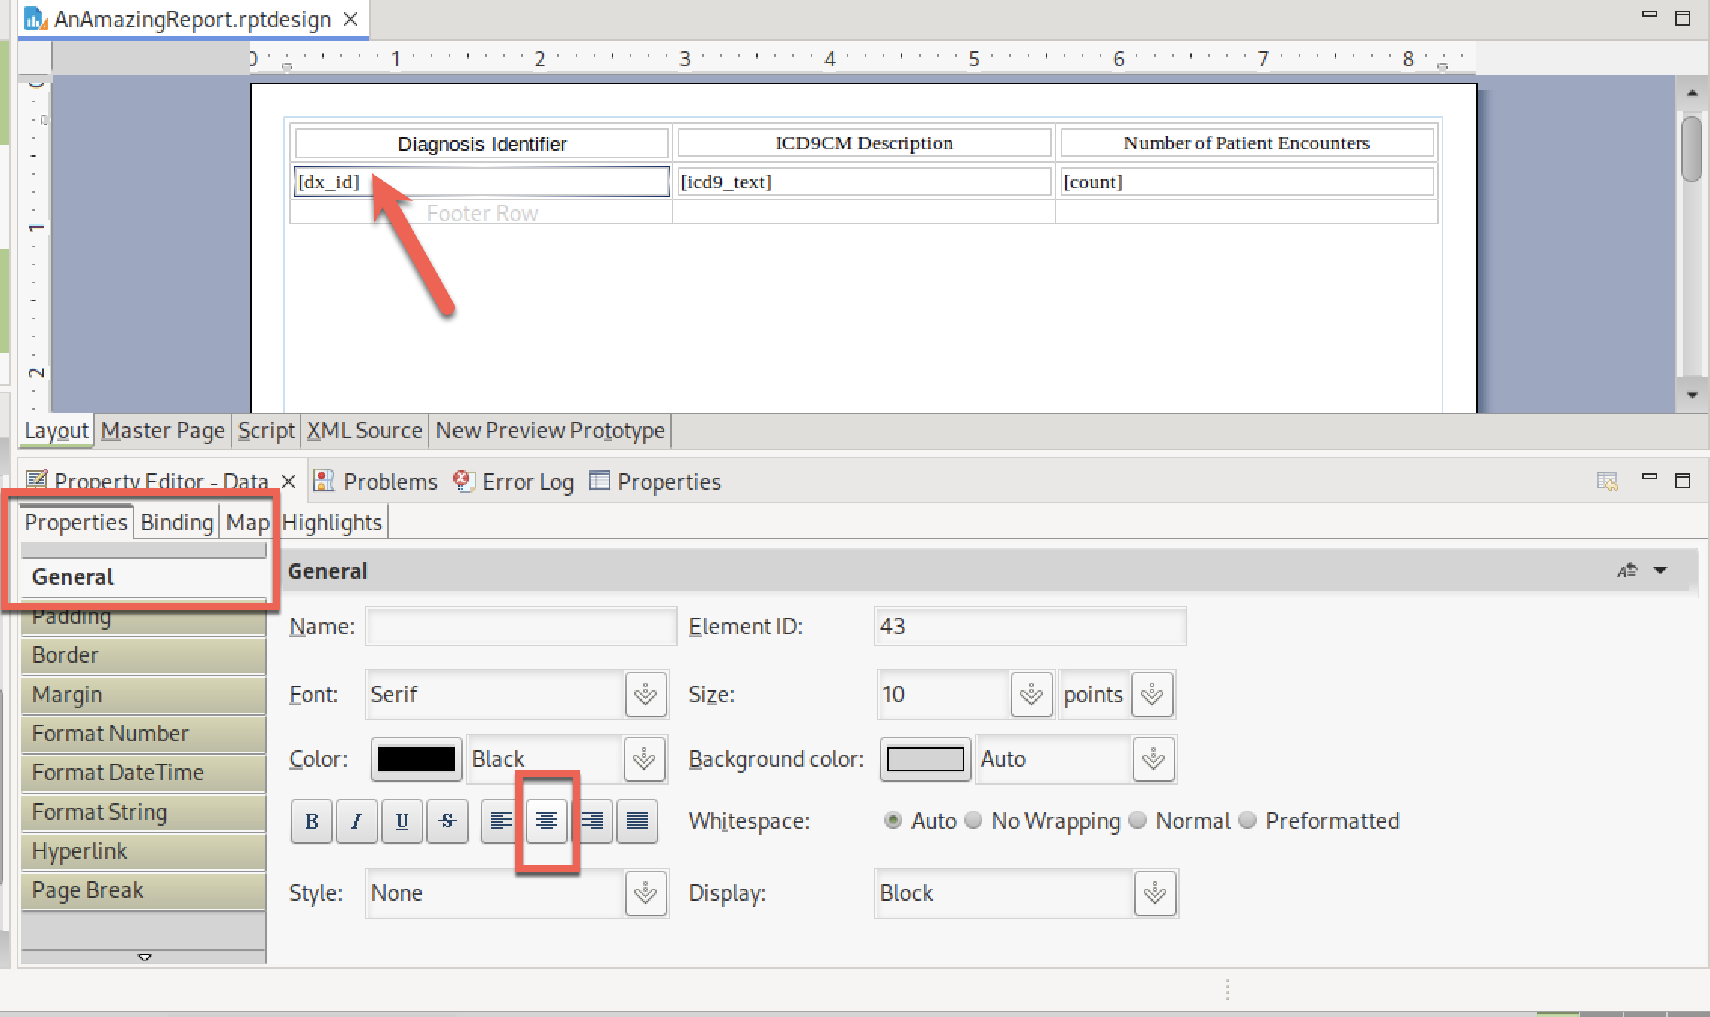

Notice how the Designer now shows the [dx_id] text to be center aligned:

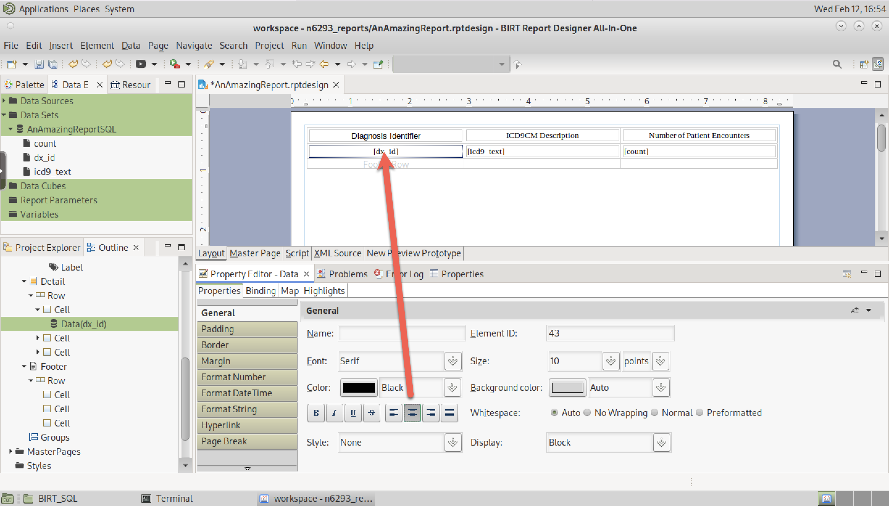

You could do a test rendering now, but I will center-align the [count] detail field first and then render. Remember to save your work prior to rendering to ensure your changes are included in the rendering (red box):

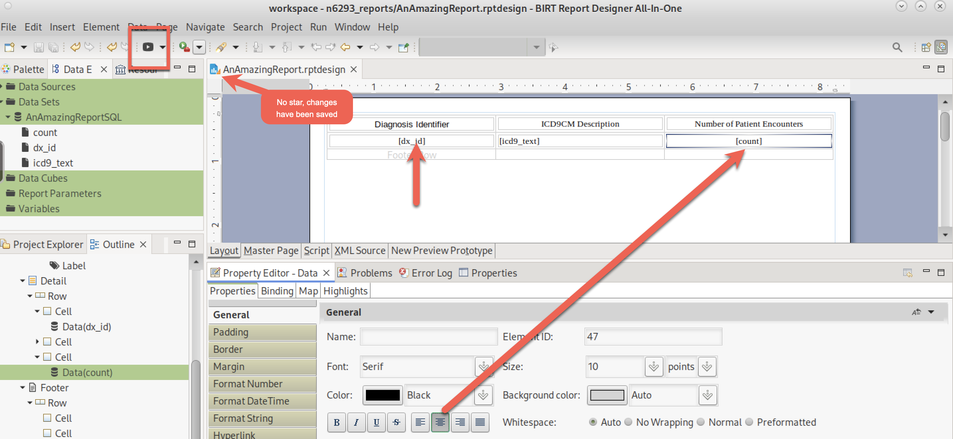

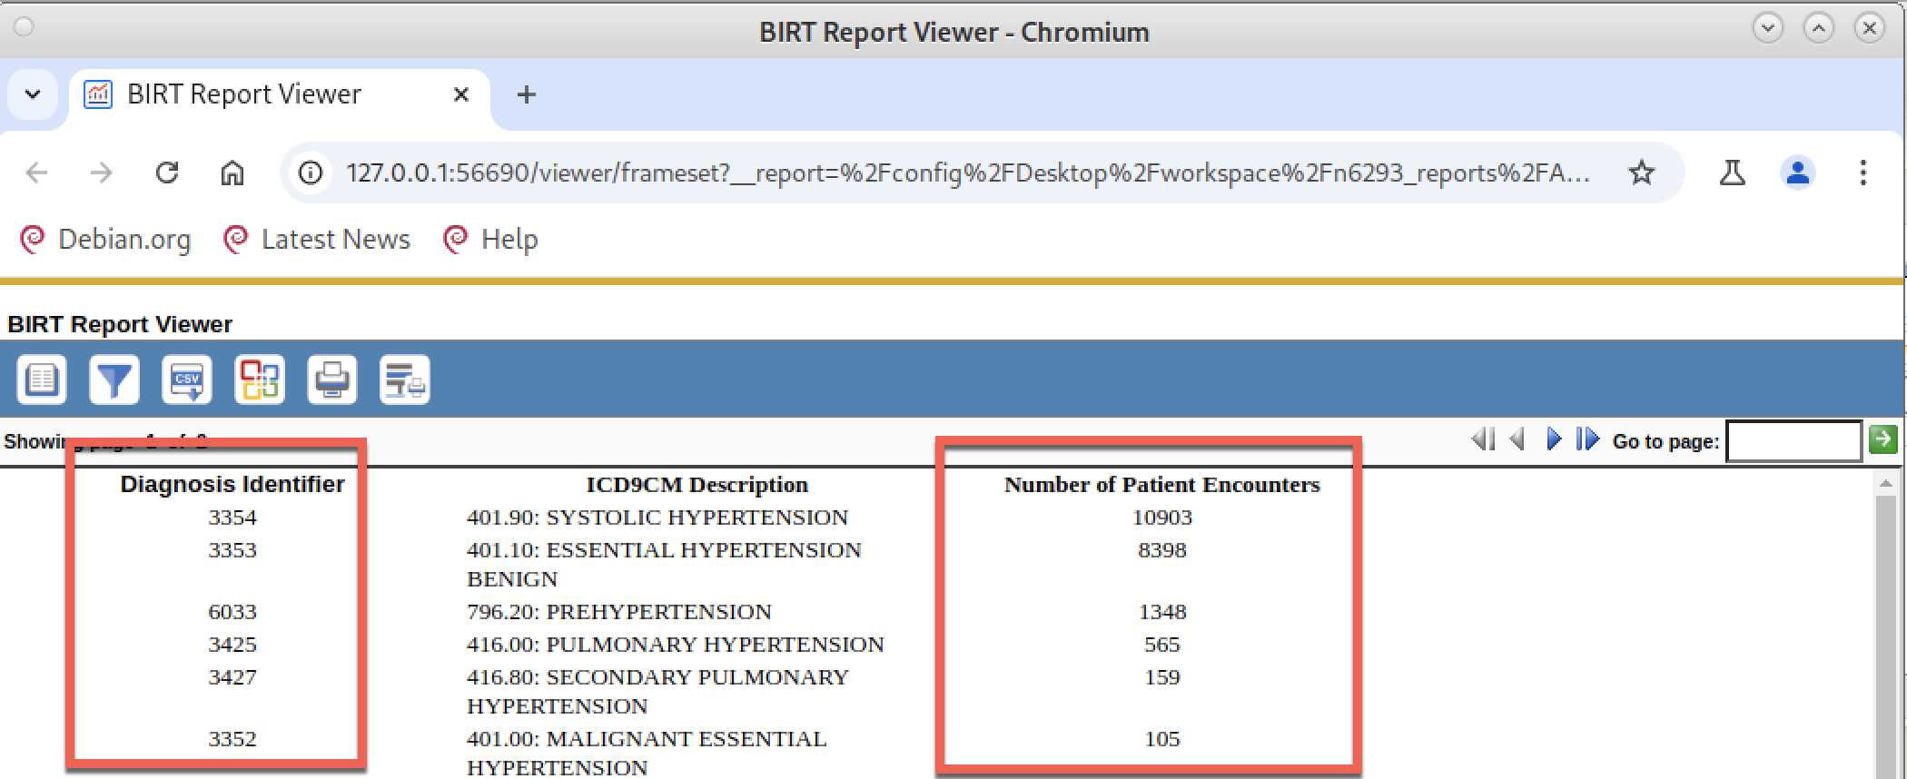

Change #2 (red boxes) looks good. Let’s move forward

**Change #3**: Make better use of the white space in each column

I don’t like how much white space there is in the first and third column while the second column has a lot of word wrapping. If we make Columns 1 and3 narrower, we could expand Column 2 and maybe not get as much word wrapping. Let’s make this change.

If you carefully move your cursor to between the columns, it changes shapes to be 🡪| . When it is in the mode, you can resize the column in either direction. Here I have already made the first column smaller, and I am now going to make the second column larger (which makes the third column smaller).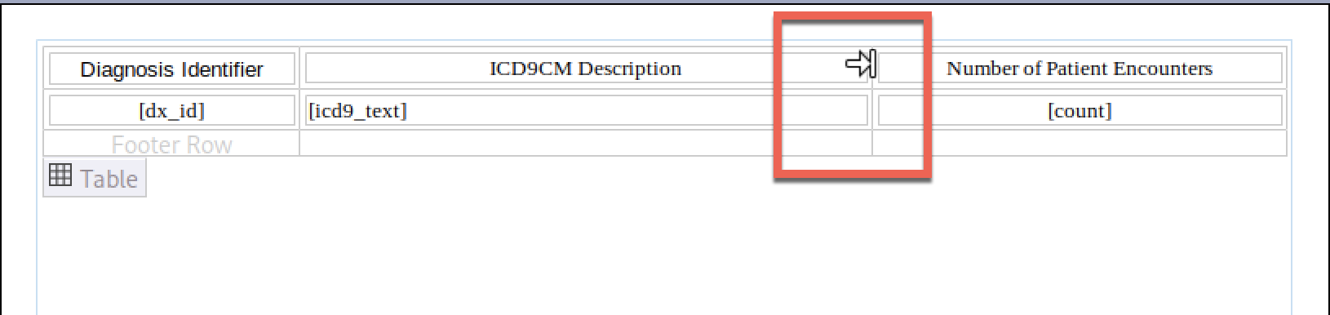

I resized-rendered-resized-rendered-resized-rendered more time than I will admit and ended up with these column widths. Notice how the labels for the first and third column auto-wrapped when I made the column widths smaller than the label text:

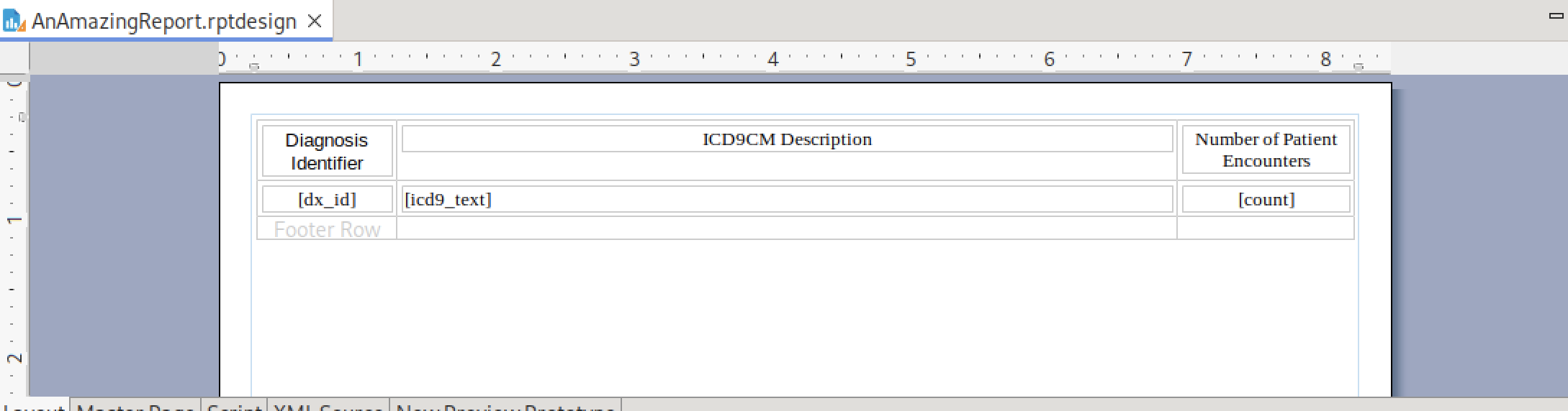

I do like the current rendering that now allows for the second column to not word-wrap:

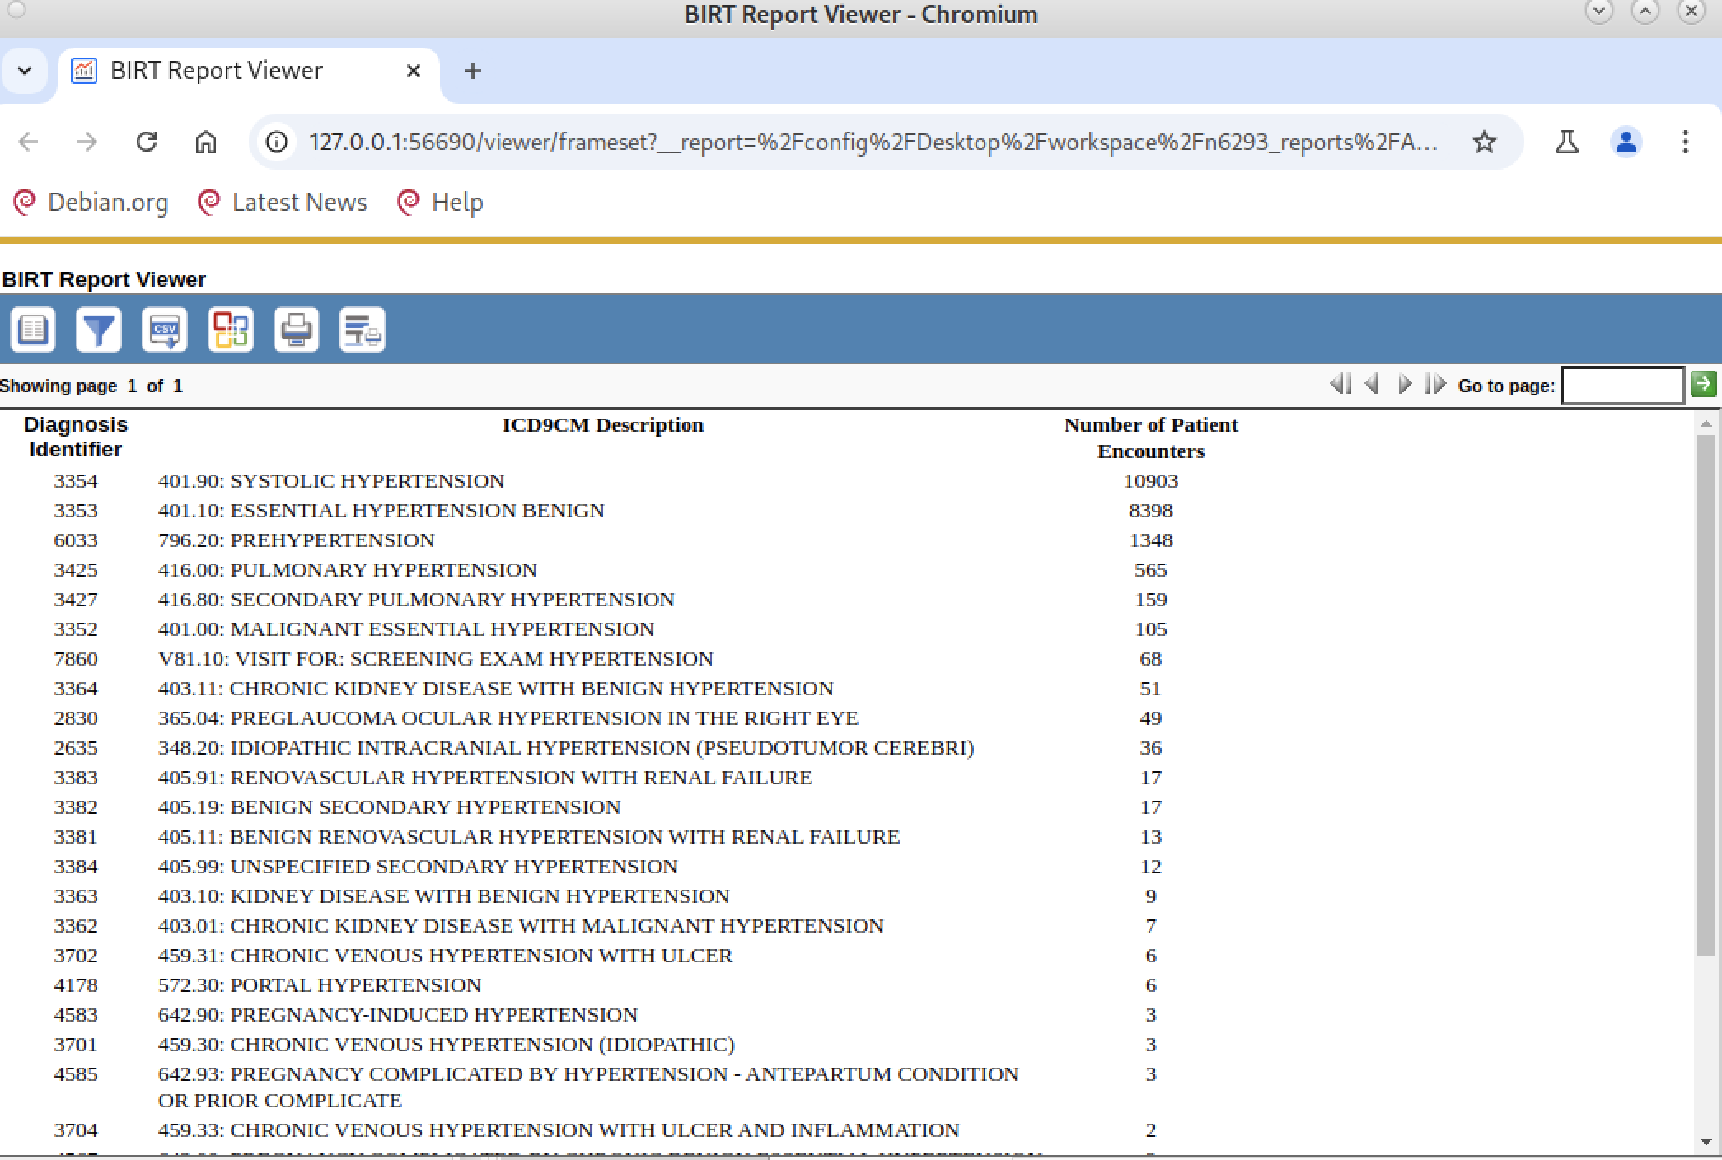

**Change #4**: Change the font color for all counts that exceed 1000 encounters

This is called “conditional formatting” because the format (font color) is now based on some condition. My plan is to leave the default color black but if the value in the “Number of Patient Encounters” exceeds 1000, the font will be red. This example is a bit contrived because I have sorted the data by counts.

To set up a rule (condition) for a change in format (font color), select the data field you want to conditionally format (red box), select the “Highlights” tab at the bottom of the Designer (red arrow), and select “Add” (red box) to add a new rule.

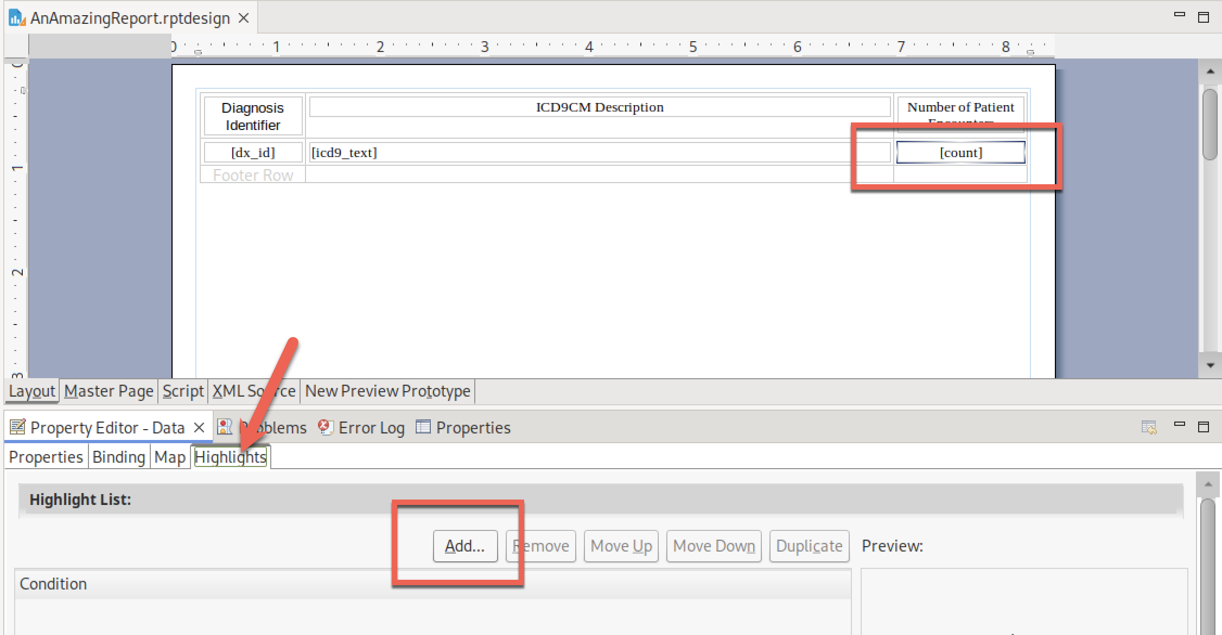

Fill in the three boxes at the top:

|  |  |  |
| --- | --- | --- |
|  |  |  |

This rule is active when the **count field** (first drop-down) is **greater than** (second drop-down) and **value of 1000** (third drop-down).

Next, select “Color” (arrow), use the drop-down (arrow) to get a long list of pre-defined colors and pick “red” (box).

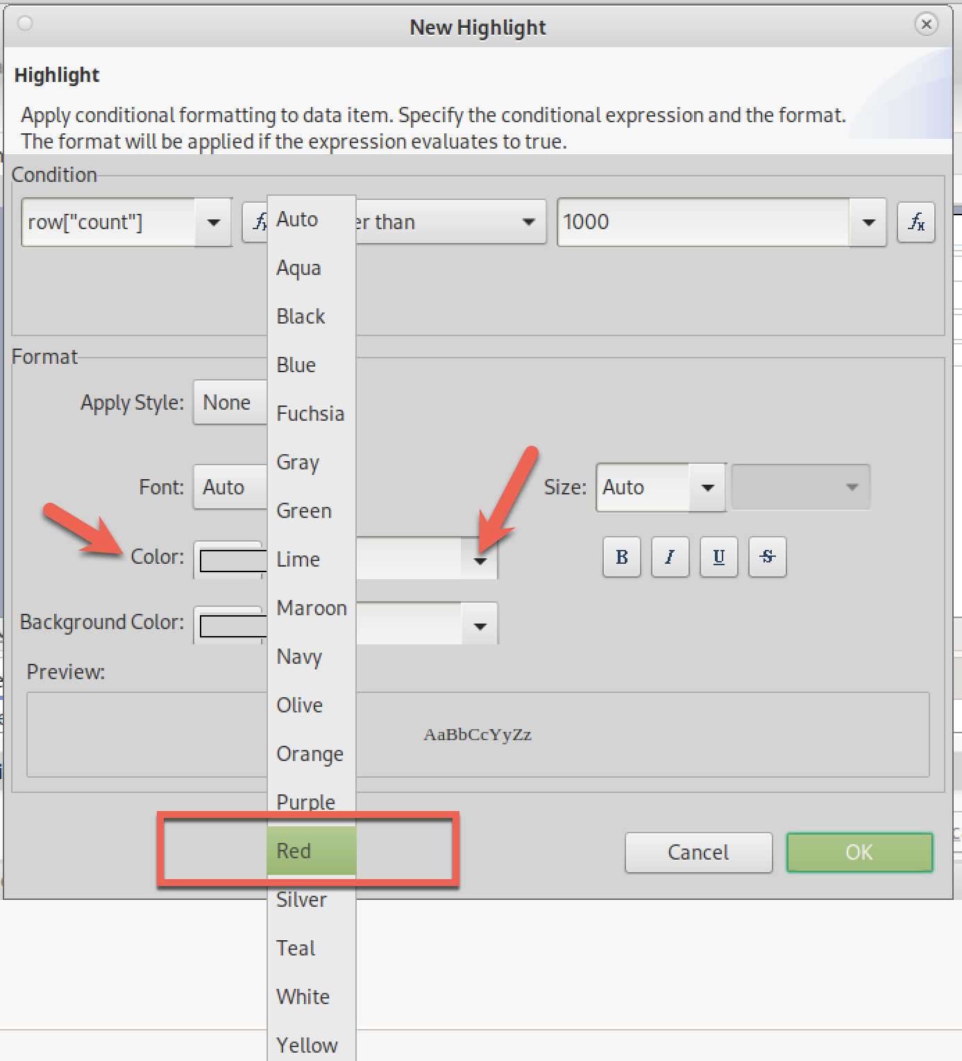

Just to be cheeky, also select bold (arrow). You can see how the text will render (box). Hit OK (arrow) to activate this formatting rule.

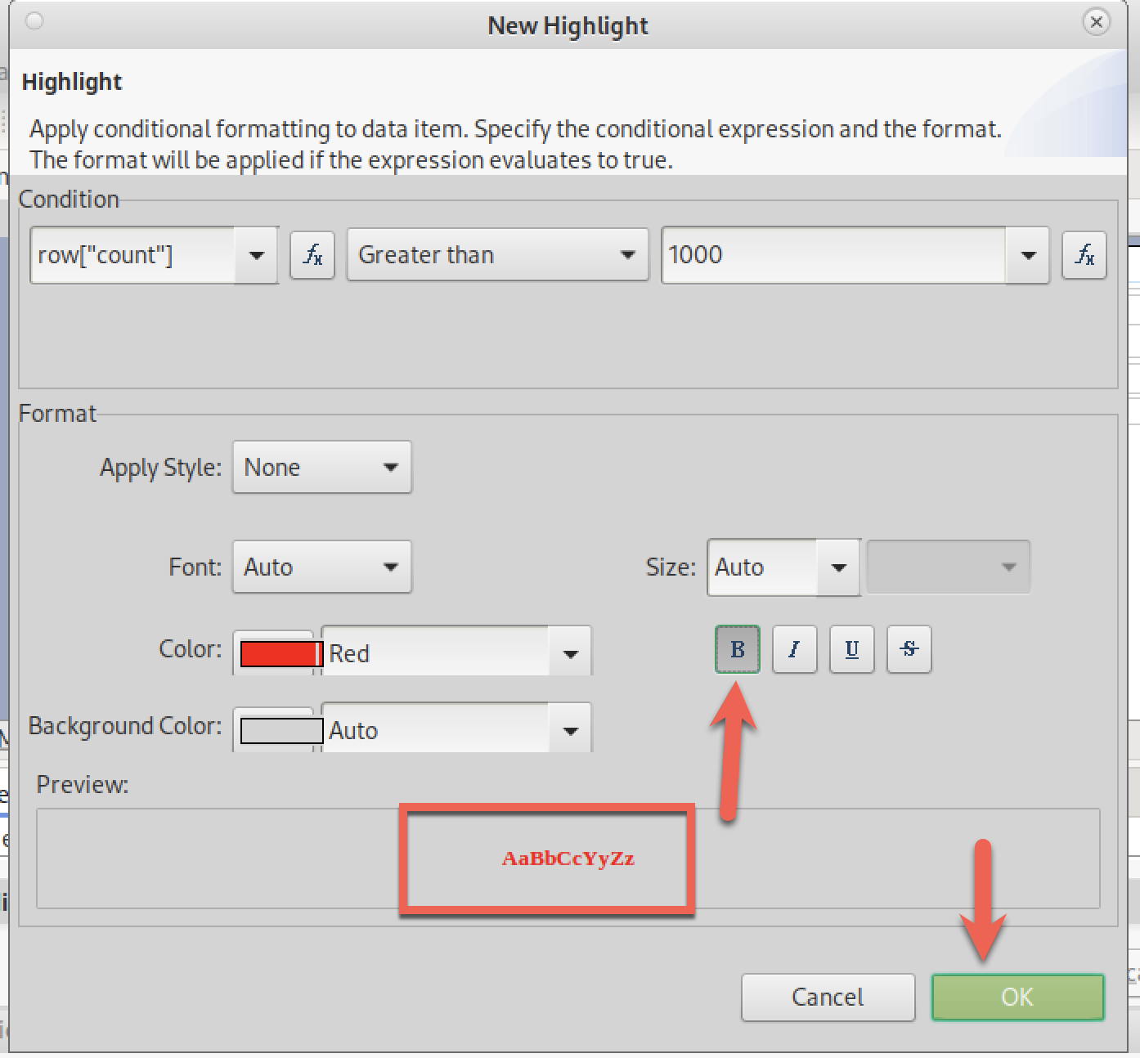

Save and render…..

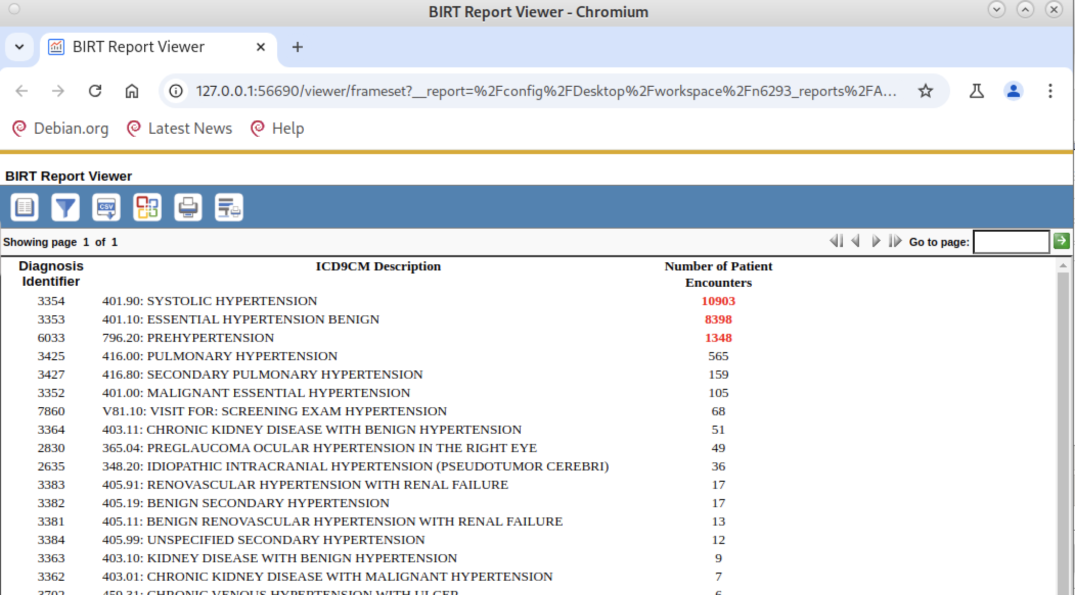

**Change #5**: Add a new text box that provide a description of what this report is showing so the user understands the report

This change is going to be a bit tricker than it looks. I want the description to appear BEFORE the table, not after the table because the user may not know to look at the end of a many-page report.

In BIRT language, I want to add a label item before the existing table item. When I select Insert -> Label (red box), not surprisingly the Designer puts the new label AFTER the table.

You can see this in the Designer GUI and also in the Outline view:

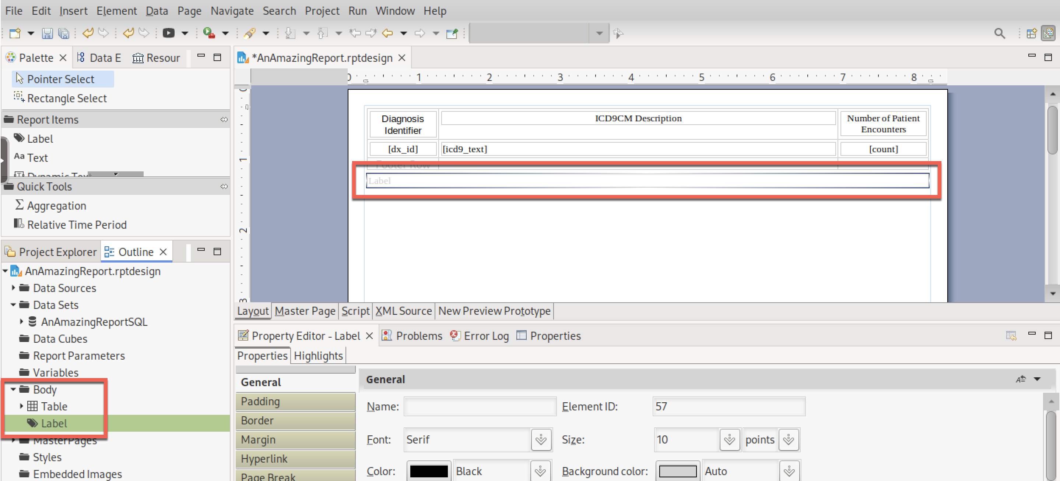

The tricky bit is moving the label to appear BEFORE the table. **This is one situation where I find using the Outline view to be easier than the GUI.** You just grab the label item and move it above the table item, and it changes position in both the outline and GUI view.

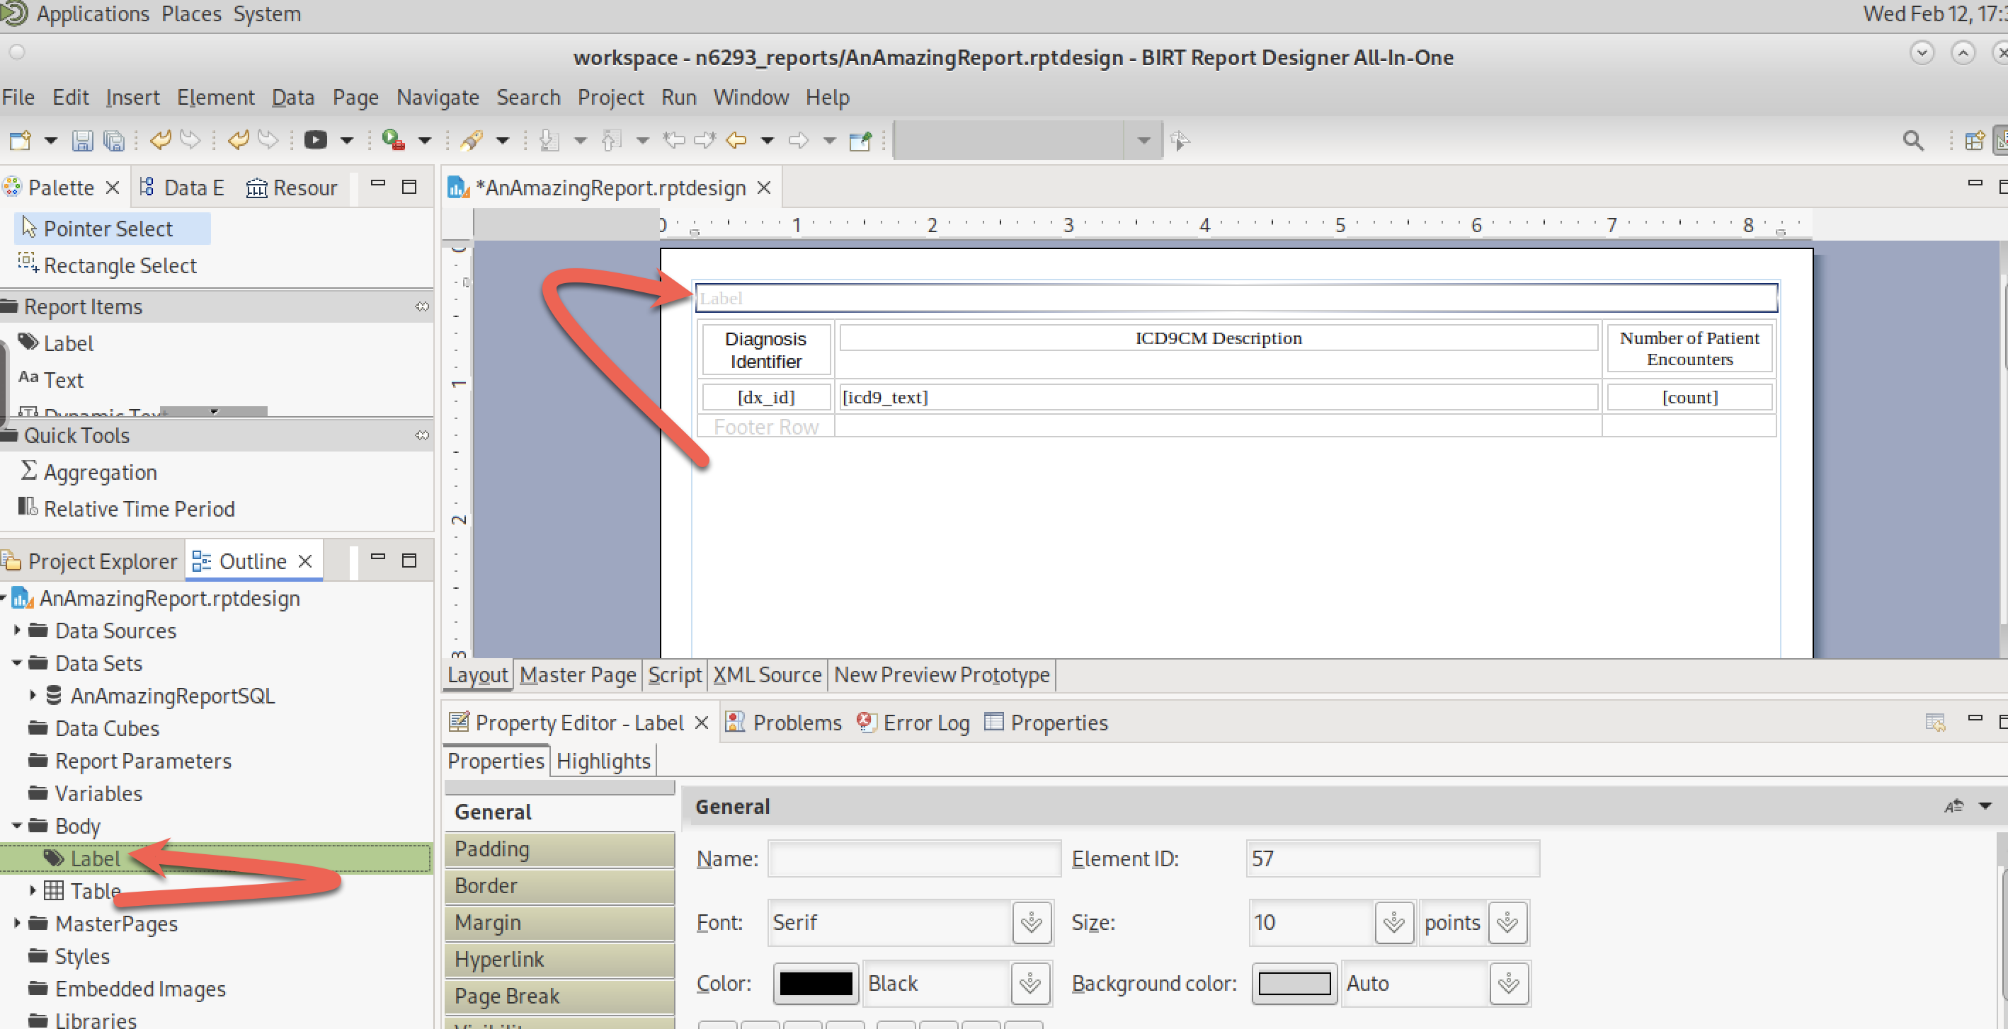

Moving the label in the GUI is harder because the GUI has difficulty moving the label above the table. I find it easier to move the table down below the label rather than trying to move the label above the table. Move the cursor into the table but do not click on any of the table’s internal items (row, column, cell). Grab the table tag (red box) and pull it down below the label

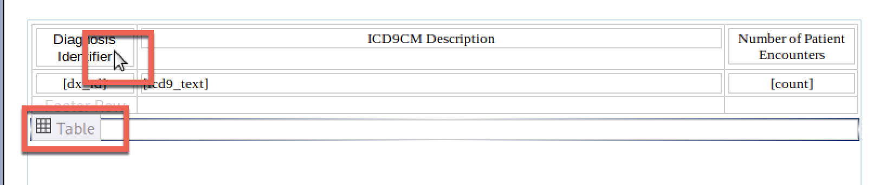

The result is the same. But I still find using the Outline view to move items around is much easier. YMMV…..

Now that we have the label above the table, click in the label item and type in whatever description you want about the report. This is what I did.

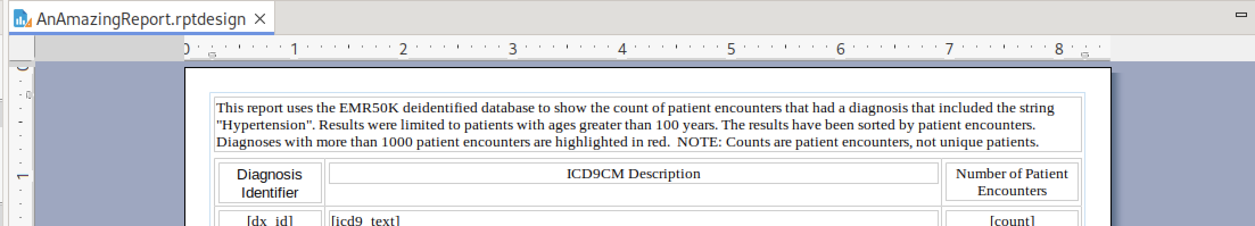

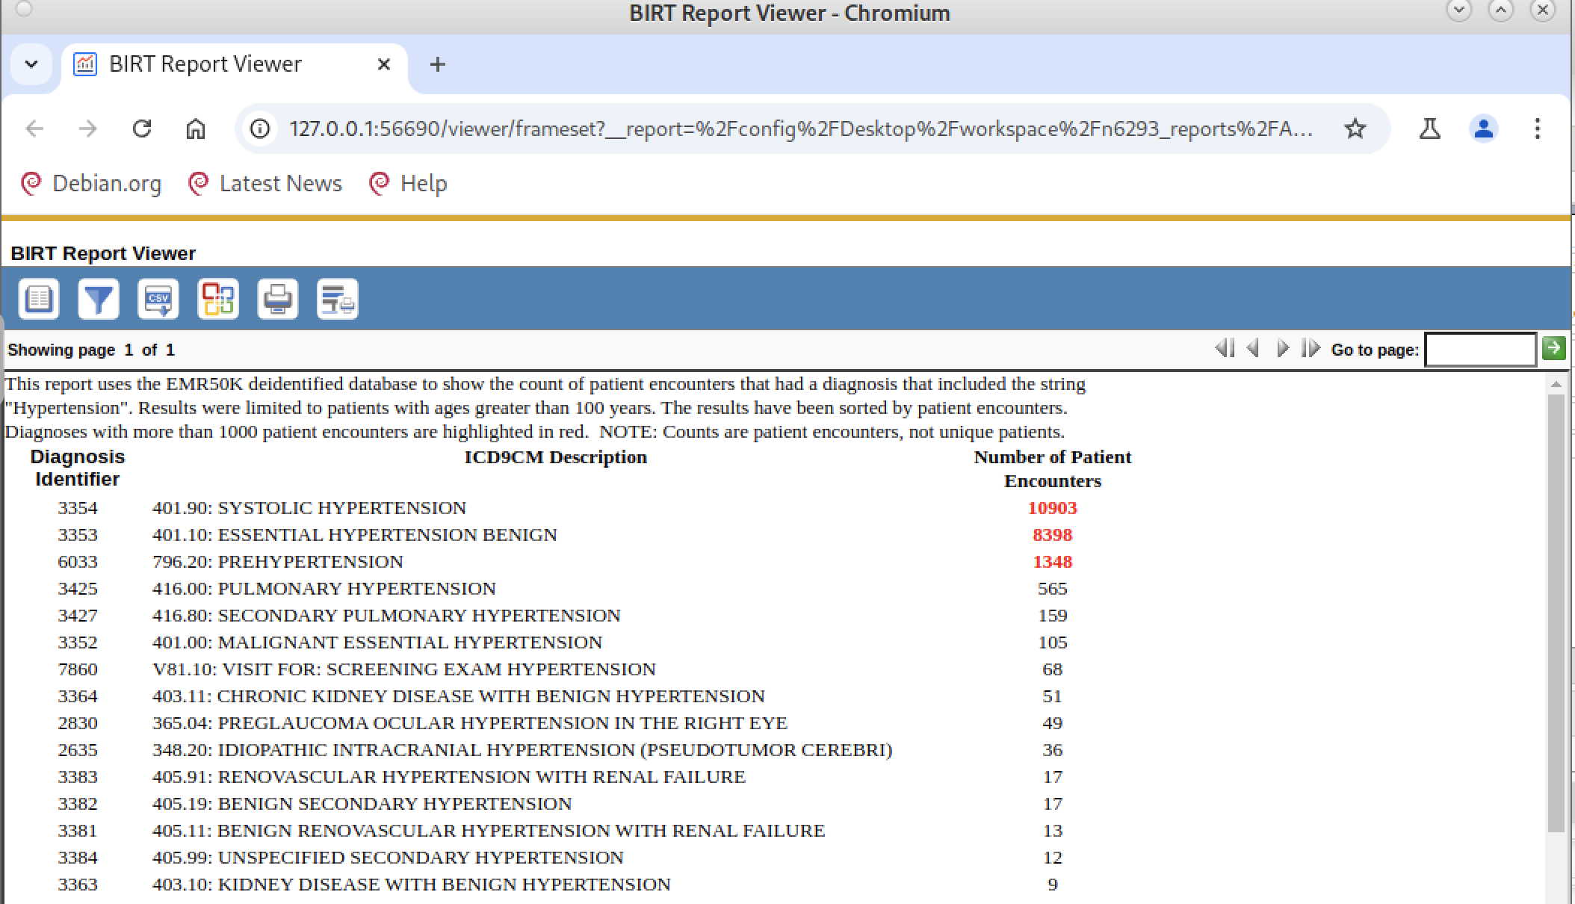

One thing I discovered is that BIRT doesn’t allow carriage returns in labels. You use a more complex TEXT item to get additional formatting. TEXT items use HTML formatting, so you need to know HTML to use that approach. Or, you can cheat and simply add another label item for the text you want in the new paragraph. For class, if you use a report description (which I highly recommend), just use a single label item and don’t worry about pretty printing or paragraph formatting.

**Change #6**: Add the CU logo (this is just showing-off. Beyond class expectation)

I want to add the CU logo to “brand” this report. I want the logo to appear at the **top of each page** so I’m going to put it into the report header. Recall that the report header/footer is found under the “Master Page” tab (lower arrow), not the standard “Layout” tab (lower “x”):

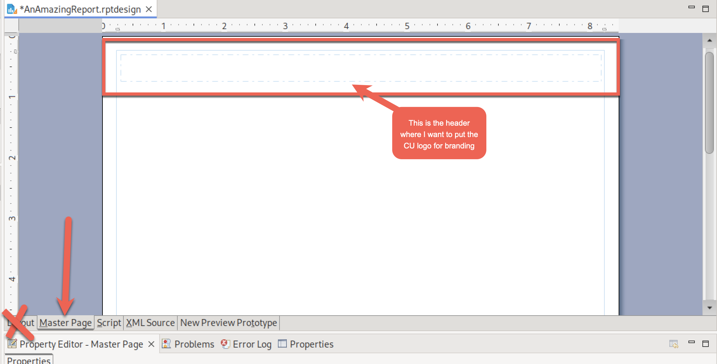

Right click in the dashed box that represents the header, select Insert, select Image

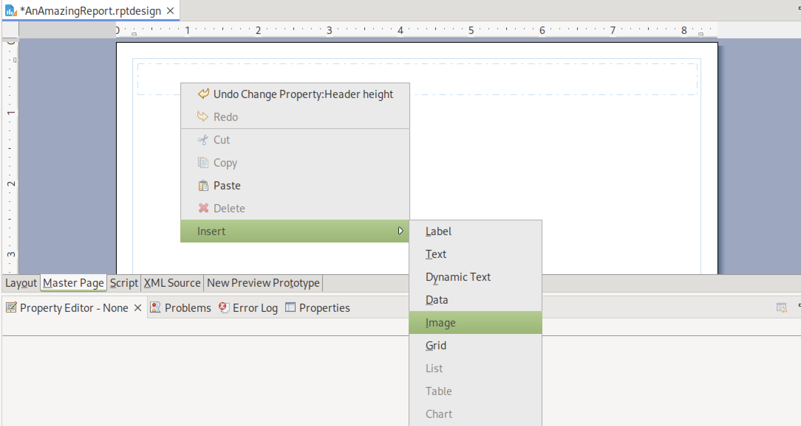

Select “Image file in shared resource” (red box) then select the open folder icon (arrow):

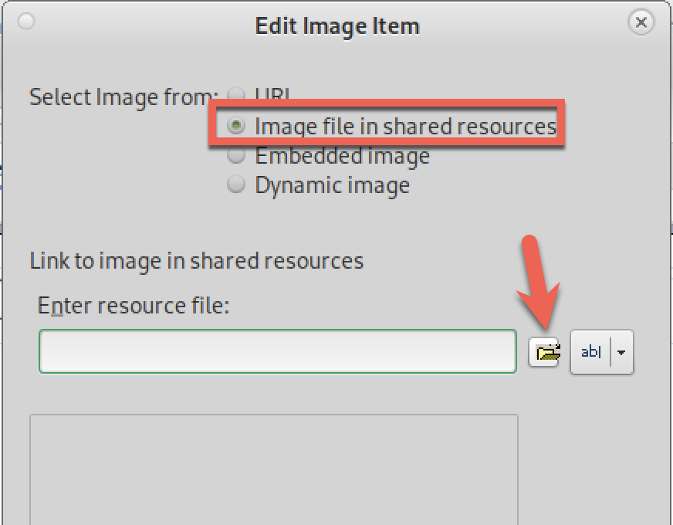

Select the only SVG (image) file and then OK, and then Insert in the next dialog box.

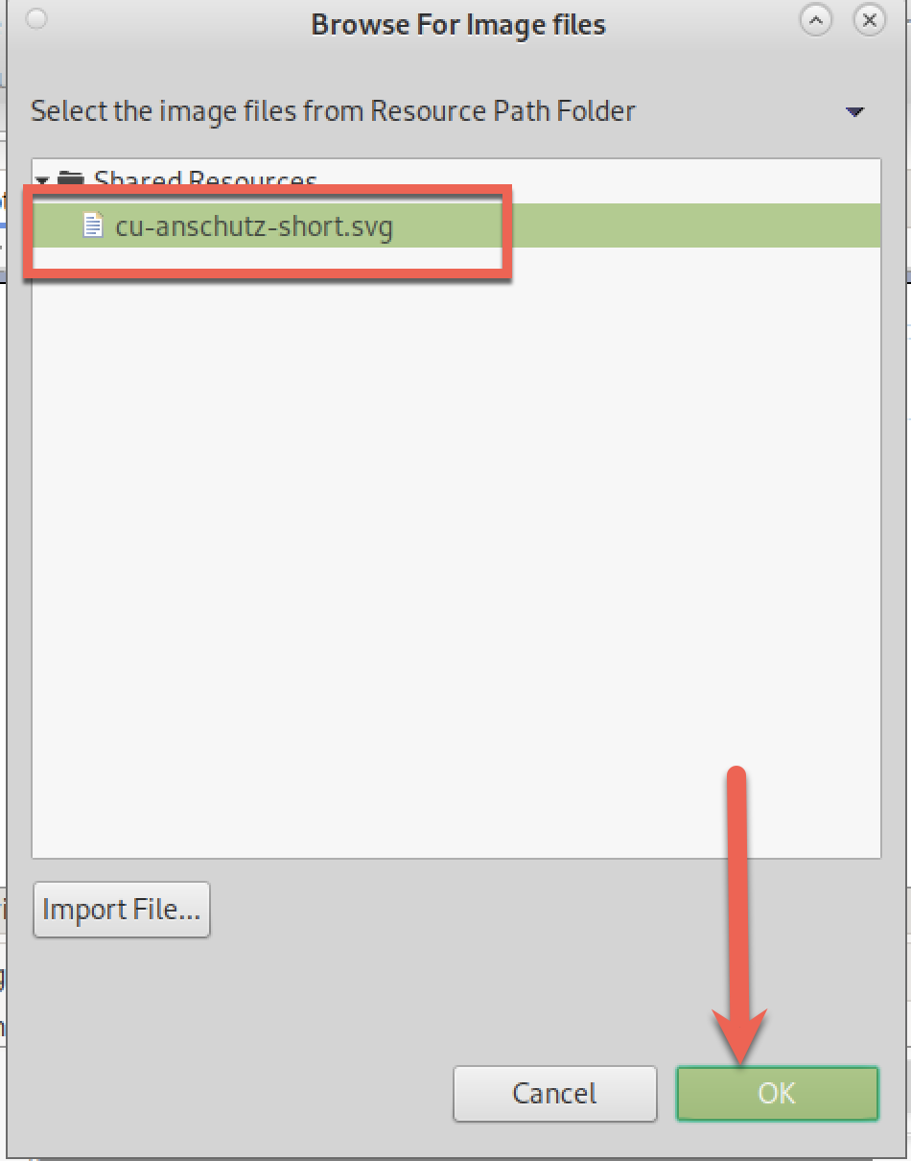

Save and render:

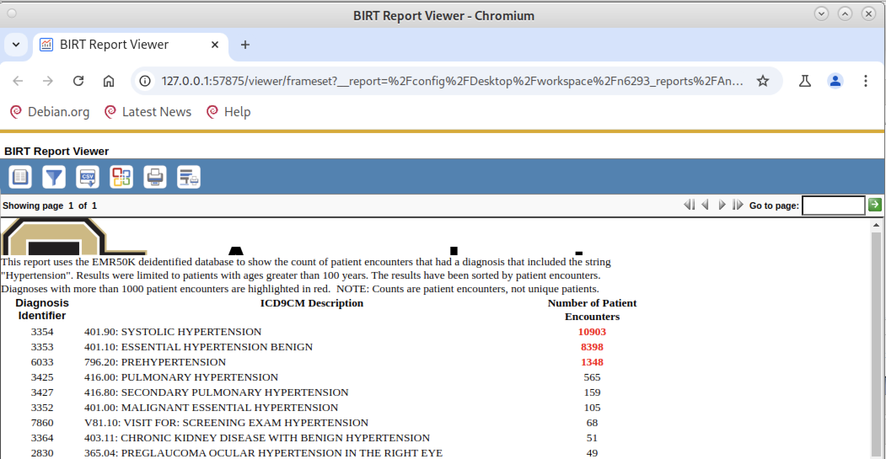

Well, that isn’t what I wanted. The logo is much too big for the small space for the header. I have two choices (or do both): increase the size of the header or decrease the size of the logo. Let’s do the second.

Either click on the image icon in the GUI designer (arrow) or (equivalently) click on the “Image” item under Master Pages, Simple Master Page, Header (arrow).

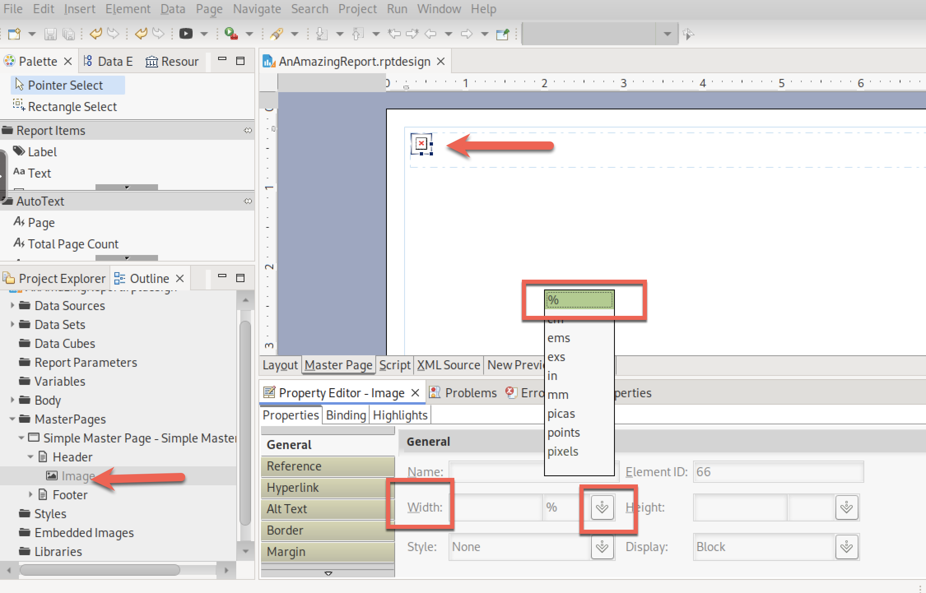

Click on “Width” (red box), click on down arrow (red box) and select “%” (red box). Enter 25 as a starting point. Do the same for Height for 25% also. Save and render:

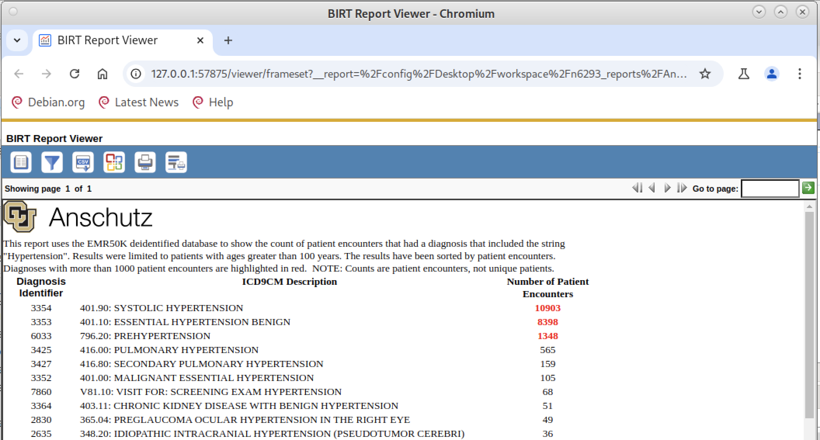

I like this rendering but I will also show you how to enlarge the header space so you could use a larger logo if you wanted.

Click on MasterPages, Simple MasterPage in the Outline view (arrow). Change Header height (box) to 1.0.

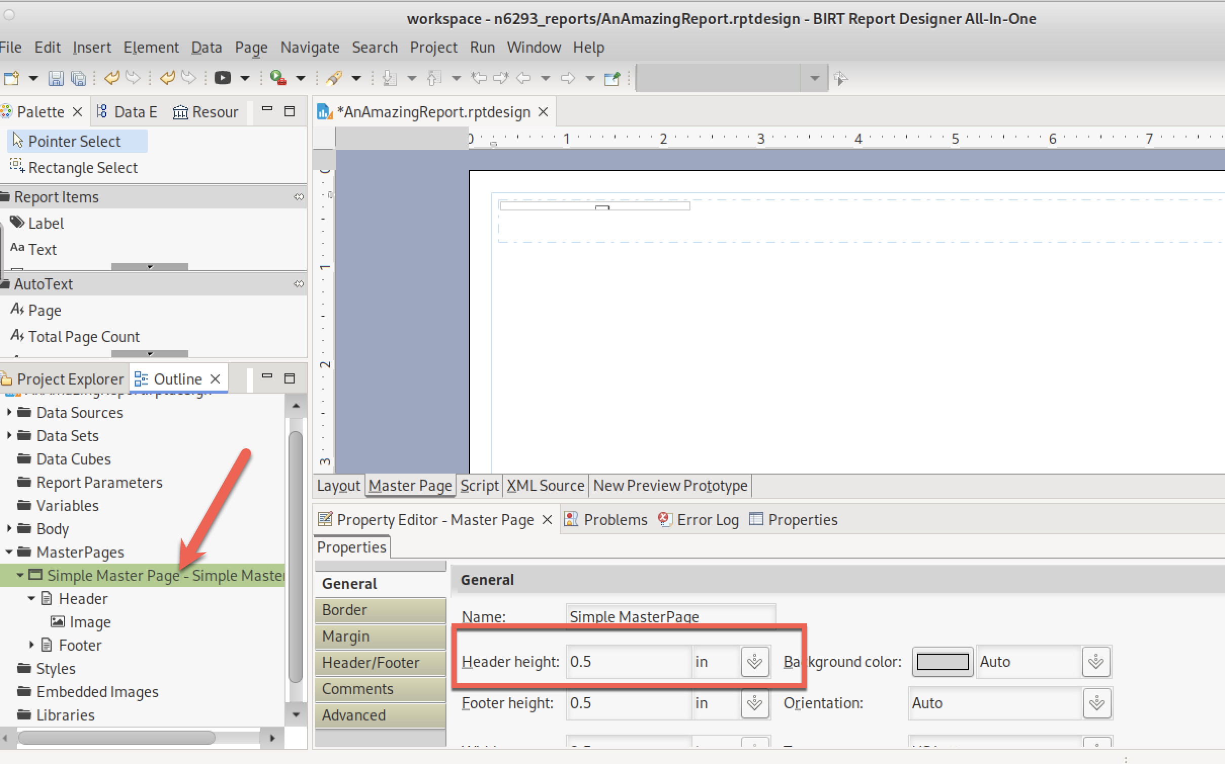

Save and render. What you see now is more space that you could use to increase the size of the logo or add some additional items to the header if you wanted.

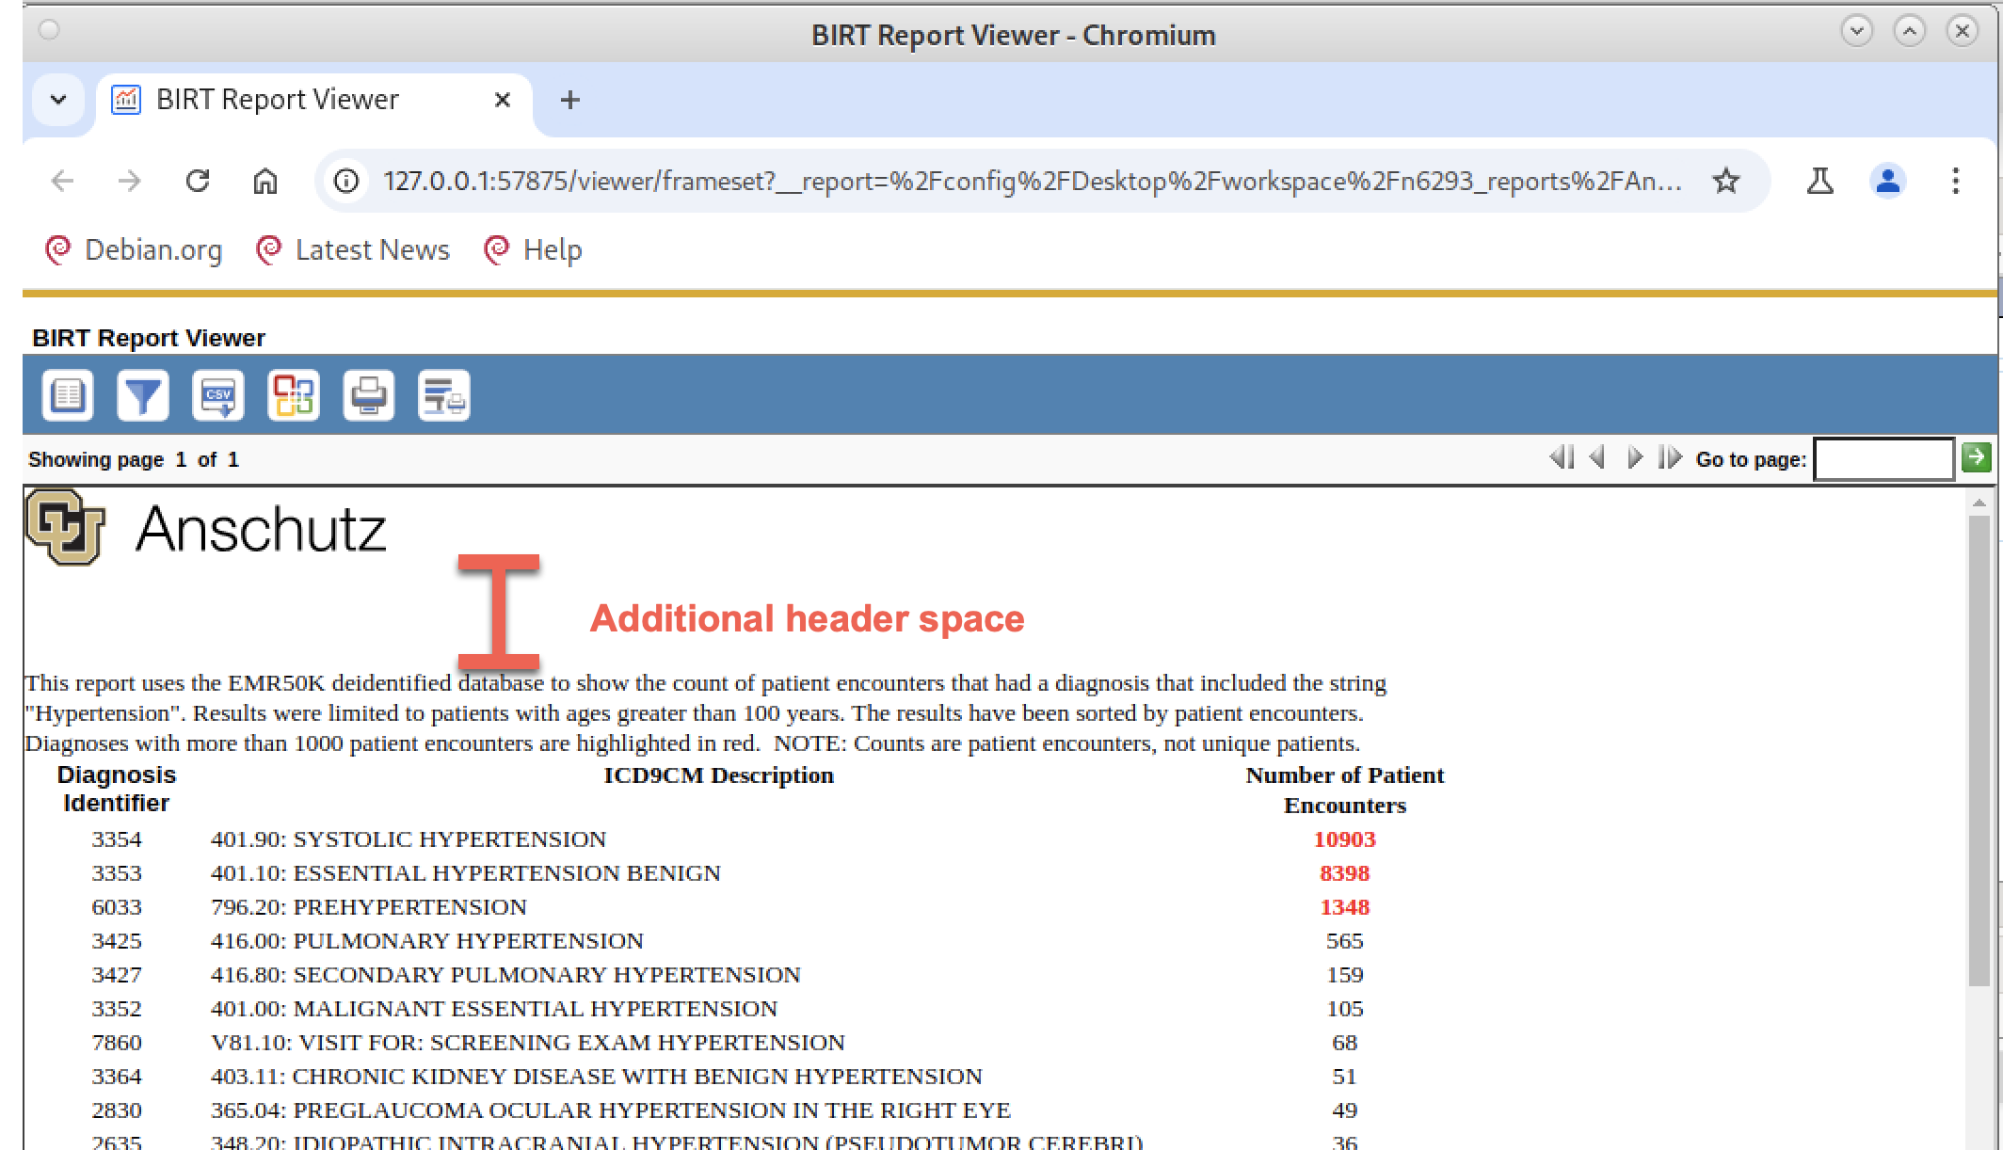

# Report #2

What follows is beyond what is expected for the class, but I thought I would show you how the previous query could be changed and expanded if you wanted to show a **list** of **\*\*PATIENTS\*\*** rather than the **number** of **\*\*ENCOUNTERS\*\***.

I also push the envelope to show you how to convert date of birth (DOB) into Age In Years.

Remember – do this SQL work in PG Modeler rather than BIRT. You won’t regret it.

Getting patients is a bit tricky for a couple of reasons:

1. Neither the DIAGNOSES nor the ENC_DIAGNOSES tables contain a patient ID (PAT_ID). To get a PAT_ID, we need to bring in the ENCOUNTER table, which we did not need in the first repor.
2. I want to calculate patient age, which needs the patient’s date of birth (DOB). That variable only appears in the PATIENT table. So, in addition to bringing in the ENCOUNTER table, we also need to bring in the PATIENT table. The connecting variable here is the PAT_ID that appears in both the ENCOUNTER and PATIENT tables.
3. Patients are seen in multiple encounters, so the same PAT_ID will appear multiple times in the ENCOUNTER table. We want to count the same patient only once. That is, we seek to count the number of DISTINCT patients for each diagnosis
   1. Note: A patient can have more than one diagnosis. The same patient will be included in the counts for each of their diagnoses. But within a diagnosis, we only want to count that patient once.
   2. Make sure you understand the previous note.

OK. First task is to bring in the ENCOUNTER table and then the PATIENT table.

* To bring in the ENCOUNTER table, we need to do an additional JOIN using the ENC_ID that is in both ENCOUNTER and ENC_DX. (green arrow)
* To bring in the PATIENT table, we need to do a second JOIN using the PAT_ID that is in both ENCOUNTER and PATIENT. (red arrow)
  + Because we have the PATIENT table JOINED, we can bring in DOB (green box)
* To count a patient only once for each diagnosis, we must use the DISTINCT clause (red box). Try the query with and without the DISTINCT clause to see the difference.

The new query with all of these changes looks like this:

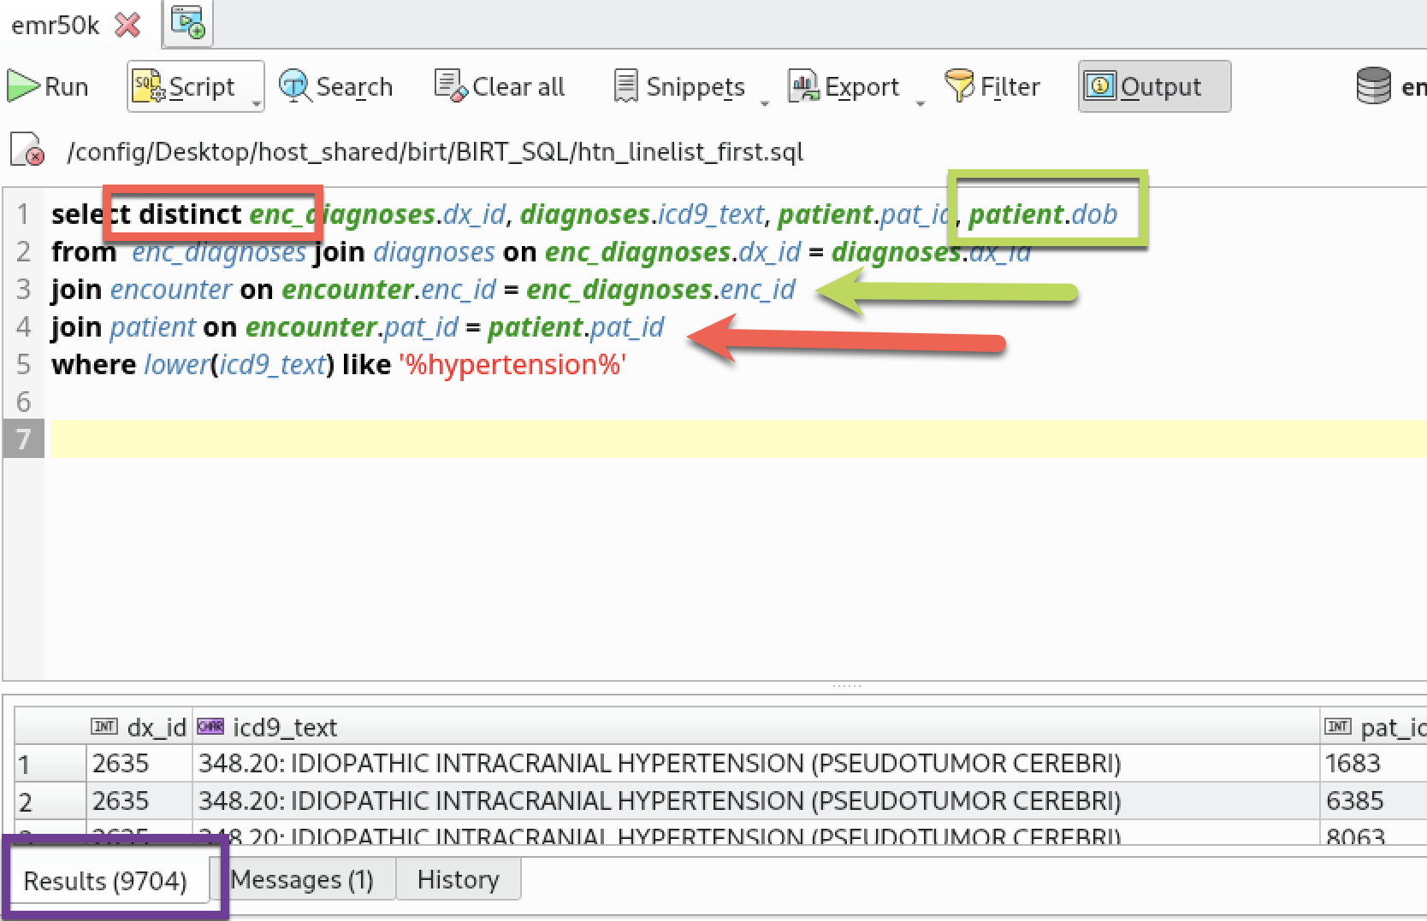

Notice that this query returns 9,704 rows (purple box) which is too many for our final query. We will cut this down in a later step.

Now that we have DOB, we can focus on calculating the patient’s current age. This requires some advanced SQL knowledge. We need to learn how to find the **current date** and then how to use the **current date and DOB to calculate current age**. We also want to limit age to just age in years (no fractions/decimals).

How do I do these calculations? Hmmm, I don’t know how to do this (I really do but I am assuming you don’t). Here Google is your friend. We are using the Postgres database (also called Postgresql).

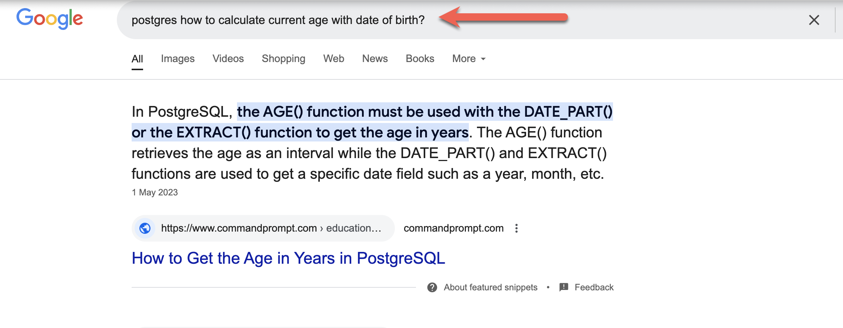

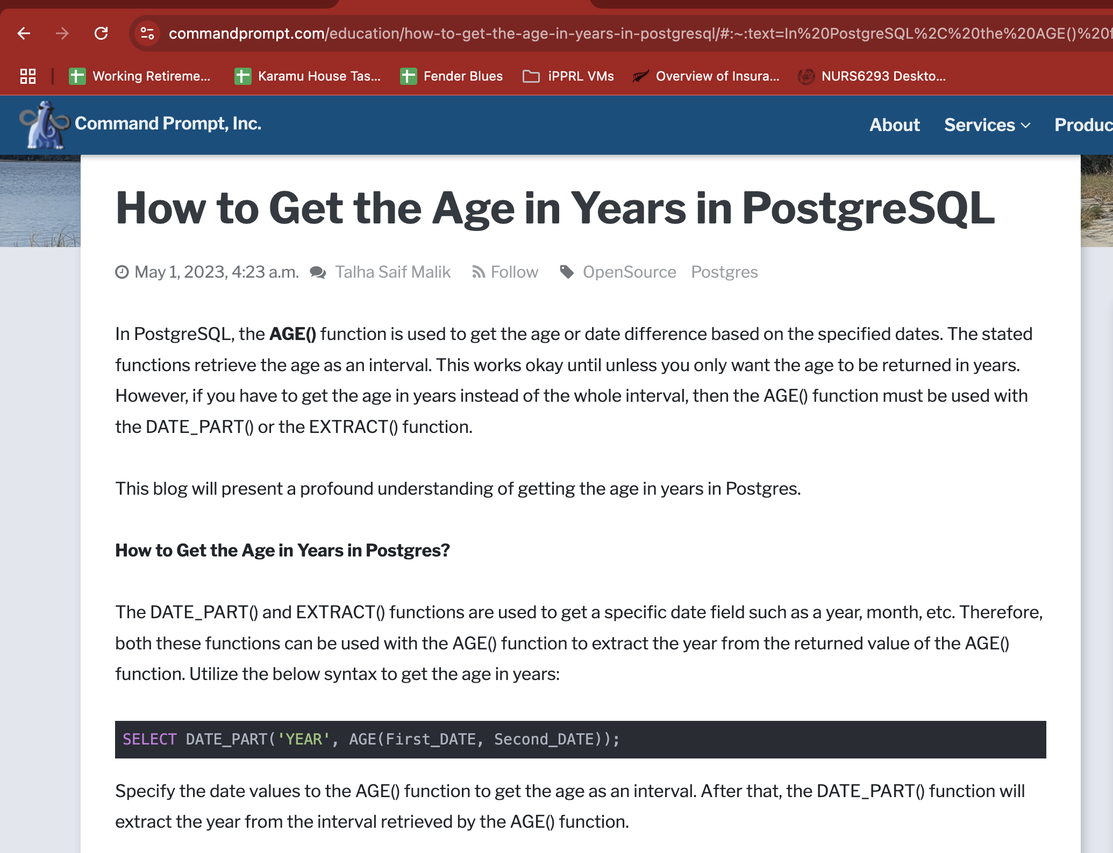

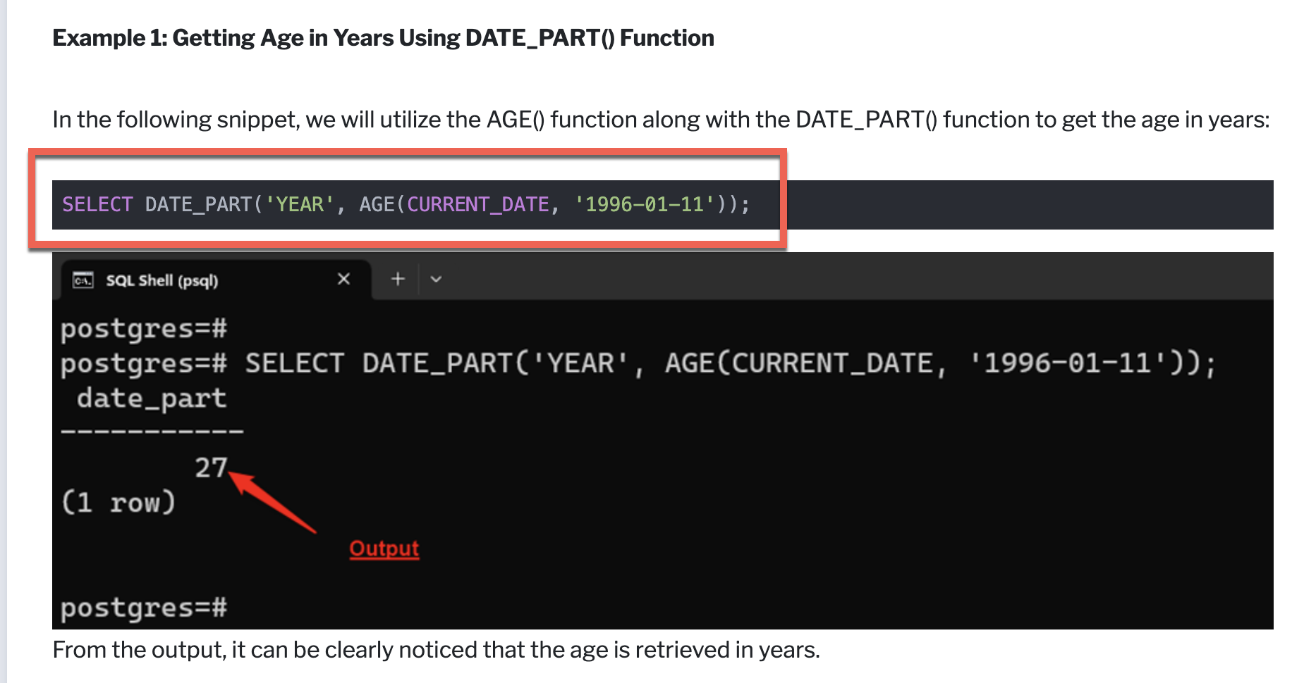

BINGO! The red box shows the command that I want so I replace ‘1996-01-11’ in their example with DOB in our query (red arrow) to get:

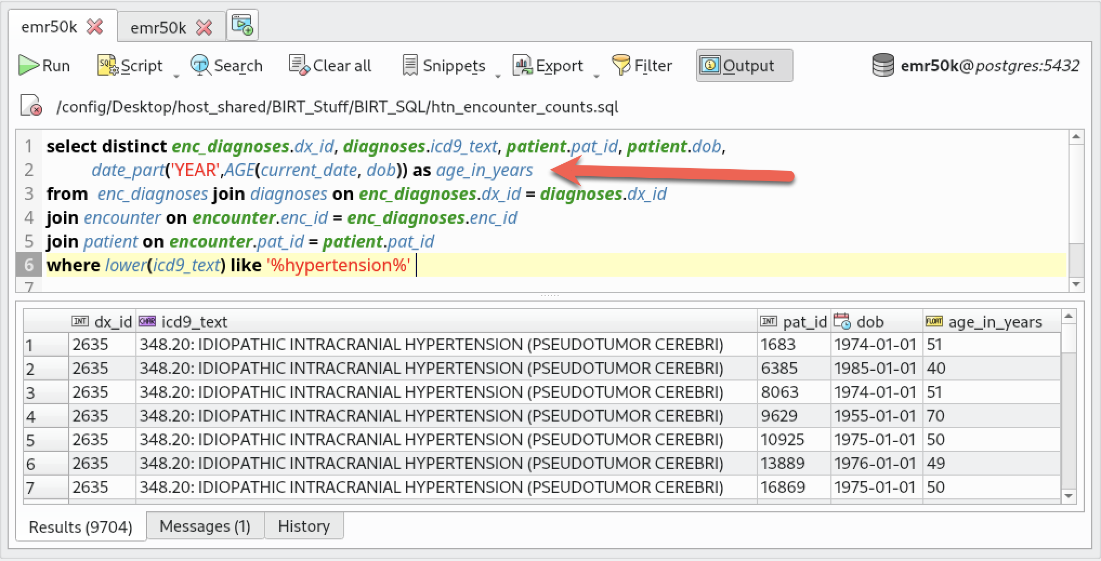

Note that I renamed the last column to be “age_in_years” using the AS clause (red arrow).

Is this not truly exciting? (I know, a true indication of a “no-life” person….)

I want to make two changes:

* Let’s order the previous query with the oldest age at the top.
* The current query returns 9,704 rows – too many for a report to run quickly. I will add a WHERE clause that limits the age until the number of rows returned is reasonable for the report to run quickly:

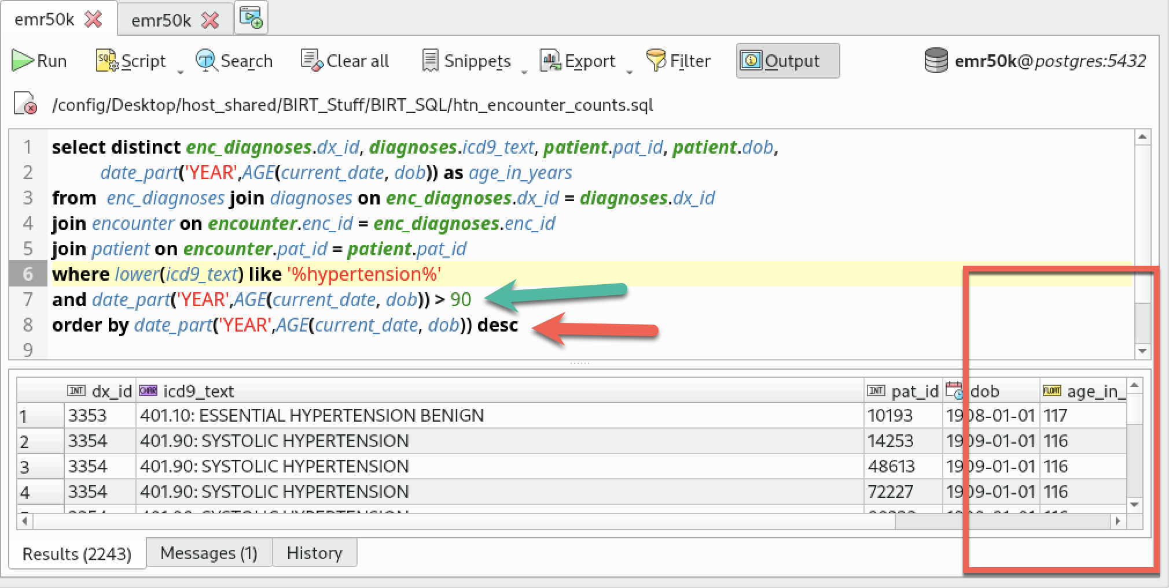

The red arrow sorts the row by age. Look at the red box – we have some 100+ folks in our database (because we do not have date of death in our deidentified database…….).

I limited the results to include only folks over 90 (green arrow) but that returns 2,243 rows. While BIRT can handle this number of rows, it is very slow in our Docker environment. Increasing the age (red box) to >100 returns 727 rows, which is more reasonable.

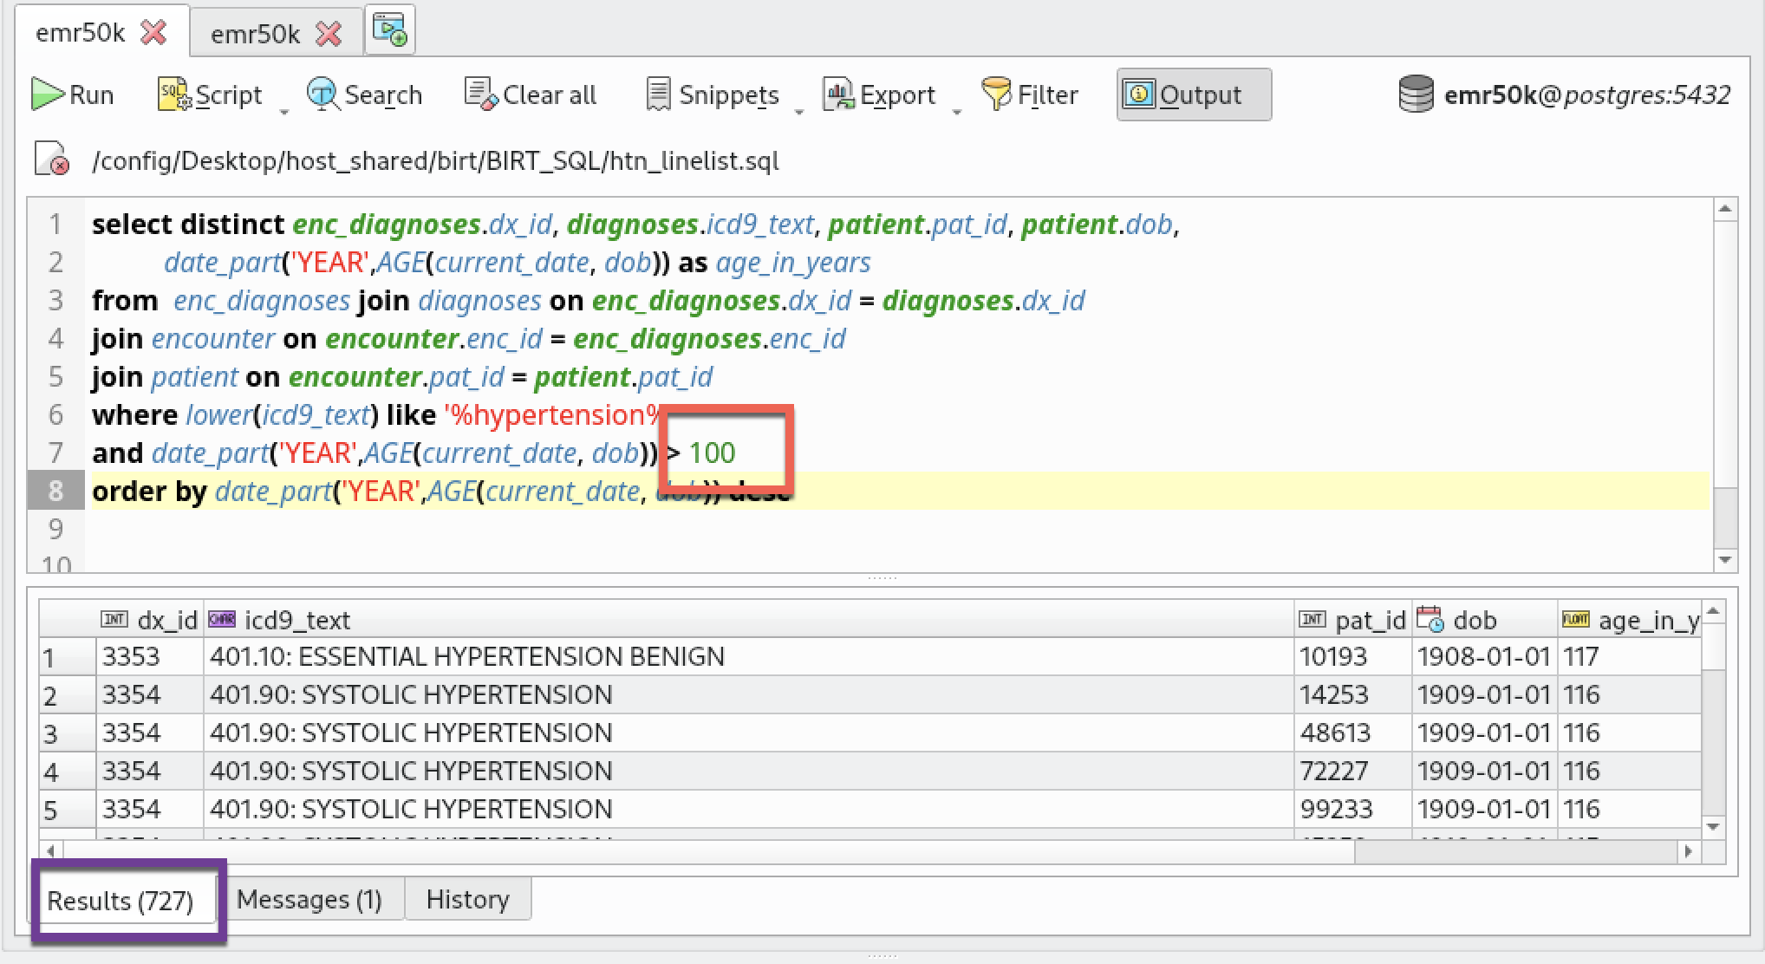

The final query looks like:

select distinct enc_diagnoses.dx_id, diagnoses.icd9_text, patient.pat_id, patient.dob,

date_part('YEAR',AGE(current_date, dob)) as age_in_years

from enc_diagnoses join diagnoses on enc_diagnoses.dx_id = diagnoses.dx_id

join encounter on encounter.enc_id = enc_diagnoses.enc_id

join patient on encounter.pat_id = patient.pat_id

where lower(icd9_text) like '%hypertension%'

and date_part('YEAR',AGE(current_date, dob)) > 100

order by date_part('YEAR',AGE(current_date, dob)) desc

We could dig deeper and deeper, like looking at differences by SEX. But we need to get started on writing our report, which is the main objective of this module.

**Creating a report that lists patients, grouped by Age:**

In this report, I want to list all patients, one patient per line, **grouped by age**. I could have created a different report where I list one patient per line grouped by diagnosis instead. Something you might want to consider…….

We begin like Report #1. We start with a blank report, create a data set by copy-paste our beautiful SQL from PGModeler into crude BIRT and then drag all of the fields in the BIRT data set into the blank report to get a table. This gives up an ungrouped report that lists all patients, one per row:

|  |  |  |
| --- | --- | --- |
|  |  |  |

|  |  |  |
| --- | --- | --- |
|  |  |  |

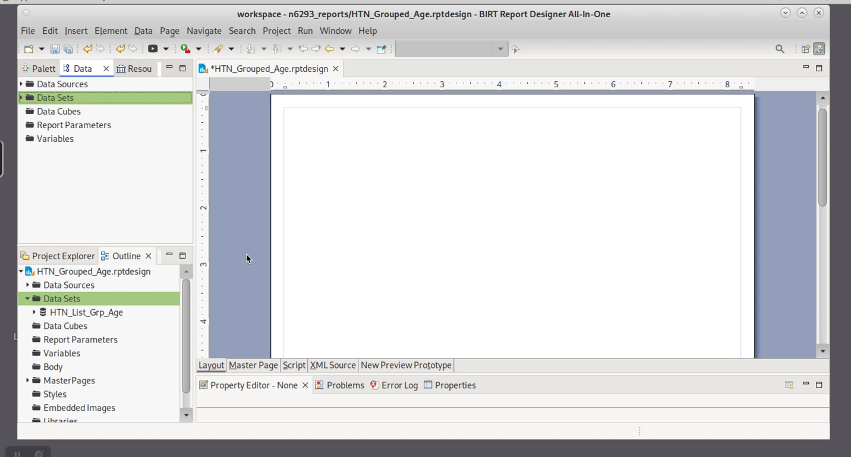

|  |  |  |
| --- | --- | --- |
| **From PGModeler** |  |  |

Movie: Dragging data elements into blank report, then preview:

We now have a “standard” line listing of patients. We want to add a Grouping item to the report so we can group patients by Age.

**Right click** on the Details row (the middle row), select “Insert Group”:

|  |  |
| --- | --- |
|  |  |

Name the group (red box). Select drop-down (red arrow), pick age_in_years (red box) for the grouping variable, change sort order to descending (green arrow) to show the oldest folks first:

|  |  |
| --- | --- |
|  |  |

Let’s see what we get:

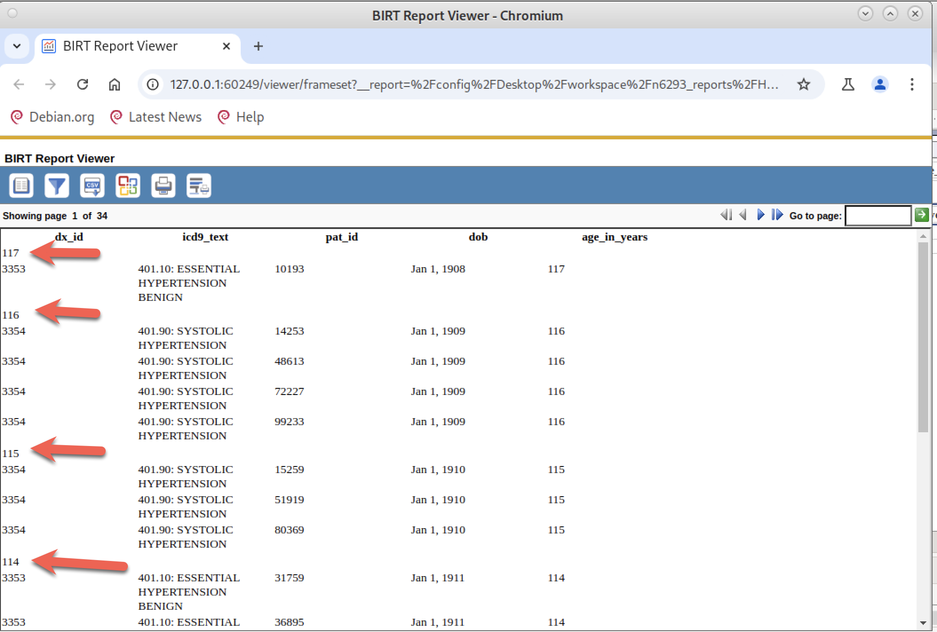

It’s a bit tough to see but we have each age group (red arrows: 117, 116, 115,114) followed by a listing of patients with that age (see “age_in_years” column in far right – aligns with the group age).

We have the basics of a grouped report in place. But now we need to spend time making the report much more visually consumable.

Like with Report #1, I’m going to change the column labels to be more user friendly, and also work with center alignment and column widths for better visibility. At this moment, I am not focusing on improving the readability of groups.

Here is what I have after fiddling around with renaming columns, center-aligning and working with column widths. All changes are exactly like Report #1:

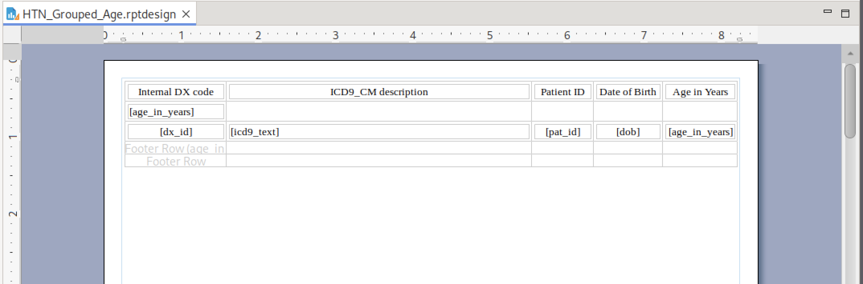

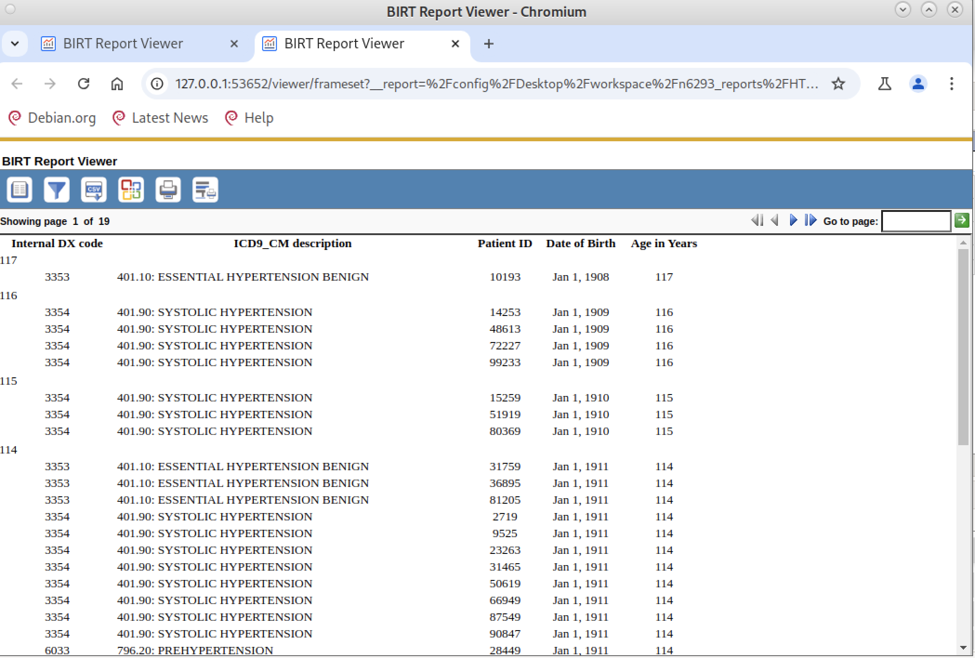

Time to focus on making the report more visually appealing.

Here are the changes I will make:

1. Add a solid line at the **end of each group** that visually separates the groups.
2. Change the Group Header. Currently it only shows a number (Age_in_Years). Create a better Header.
3. Expand the Group Header to include the number of patients in each group.
4. Expand the Table Header to include the total number of patients in the record. Note that the Table Header focuses on the entire table whereas the Group Header focuses only on each group separately.
5. Add the Report Description and the CU branding logo using the same methods described at the end of Report 1.

**Change 1**: Add a solid line at the end of each group:

For this, we use the GROUP **footer** (not the TABLE footer) because it is “printed” at the bottom of each group. We add a solid line border across at the bottom of the Group Footer. Watch the **video** as I select the GROUP footer row and add the solid line:

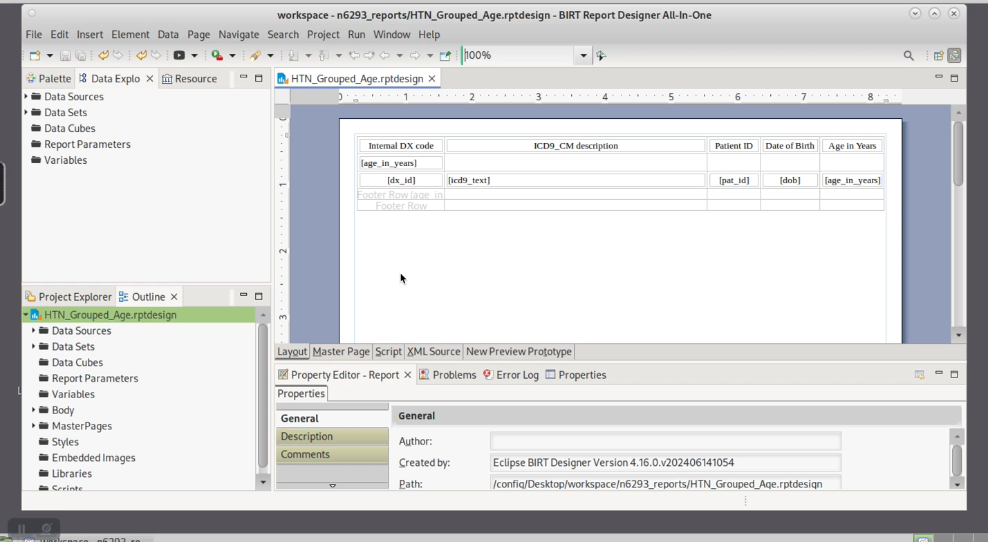

We now have a solid line at the bottom of each group:

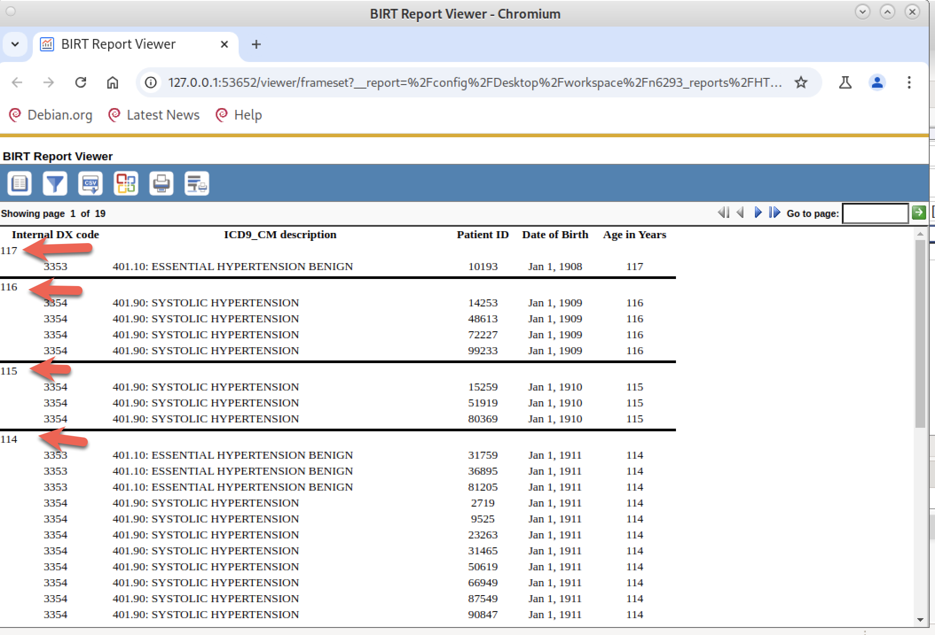

**Change #2**: Change the Group Header. Currently it only shows a number (Age_in_Years). Create a better Header (red arrows, above)

For this change, we are going to use a new element called “Dynamic Text” which allows us to add text plus data to a field.

We need to delete the [age_in_years] data element so we can put our Dynamic Text. Right click on [age_in_years] in the Group header and delete:

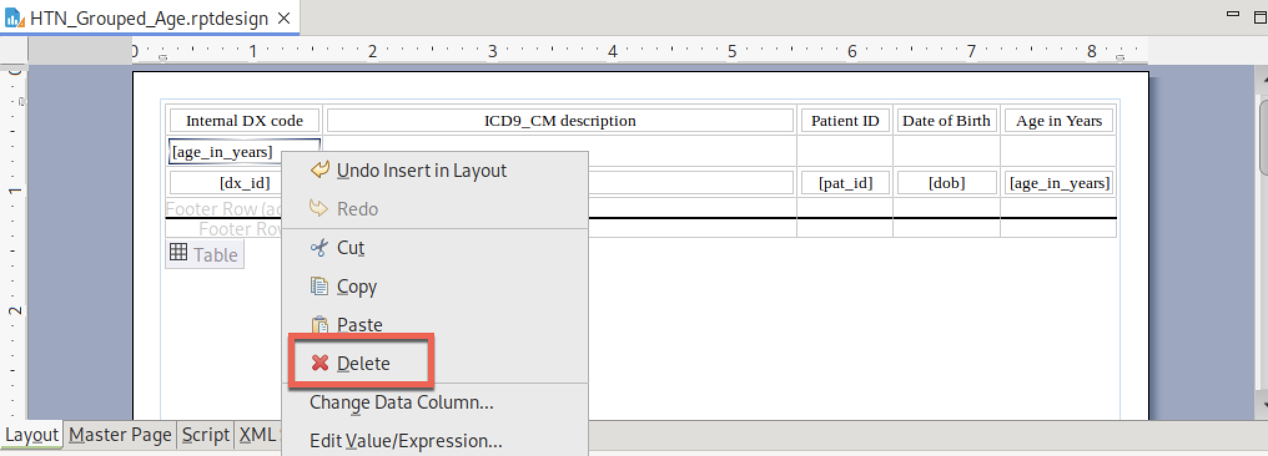

Go to the Palette, which contains all of the possible elements you can add to a BIRT report. Drag the “Dynamic Text” element into the same cell where we just deleted [age_in_years]

|  |  |
| --- | --- |
|  |  |

Up comes the “Expression Builder.” This dialog lets you combine text and data. Text must be surrounded by double quotes. You use the plus (+) symbol to combine elements – in this case, we will be combining some descriptive text plus [age_in_years] data:

|  |  |
| --- | --- |
|  |  |

In the upper box, you type: “Age in Years: [space]” and the plus character.

You click across the bottom to get to the age_in_years data variable and double click. The interface adds the **row[“age_in_years”]** data element. Hit OK.

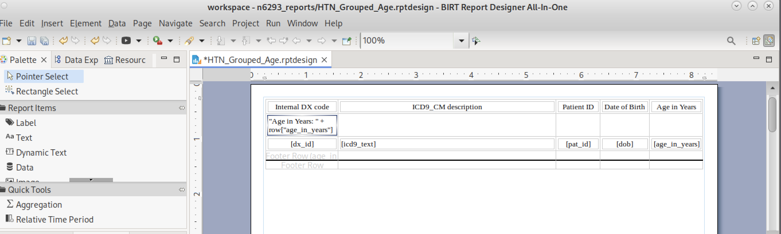

Let’s look at what we got from adding the dynamic element:

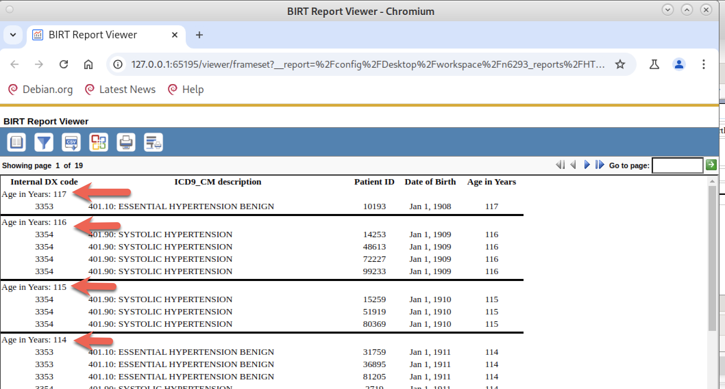

Great. Rather than just 117, 116, 115, etc, we now have “Age in Years: 117”, “Age in Years: 116” at the top (Group HEADER) of each group.

**Change 3: Add number of patients within each group**

We could extend the existing Group HEADER dynamic text box that has the Age in Years, but let’s add a second Group HEADER for this new information so the two data elements appear on different lines:

Click on the “Table” selection handle (red box) and right click on the existing Group HEADER (purple box):

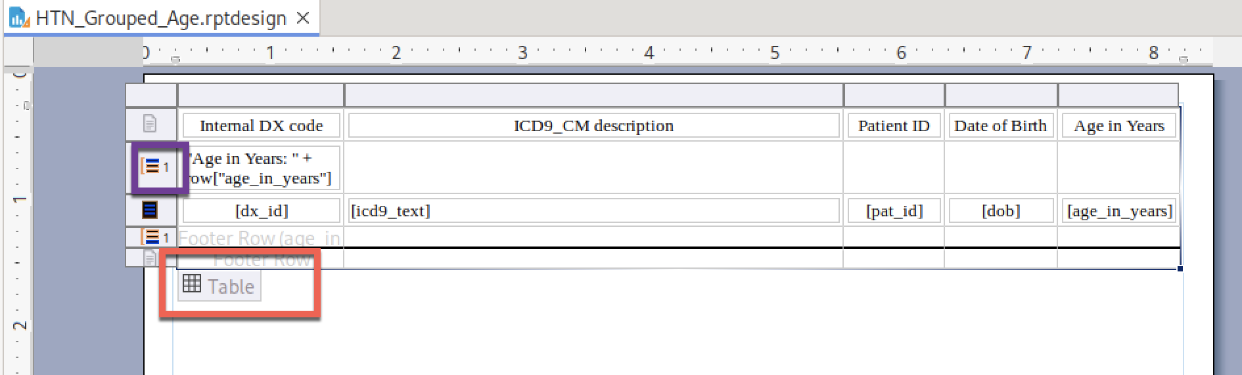

Select Insert -> Row -> Below to create a second Group Header row for our second dynamic text field:

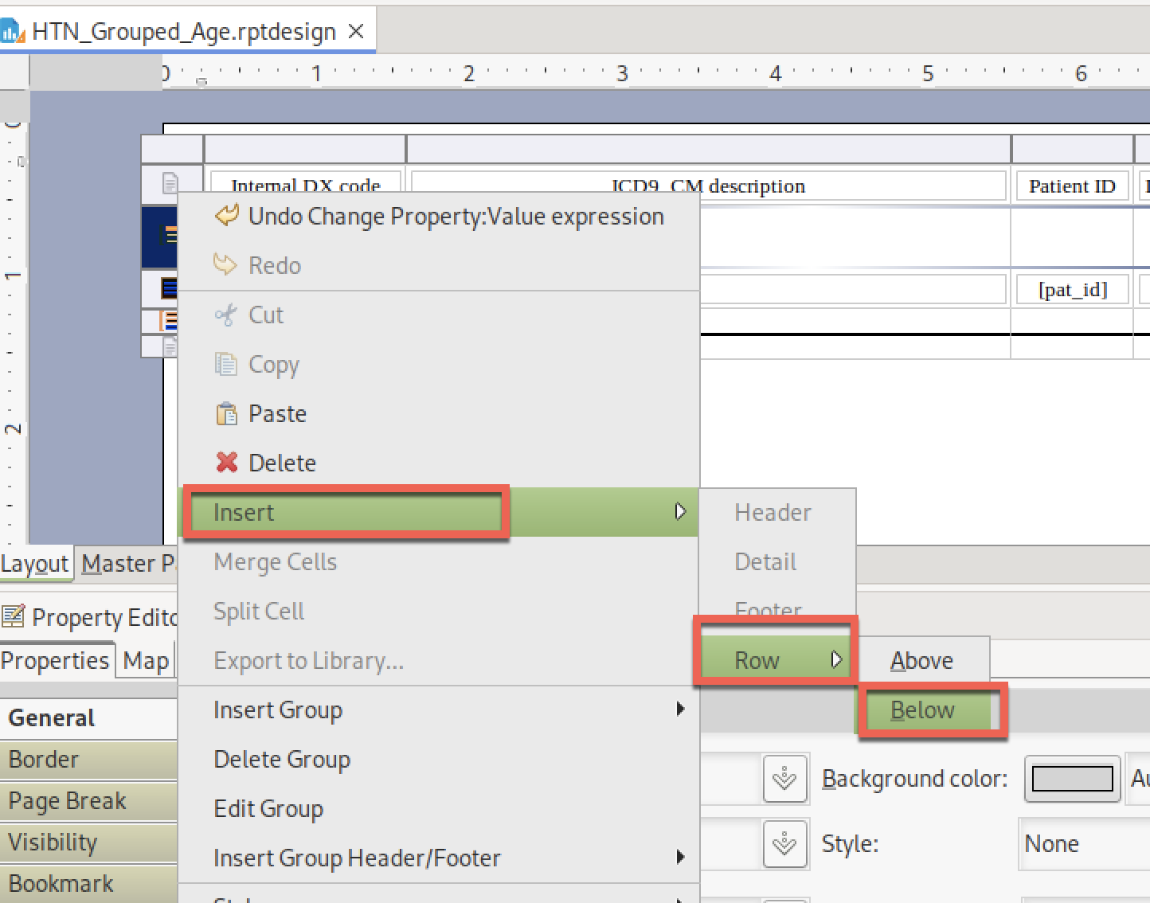

You now have a second row in the Group Header (red arrow) that we can use to include the number of patients per group:

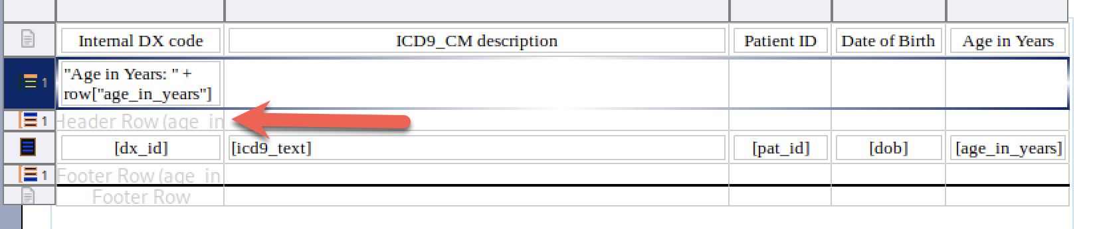

When we add the new “Dynamic Text” element here, we need to define a variable that calculates the number of patients (PAT_IDs) in each group. We do this via the “Edit bindings…..” option in the Expression Builder:

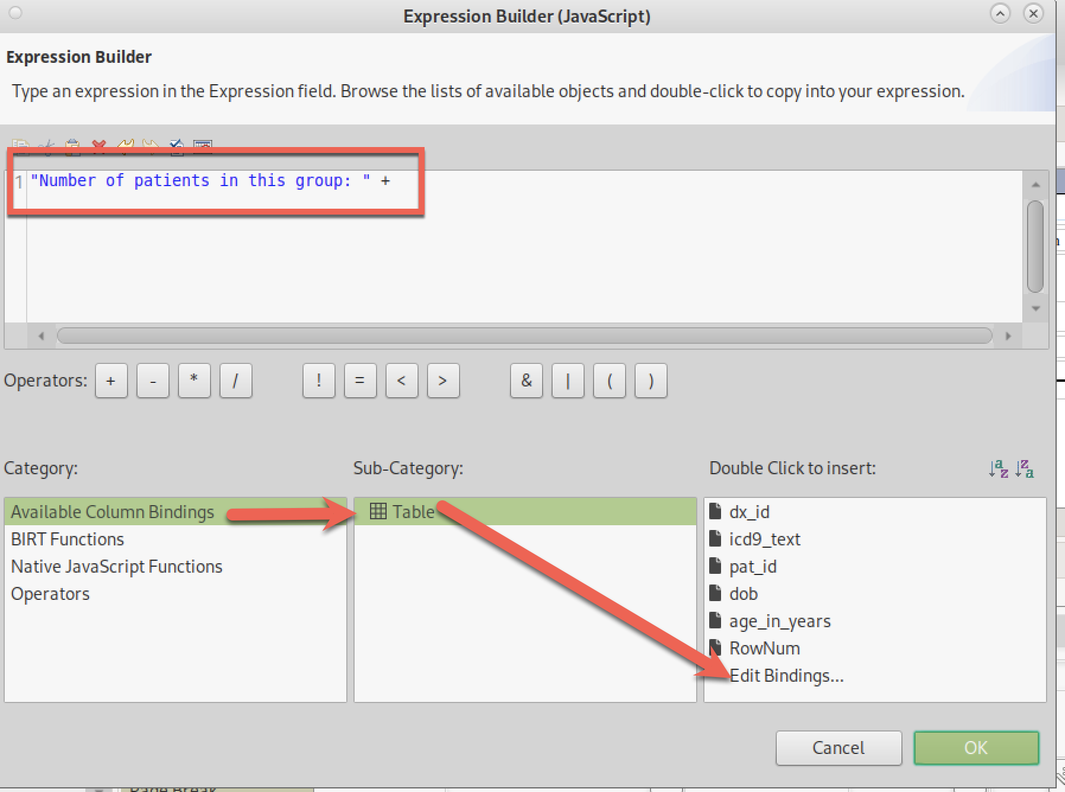

This shows all of the available data elements. We want a count, which is an aggregation so we select “Add Aggregation” (not an aggravation which I often feel about BIRT…..)

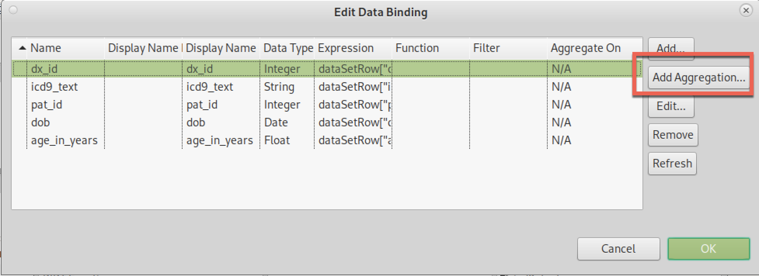

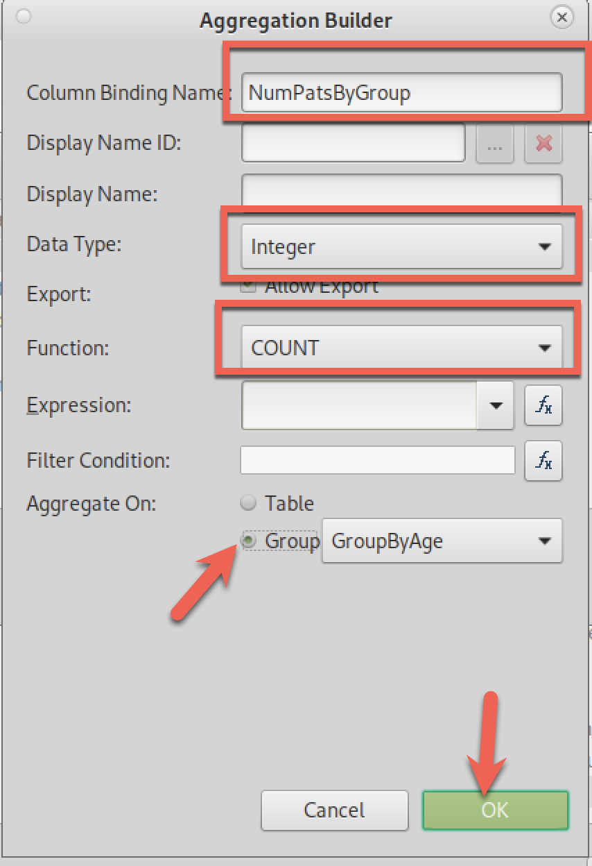

It is important to select “COUNT” as the function (third box) and “Group: GroupByAge” (arrow) so we get counts by group. Later, when we add the overall patient count, we will use this dialog box again and will select “Table” for this field to count the entire table. But for now, we focus on group counts.

We now have a new variable that we can select in the Expression Builder:

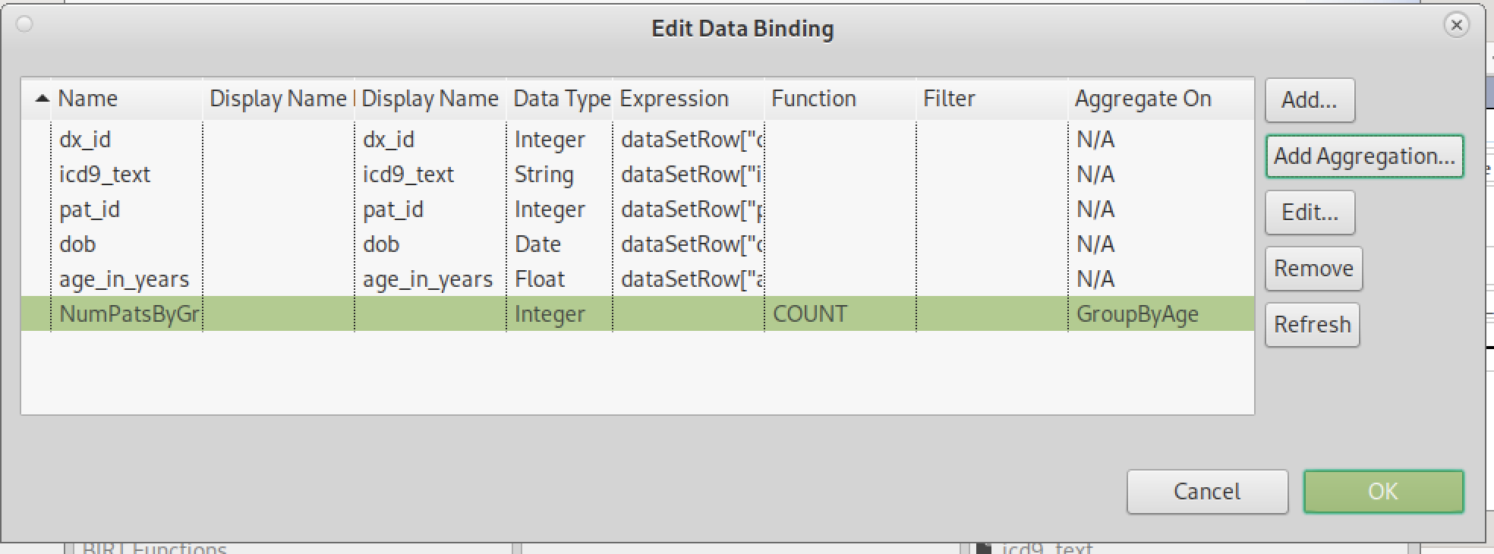

Add to our Dynamic Text:

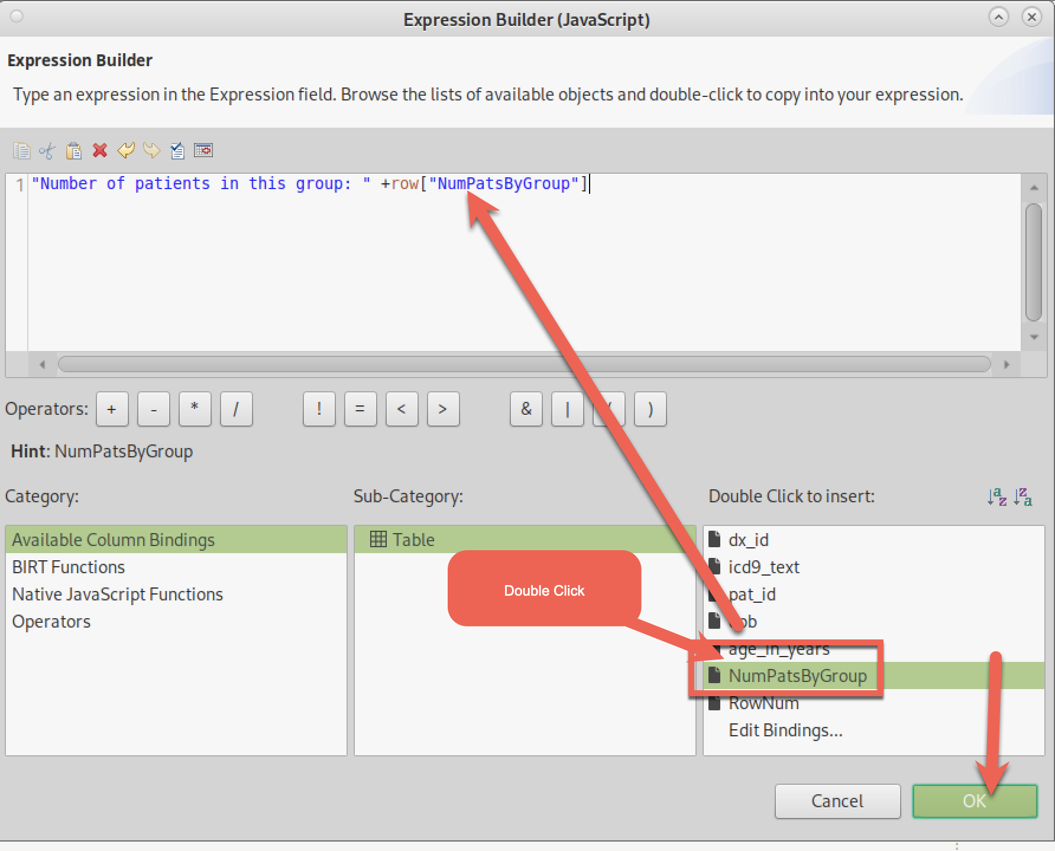

After “OK”, this is what the report looks like. There is a new Dynamic Text with our new counts:

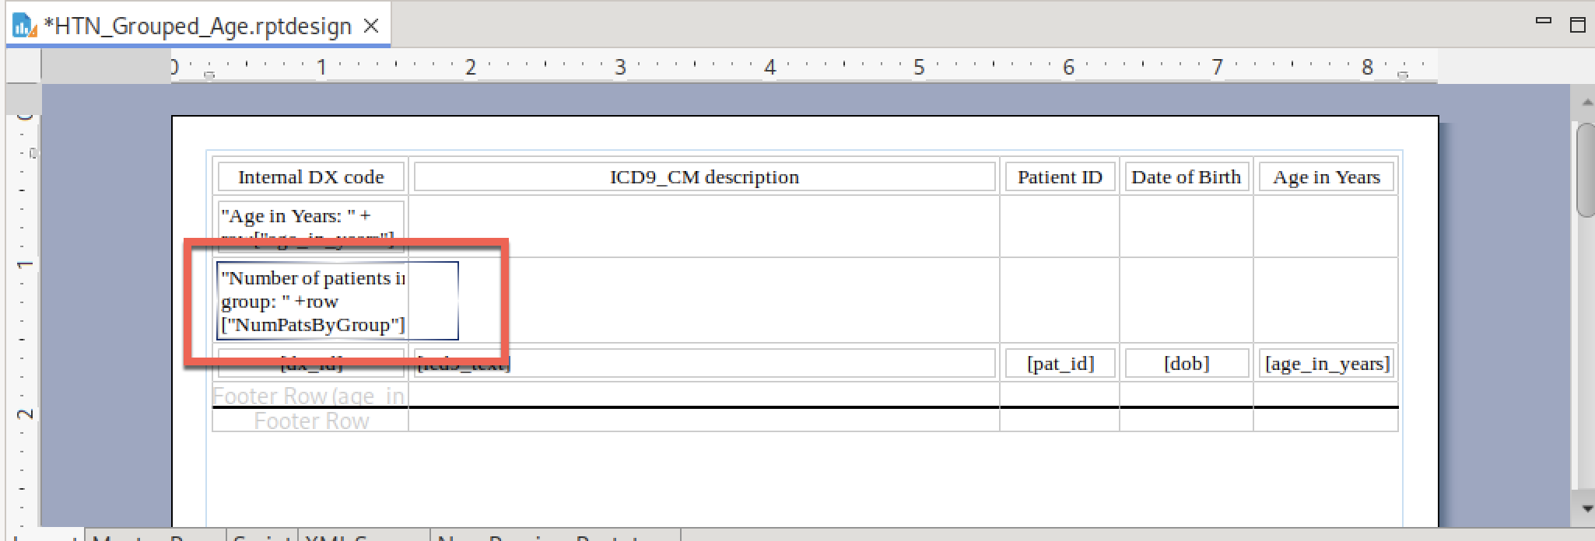

Let’s see what it looks like:

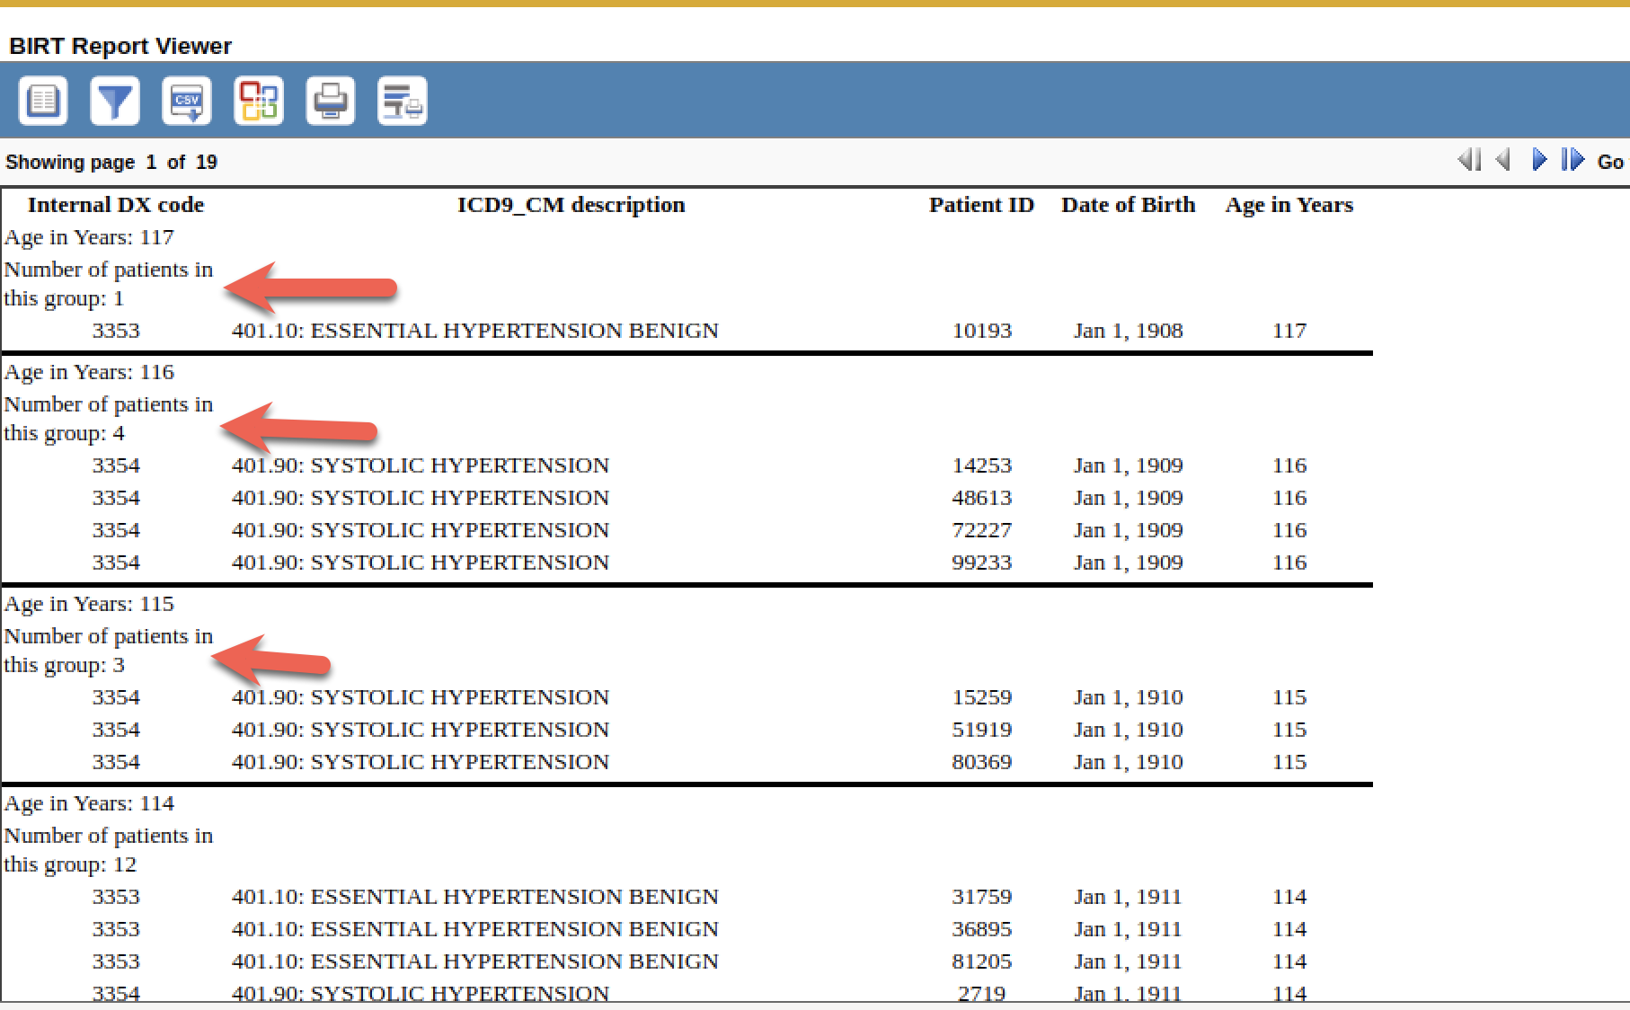

Hmmm – the text that I want is there, but I do not like the word wrapping. I want the text to flow across the columns, so it doesn’t wrap. Unfortunately, there is no option in BIRT that says “ignore columns”. You must do this by merging the columns in the row, similar to how you merge table cells in Microsoft Word.

In BIRT, you select multiple cells by Click-Drag across the cells. It is impossible to do this starting with the left cell because you select the “Dynamic Text” object, not the table cell object. The trick I used was to click on the **right-most** cell and drag leftward across that row to select all of the cells:

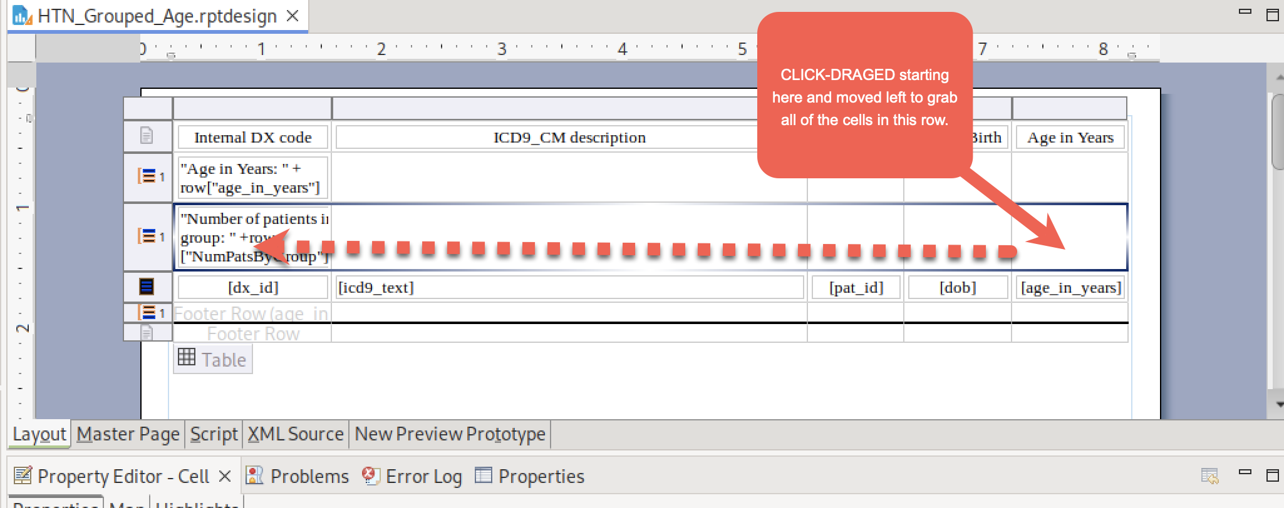

For the adventurous, there is an easier way using the Layout editor. But this way works also.

After selecting all cells in the row, right click and select “Merger Cells”

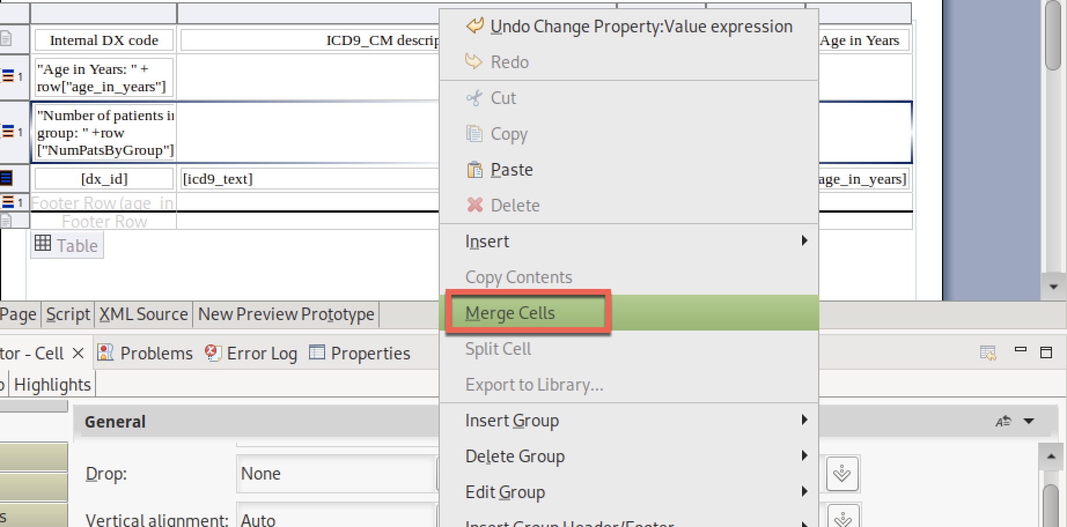

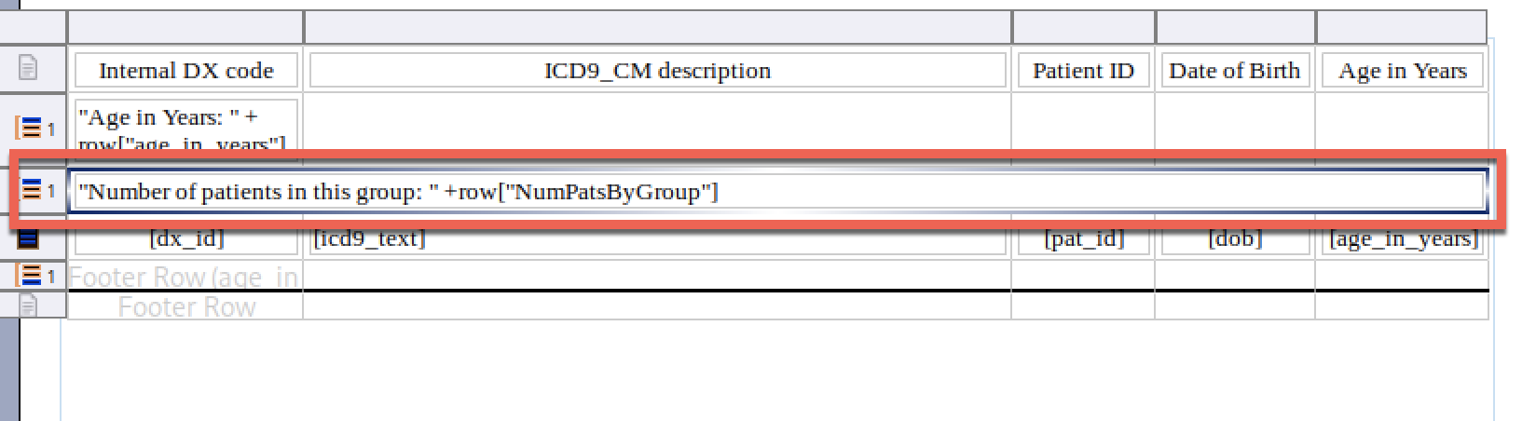

Notice the lack of column separators in the second Group Header (“Number of patients……”) compared to the first Group Header (“Age in Years….”). Let’s see what this looks like:

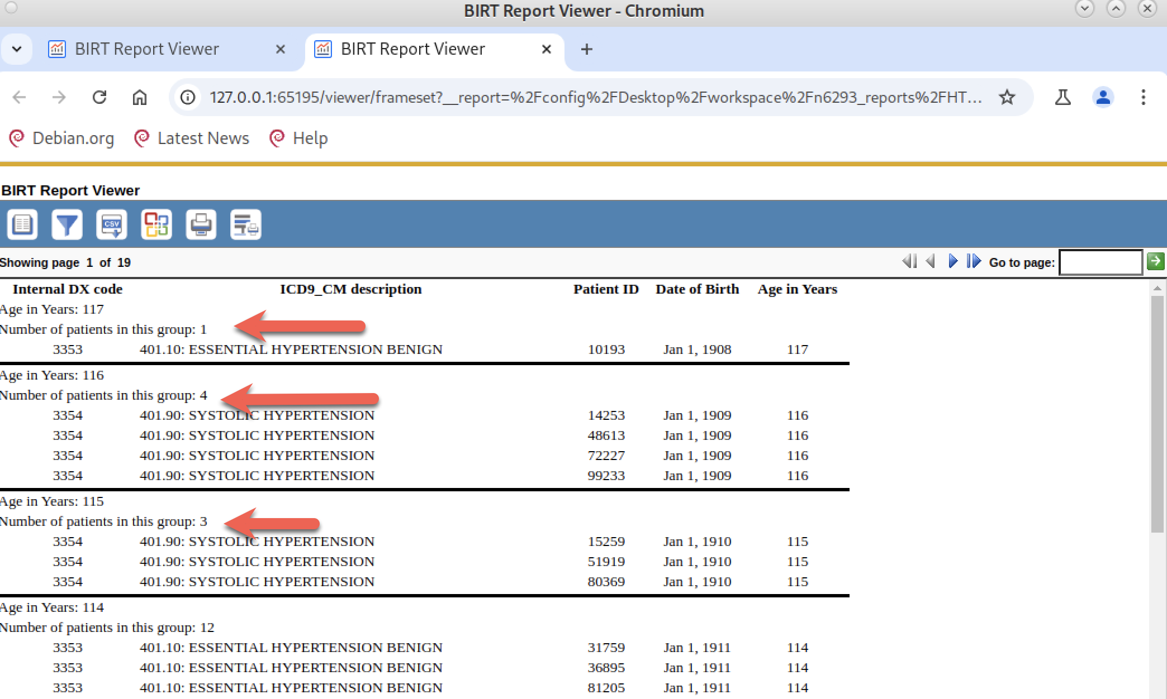

Very good! I’m going to do the same cell merging with the “Age in Years…” group header even though it doesn’t wrap. And I’m going to change the font to BOLD for both headers:

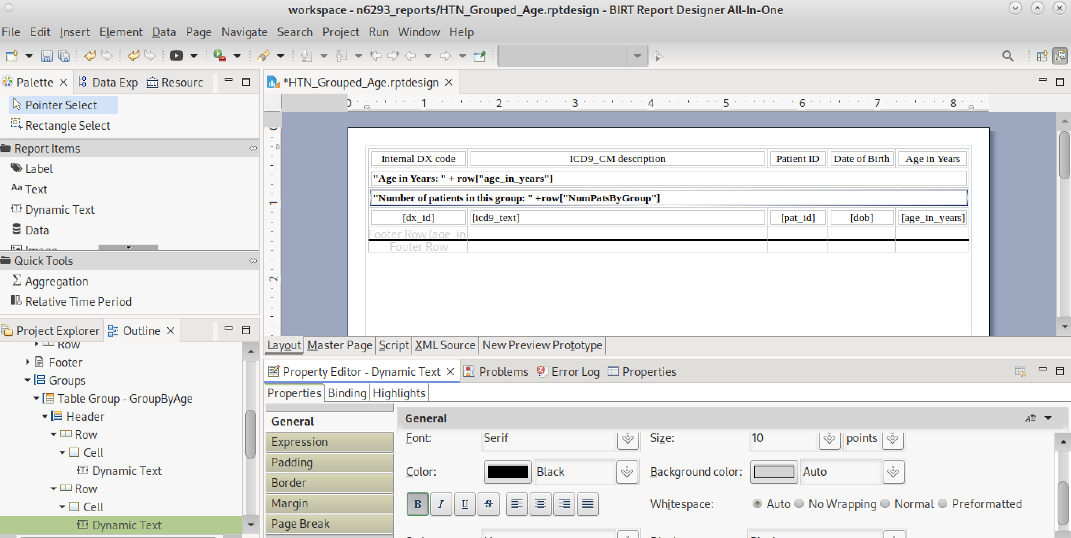

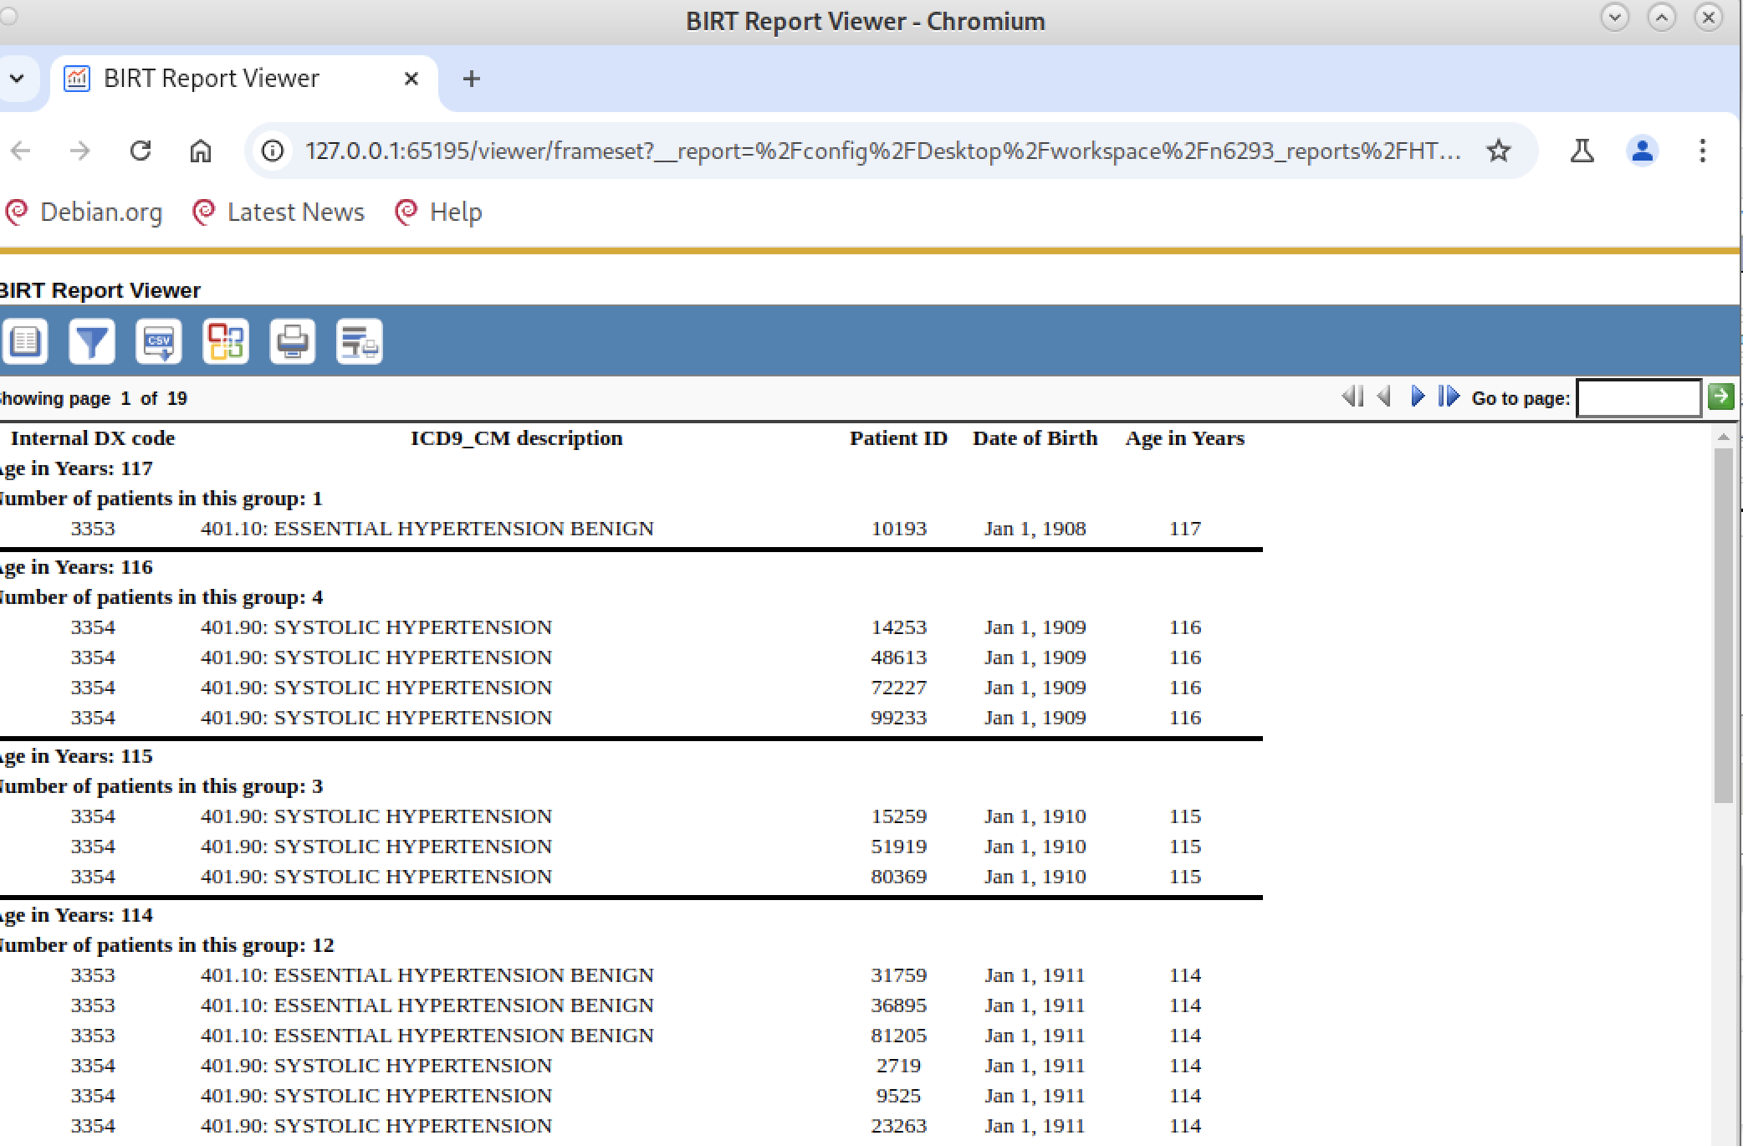

Nice!

You could spend your entire life tweaking fonts, background colors, icons/pictures. But we need to move on to the next change.

**Change 3**: Expand the Table Header to include the total number of patients in the record. Note that the Table Header focuses on the entire table whereas the Group Header focuses only on each group.

We follow the same basic steps that we did for the Number of Patients per Group but instead work with the TABLE HEADER, not the Group Header.

Select the table (red box) and then right click on the Table Header (purple box). Notice that the Table Header is above everything because it focuses on the entire table, not on groups.

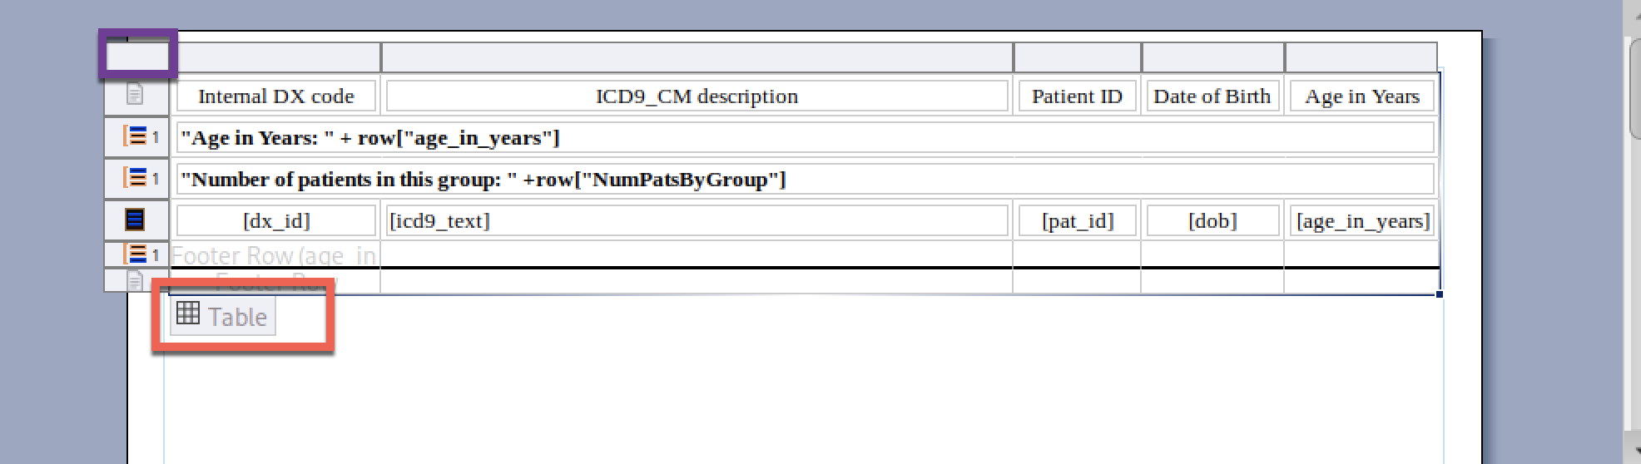

The Table Header behaves a bit differently. From a right click, you can directly insert a Dynamic Text element without having to drag from the Palette:

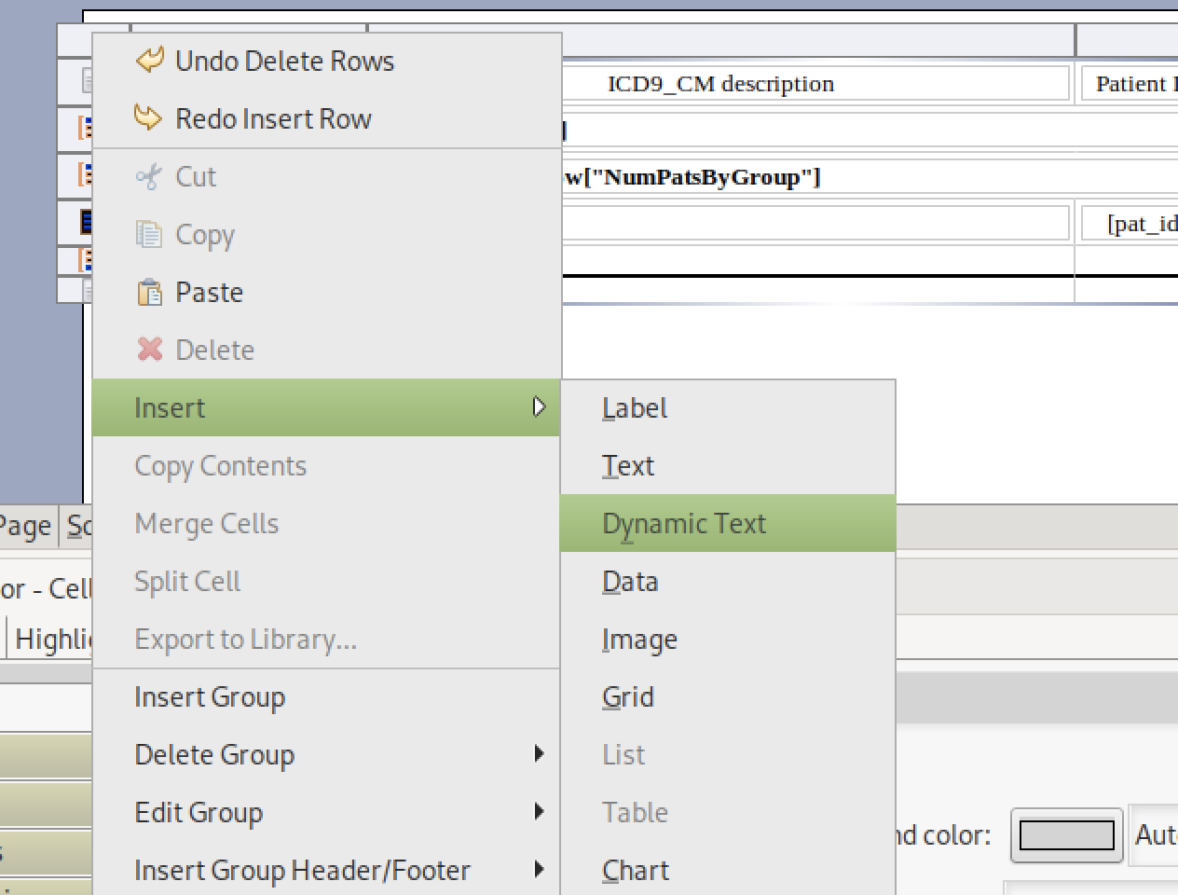

We get the same Expression Editor as before. Using the Expression Editor, add the following:

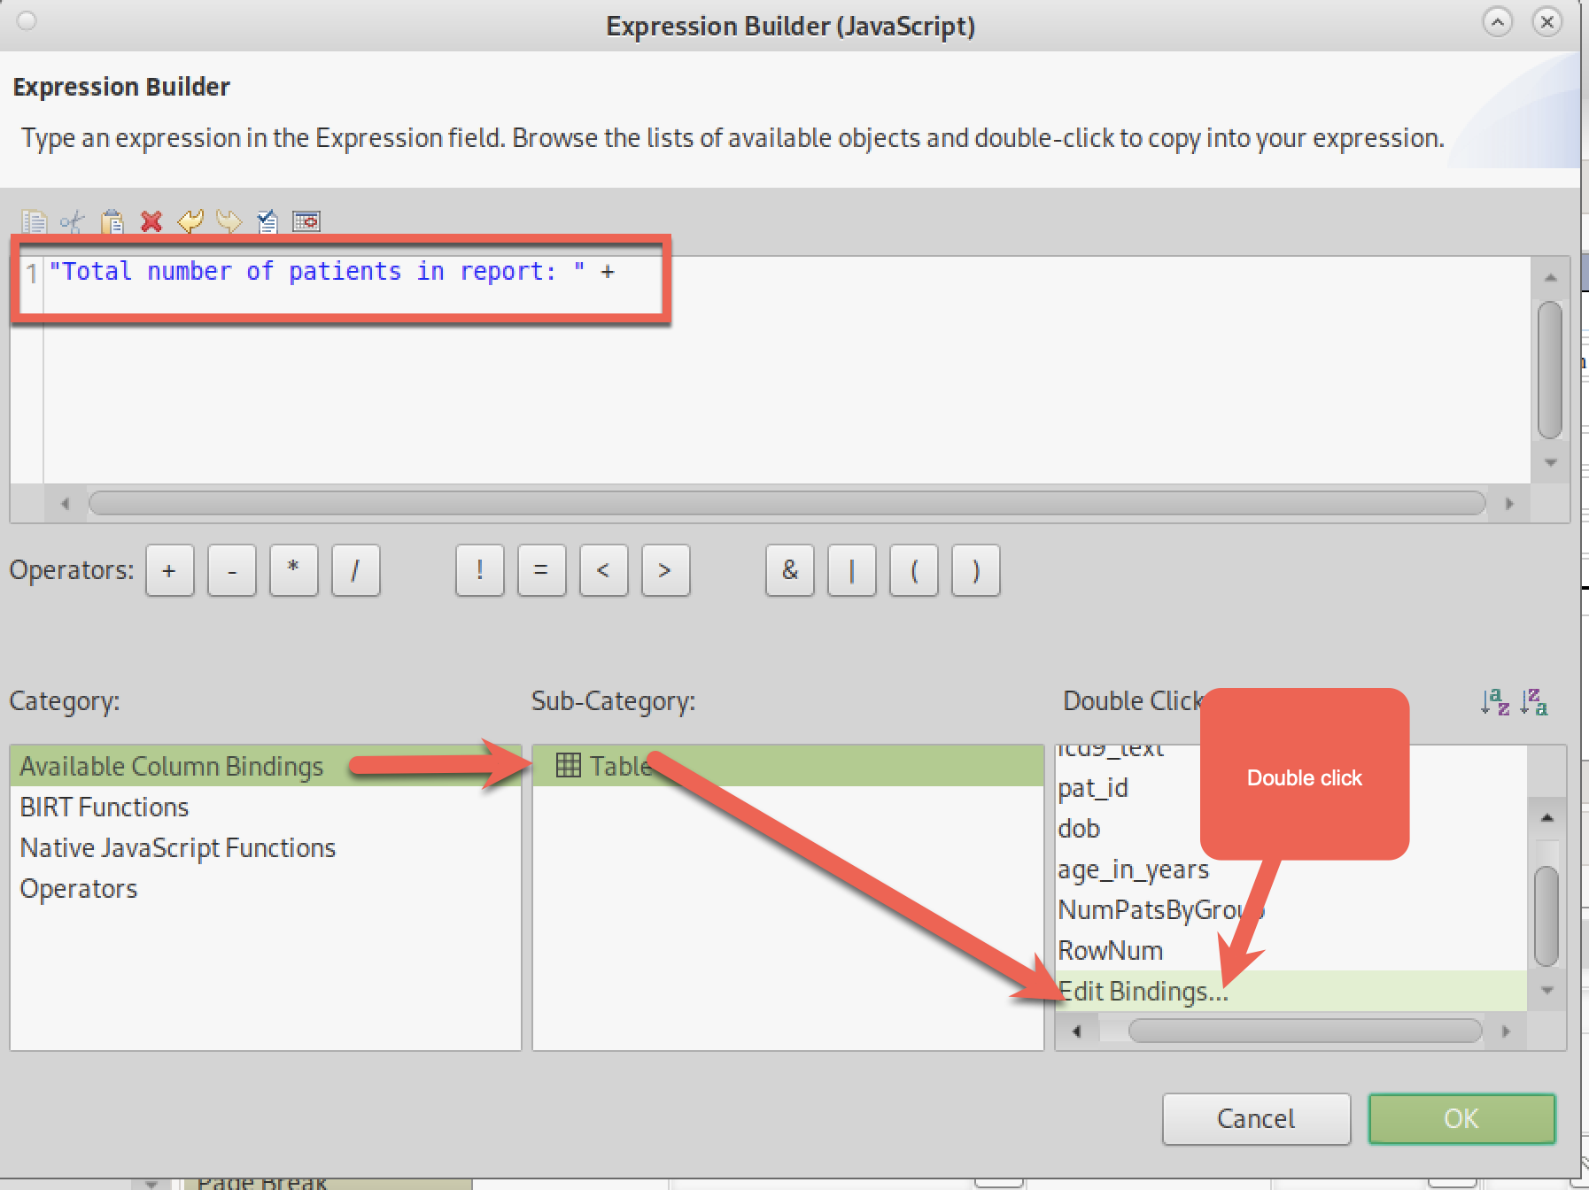

We need a new variable (BIRT = “binding”) that counts **all** patients, not just patients in each group (the NumPatsByGroup binding we created earlier).

From Edit Bindings, we do the same as we did the group count, but this time select “Table” as the aggregation since we want the count for the entire table (fourth box):

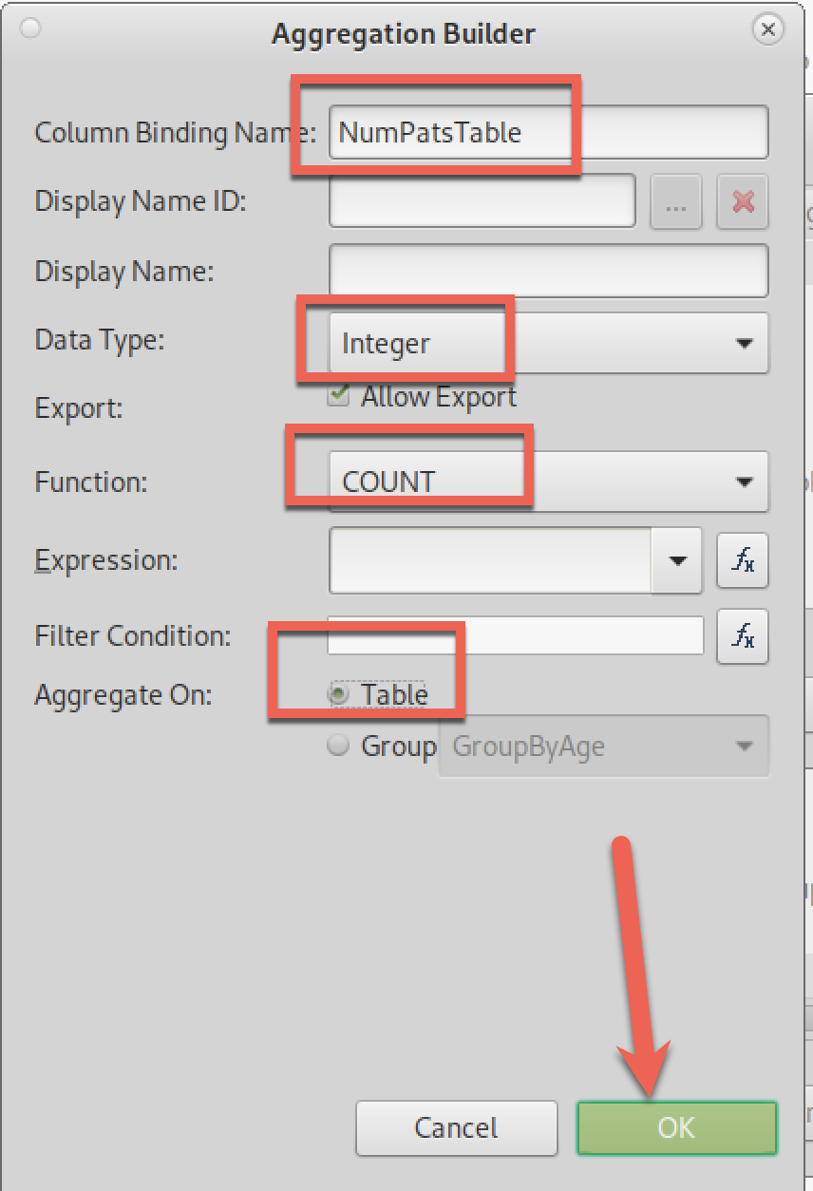

We now have a new variable “NumPatsTable” that we can use in our Table Header:

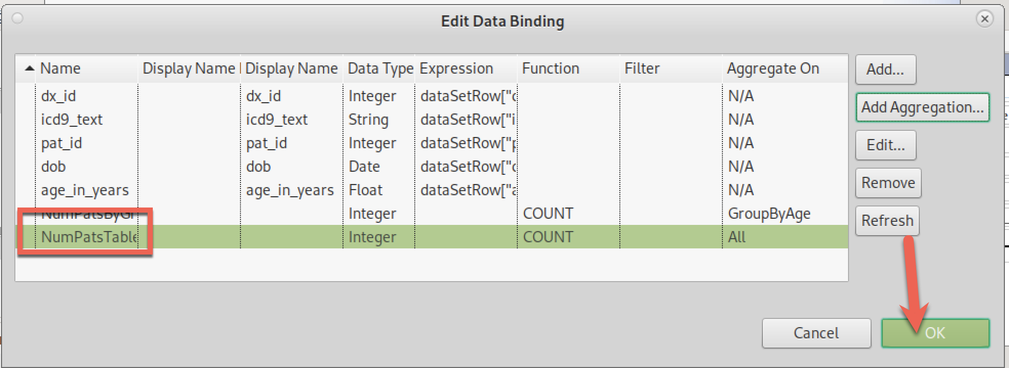

Add the new variable to our Table Header Expression:

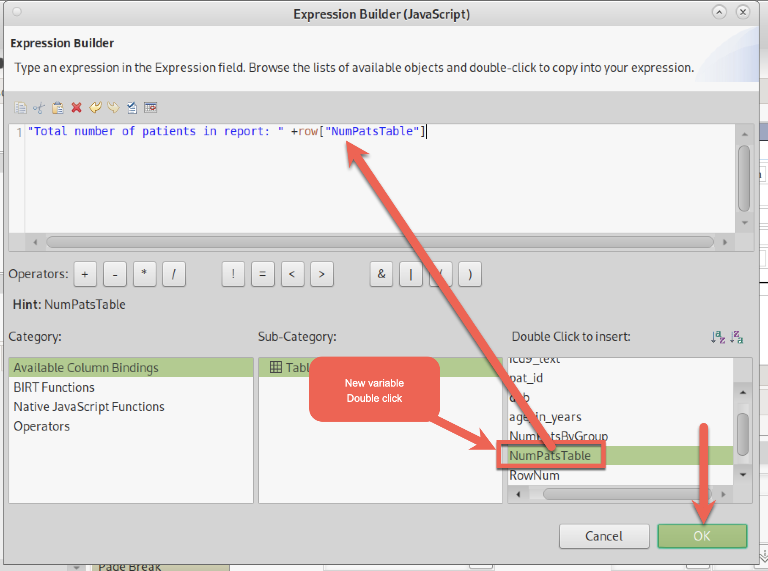

Render:

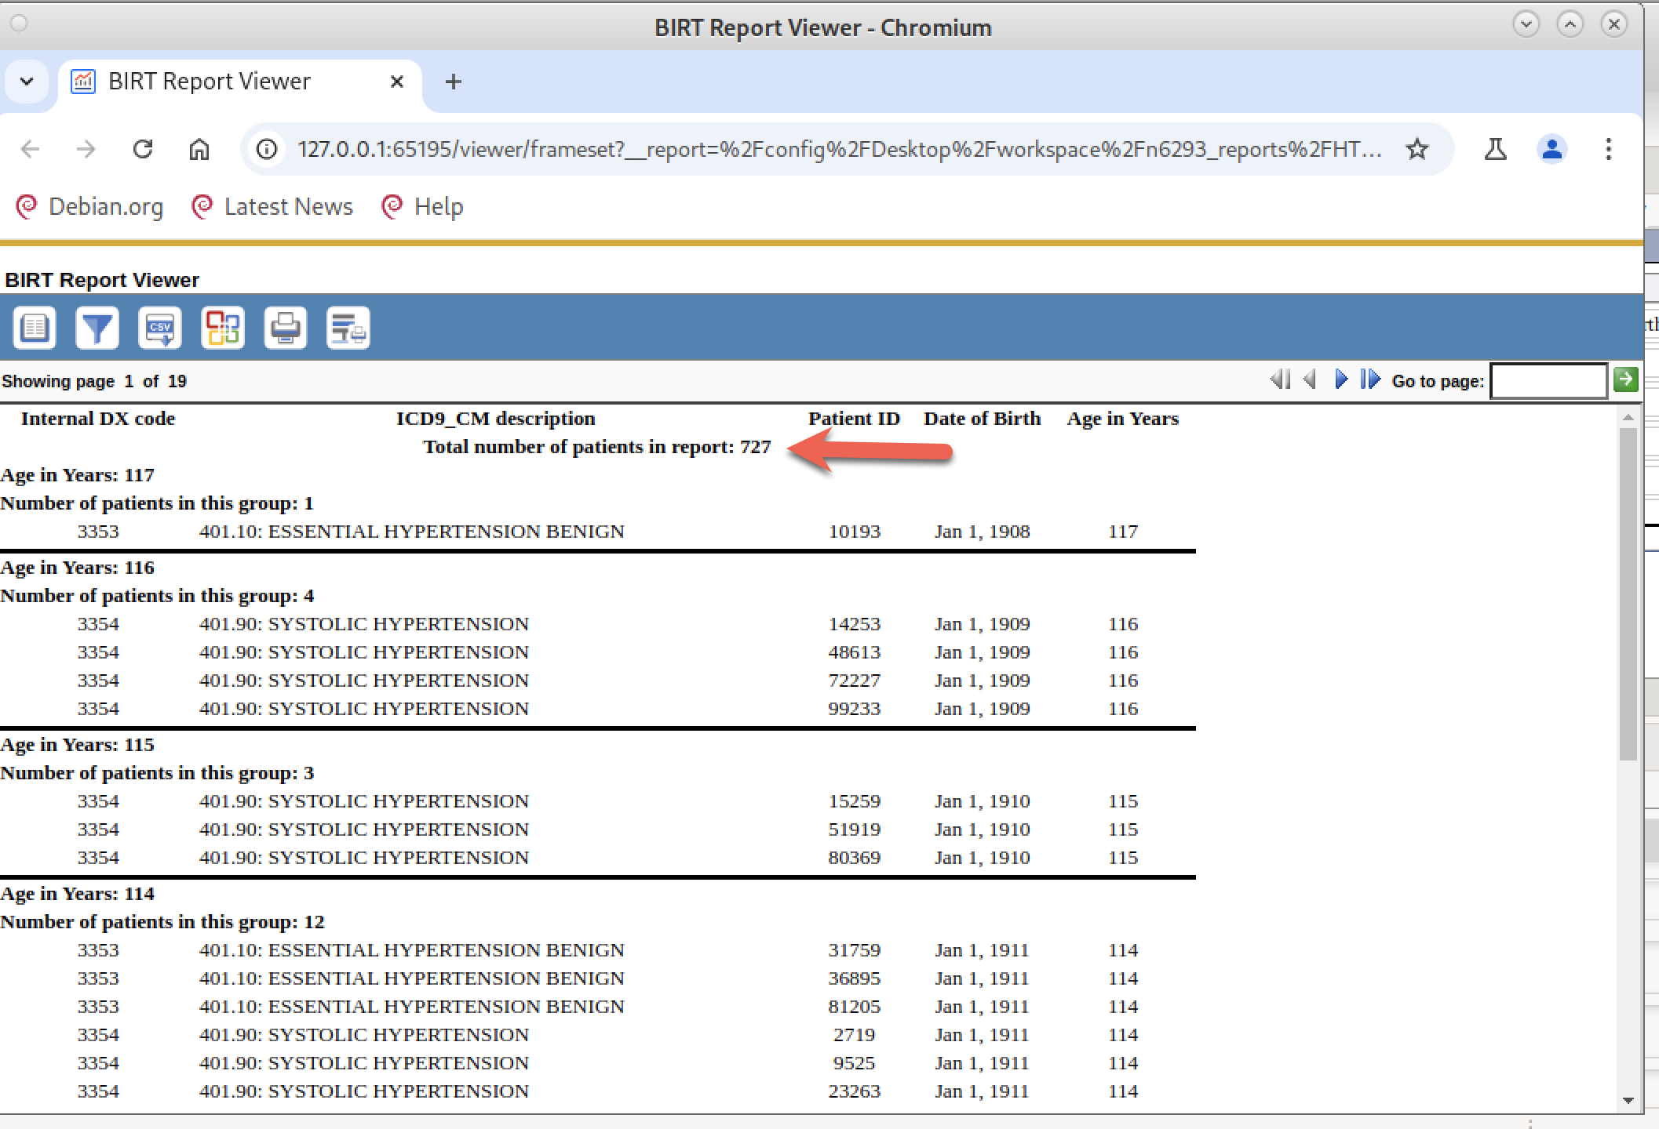

Personal taste: It feels to me that the “Total number of patients” (red arrow) gets lost underneath the column names. I would prefer the “Total number of patients in report” information to be above. I also do not particularly like the center alignment, preferring left justification. These are personal preferences.

UNFORTUANTELY, FROM WHAT I COULD FIND USING GOOGLE, THERE IS NO SIMPLE WAY TO DO THIS VERY SIMPLE TASK (switch the order of rows in a header field). The only way to get what I want to do is to start over (delete the new row) and insert the new row ABOVE rather than below the existing header row. Sigh.

I delete the newly created Header row by right clicking on the row and then DELETE. I added a new row **ABOVE** the existing header (red box) and added a Dynamic Text element. Fortunately, I do not need to define the NumPatsTable variable. It is still there:

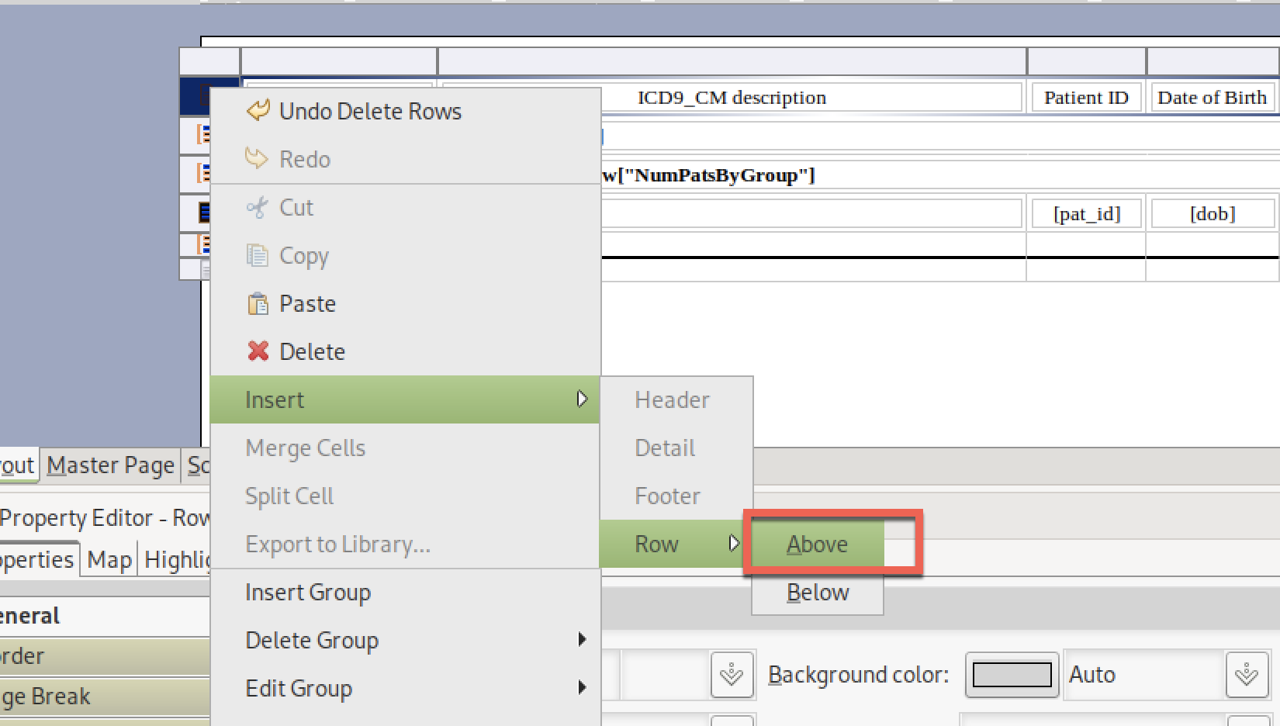

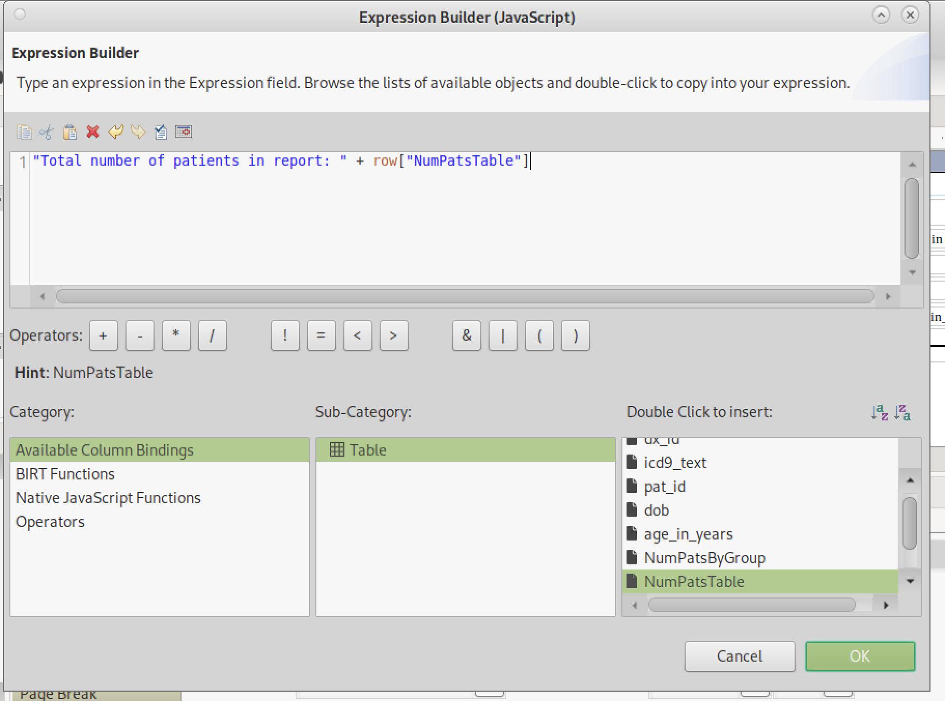

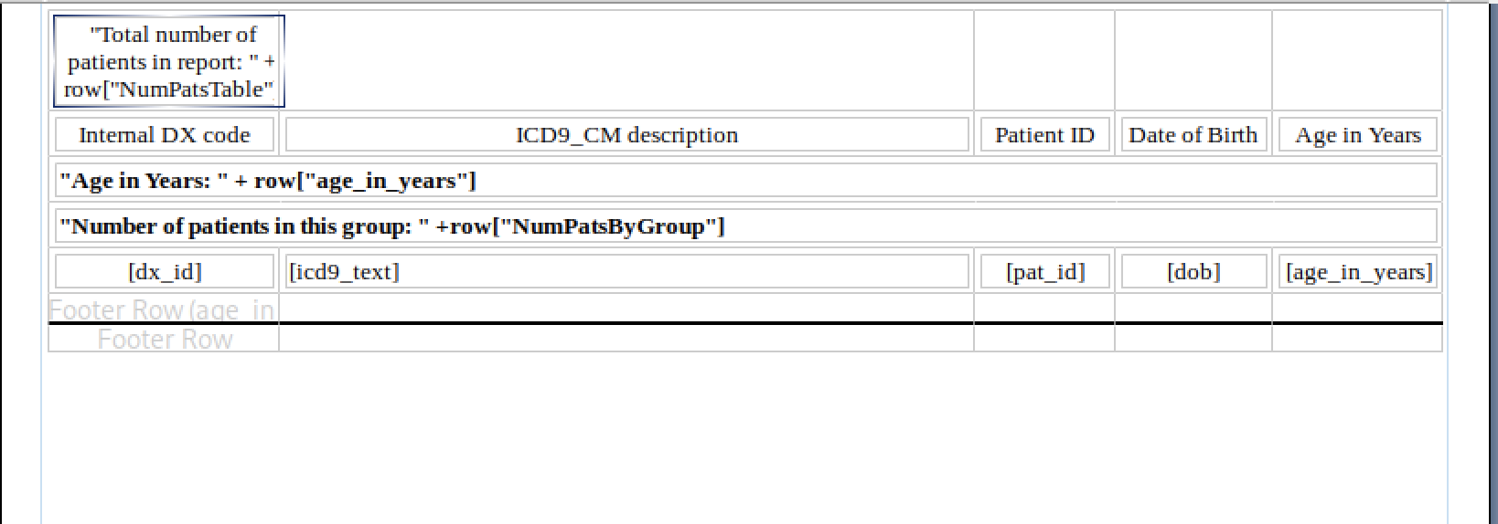

Now, merge the cells using the click-drag from the right-to-left trick. Left align and make bold:

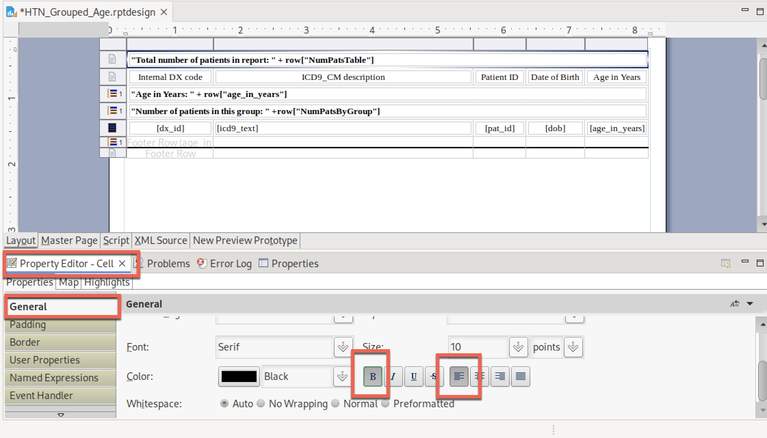

Render:

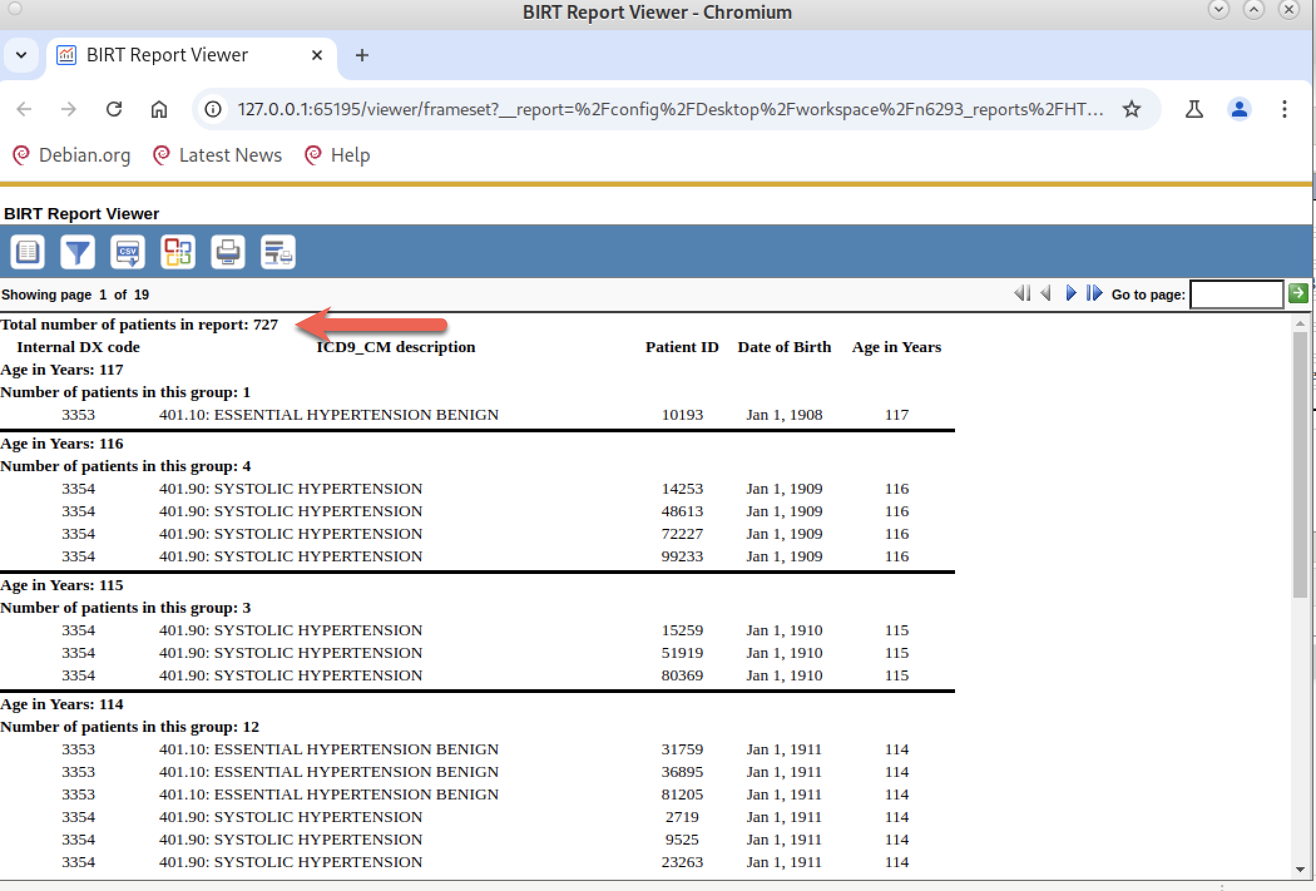

This looks good! The total count is now above the column labels.

**Change #5**: Add reports description and CU logo branding just like I did for Report #1. Nothing new, I followed the same instructions as for Report #1:

After adding a descriptive text (by adding a Label to the main report), and adding a CU logo (into the Page Header found under the “Master Page” tab) and reducing the size of the CU logo to Height =50% / width =50%, my final report looks like:

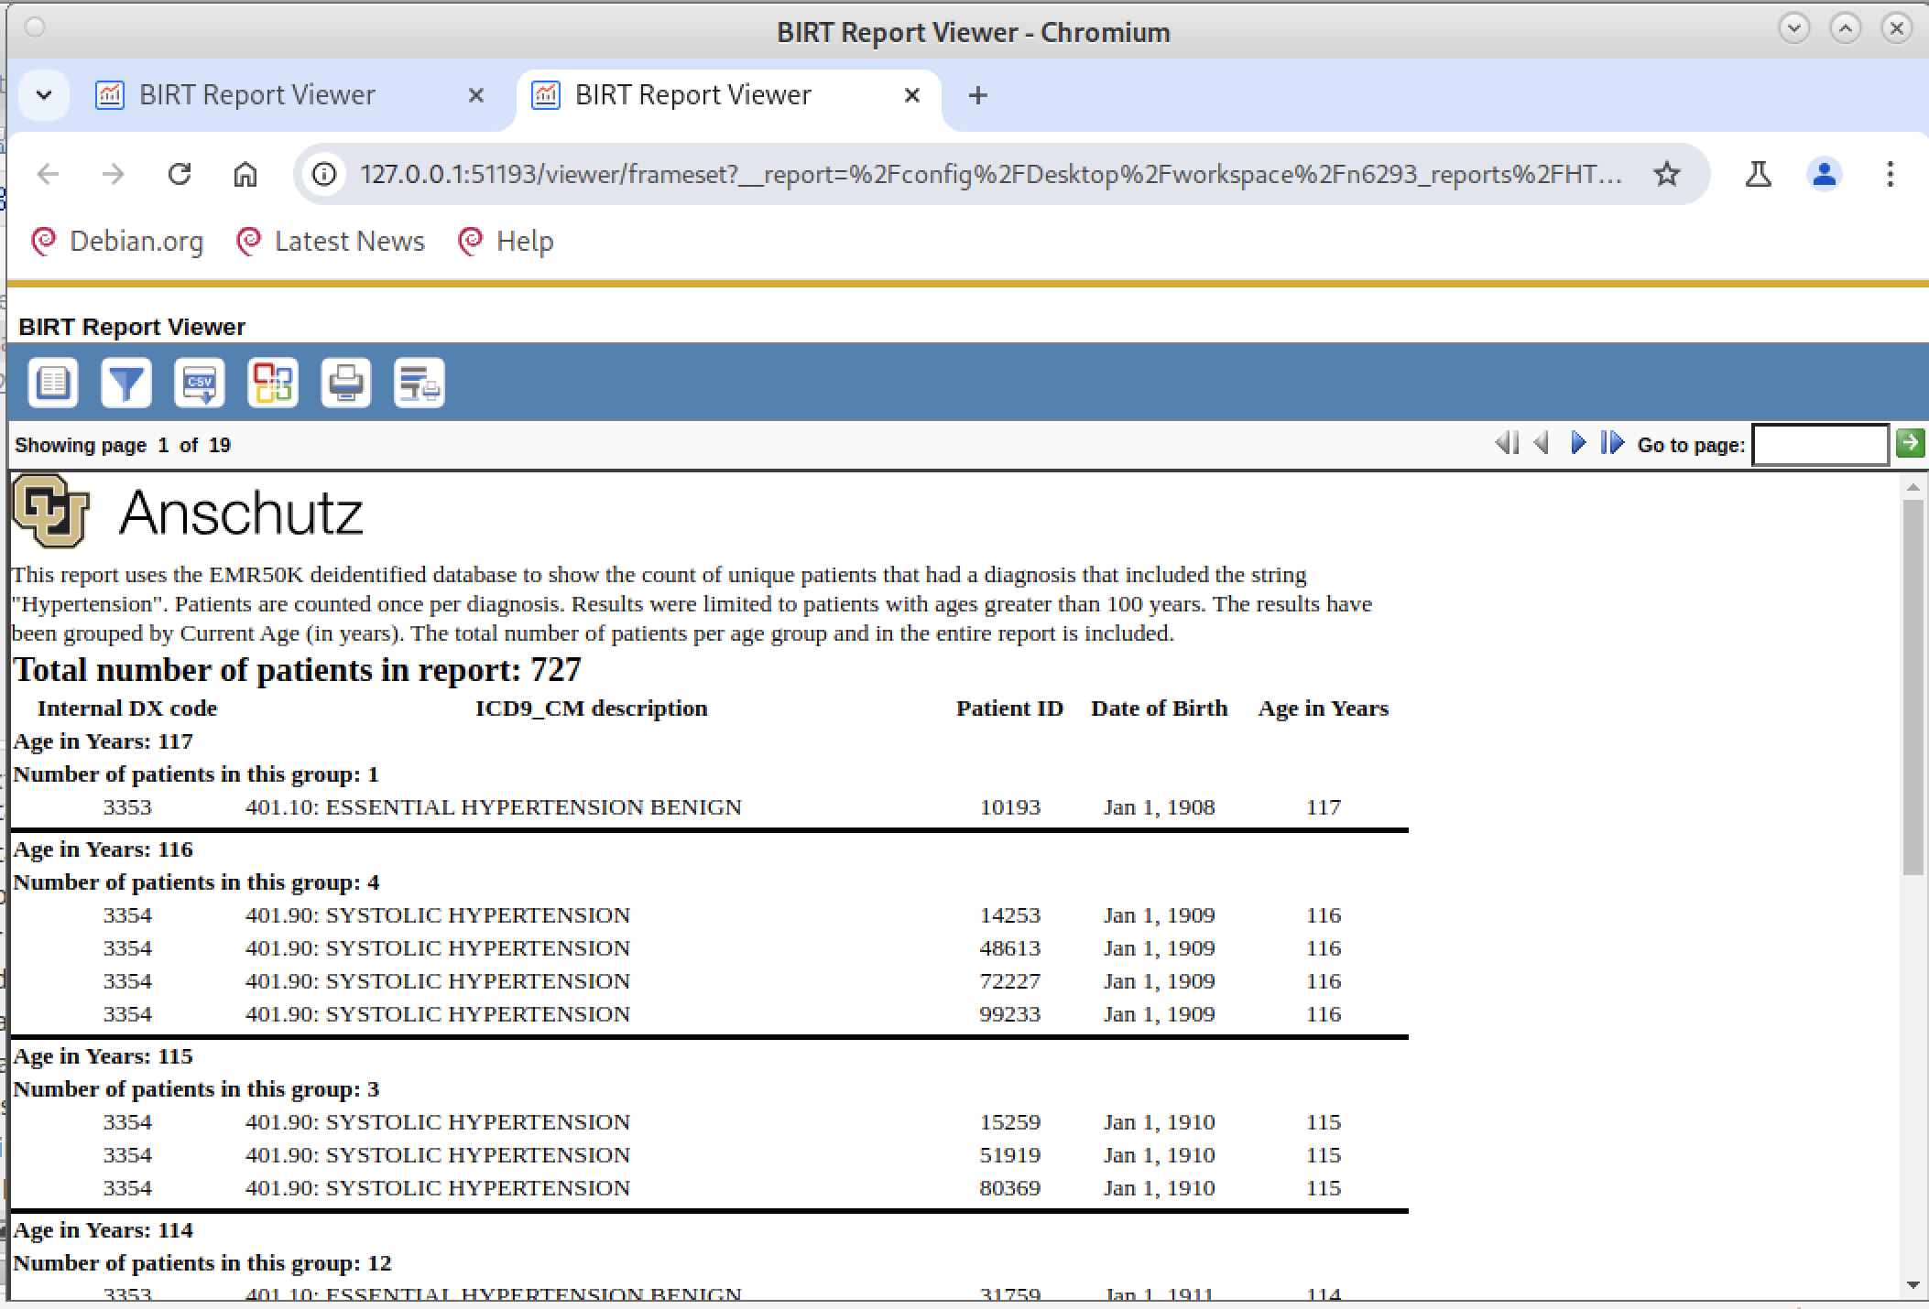

I have not tried using any of the other report templates. They are all more complicated that we need for this class. If you decide to try to use them, Google or ChatGPT might be your best friend late into the evening.